Floristic findings and revision of aquatic flora of the Kuril Archipelago reveal no clear differences between biogeographical regions
Polina A. Volkova, Maria O. Ivanova, Maksim Yu. Grigoryan, Yury O. Kopylov-Guskov, Alexander A. Bobrov

Supplementary information
Figure S1. Different types of waterbodies, where new aquatic species for Iturup and Urup islands were found. Photo: M. Ivanova: (a), Large Sphagnum bog with system of water bodies on the southern extremity of Urup Island (08.08.2021); (b), Callitriche anceps growing with Isoёtes asiatica in one of the large lakes in the upper part of this bog (southern extremity of Urup Island, 08.08.2021); (c), Dense stands of Myriophyllum ussuriense on dried peat bottom of the lake on this bog (close-up of male plants is given as an inset) (southern extremity of Urup Island, 08.08.2021); (d), Small lake in the valley of Tokotan Lake, overgrown with Potamogeton fryeri, P. berchtoldii, Sparganium glomeratum and Schoenoplectus tabernaemontani (NW coast of Urup Island, 13.07.2021); (e), Ranunculus ashibetsuensis growing on the bank of the stream, flowing into Tokotan Lake (NW coast of Urup Island, 30.07.2021). Large flaccid capillary leaves and some flower with six petals (centrally) are typical for this species; (f), Small lake on the cape near Nezabvennaya Bay – one of the localities of Sparganium angustifolium × S. hyperboreum (southern extremity of Urup Island, 06.08.2021); (g), Lopastnoe Lake (with Ivan Groznyi Volcano at the background), one of Ranunculus ashibetsuensis localities on Iturup Island (17.08.2021); (h), Valley of the Mnogoozyornyi Stream, flowing into Kupalnoe Lake (view from Tebenkova Mount), a firstly found locality of Myriophyllum ussuriense on Iturup Island (18.08.2021).

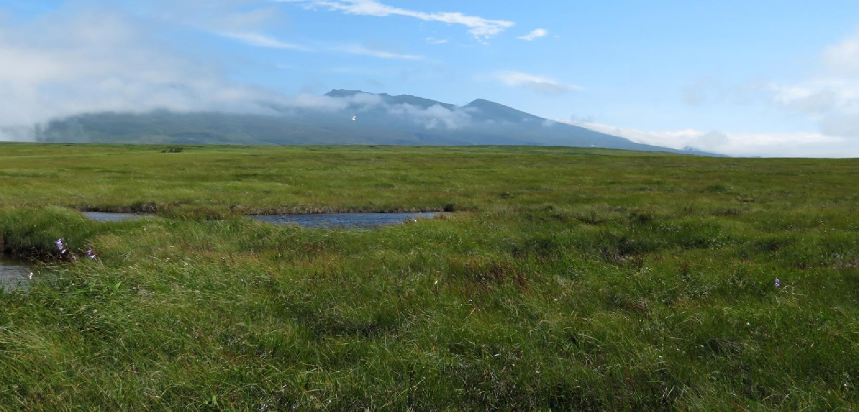
Fig. S1a.

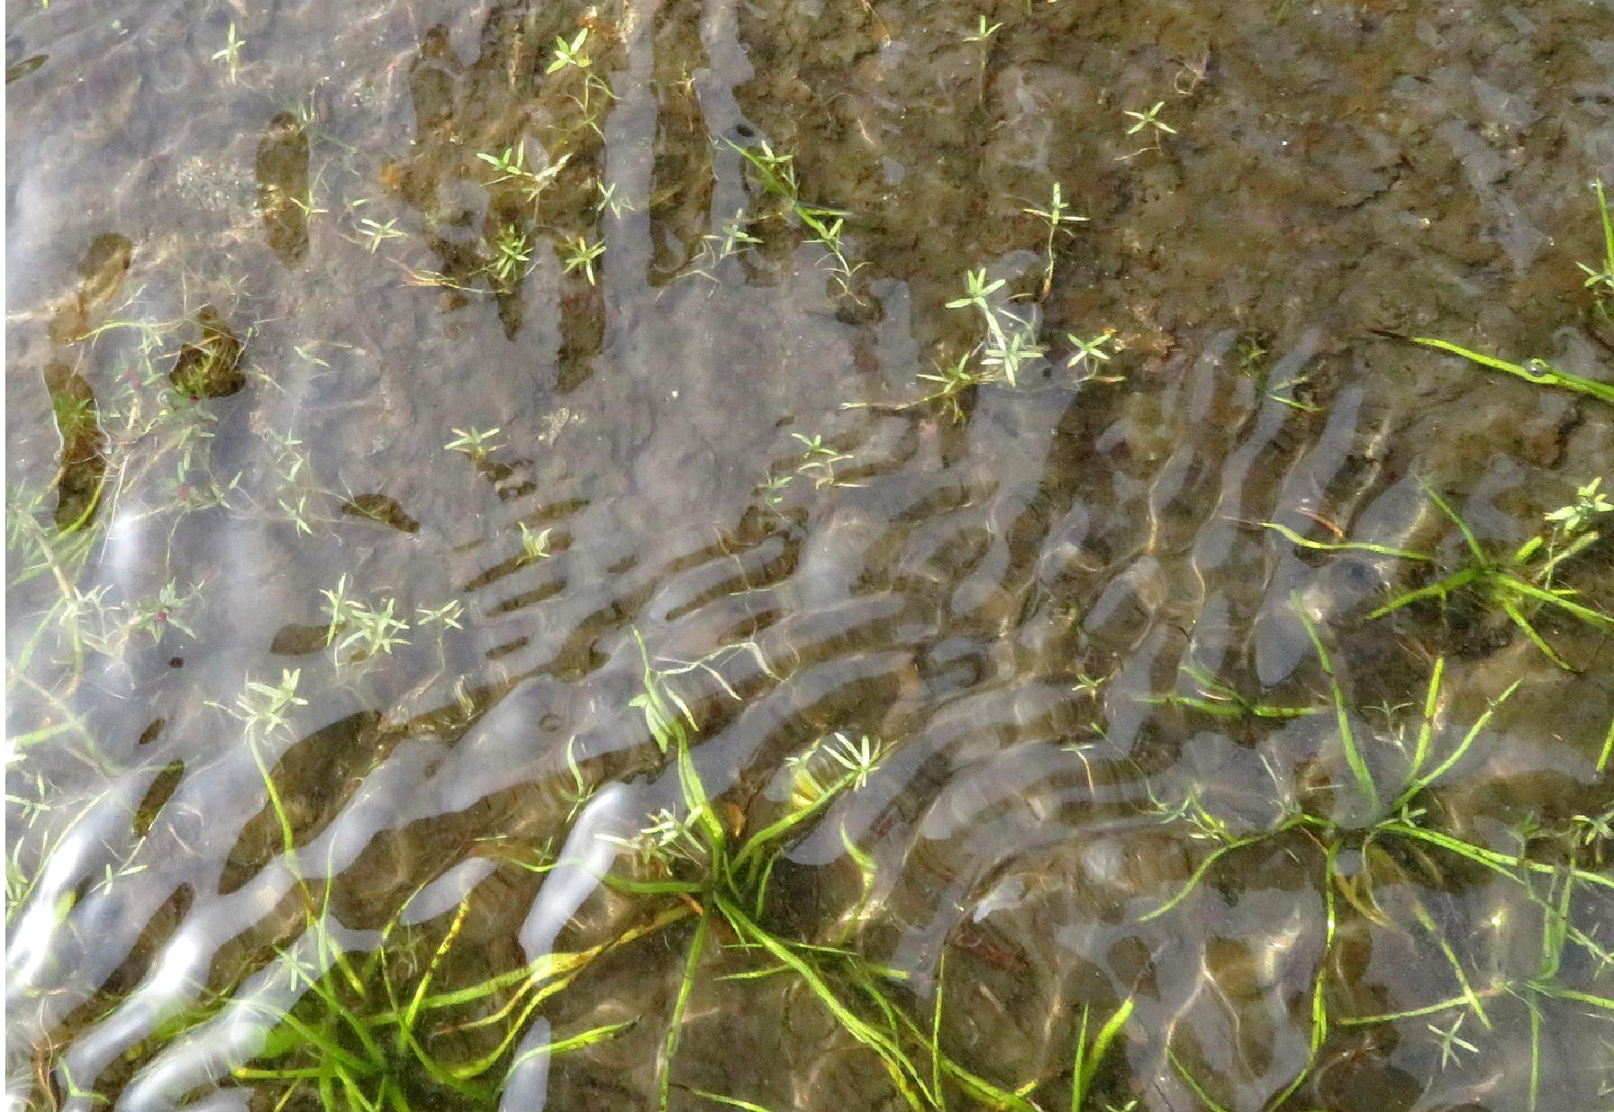
Fig. S1b.

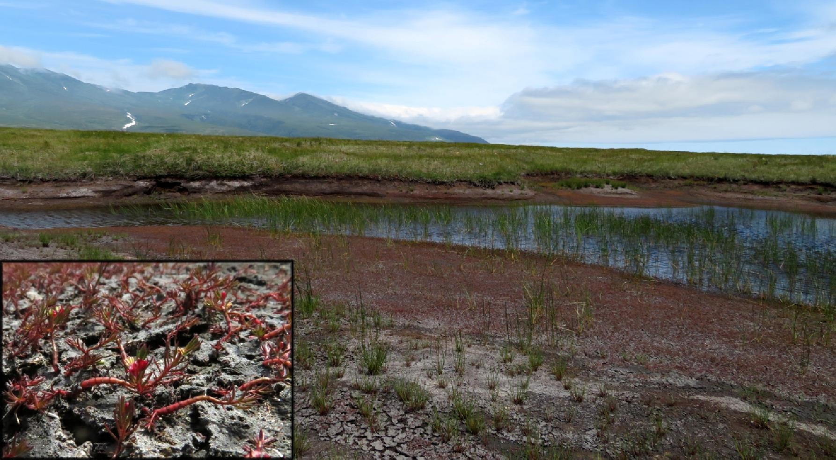
Fig. S1c.

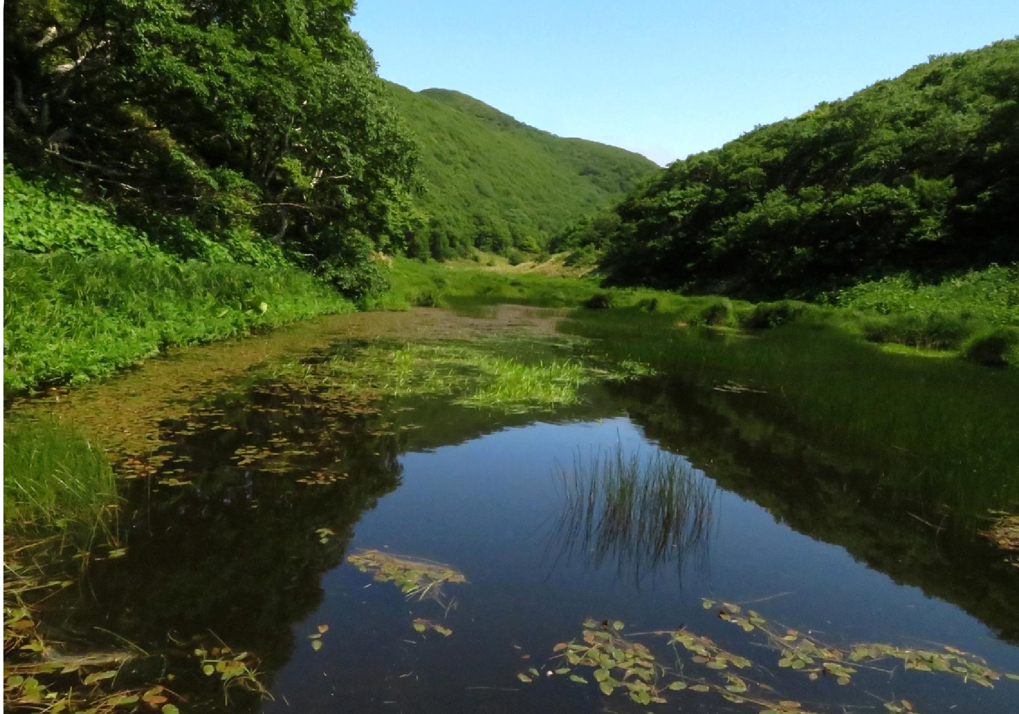
Fig. S1d.
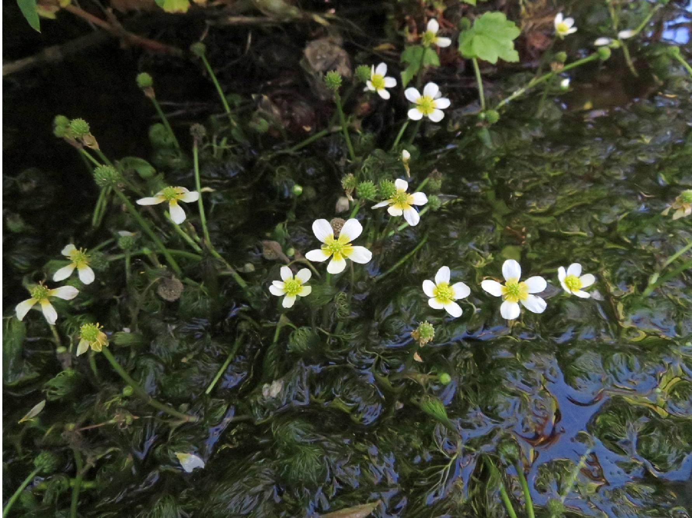
Fig. S1e.

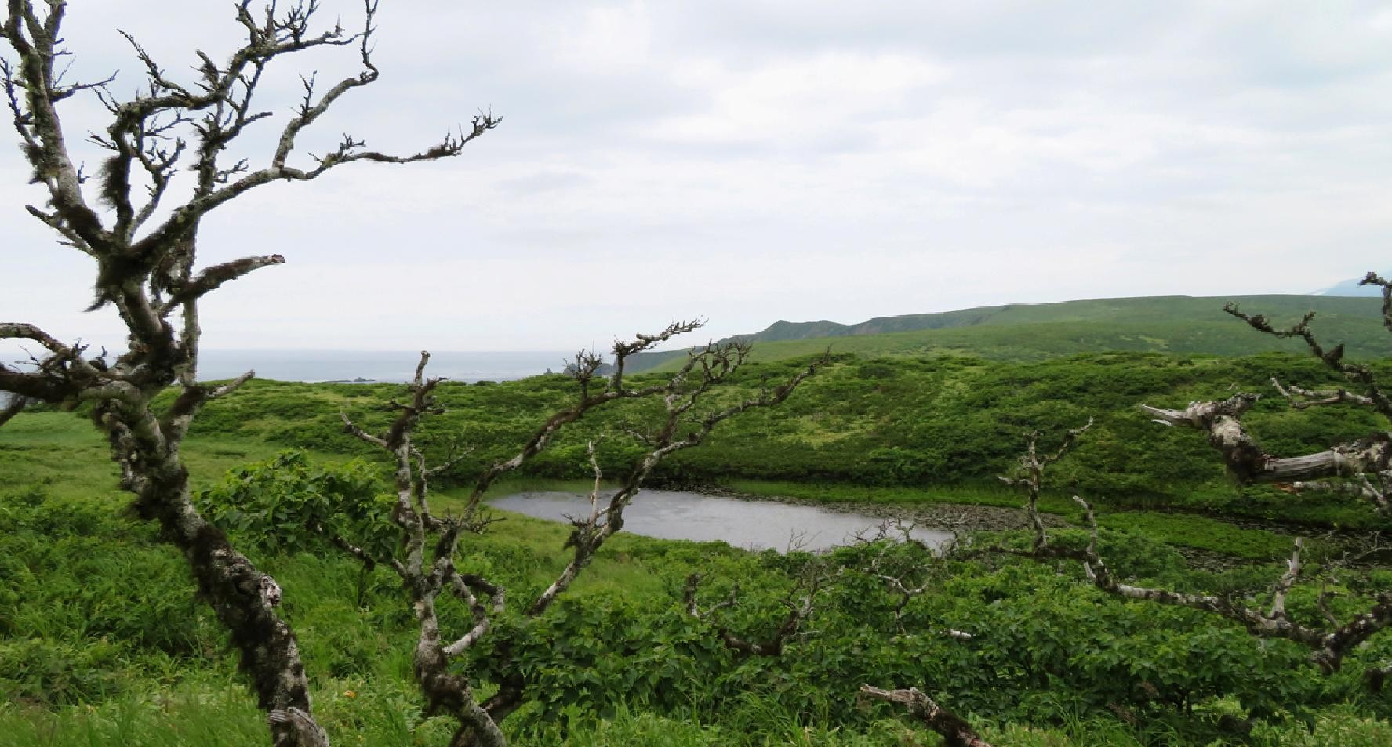
Fig. S1f.
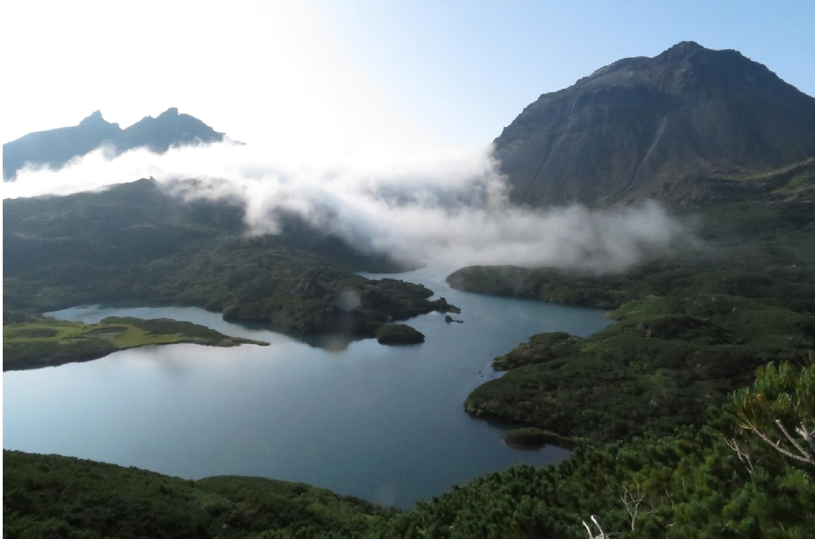
Fig. S1g.
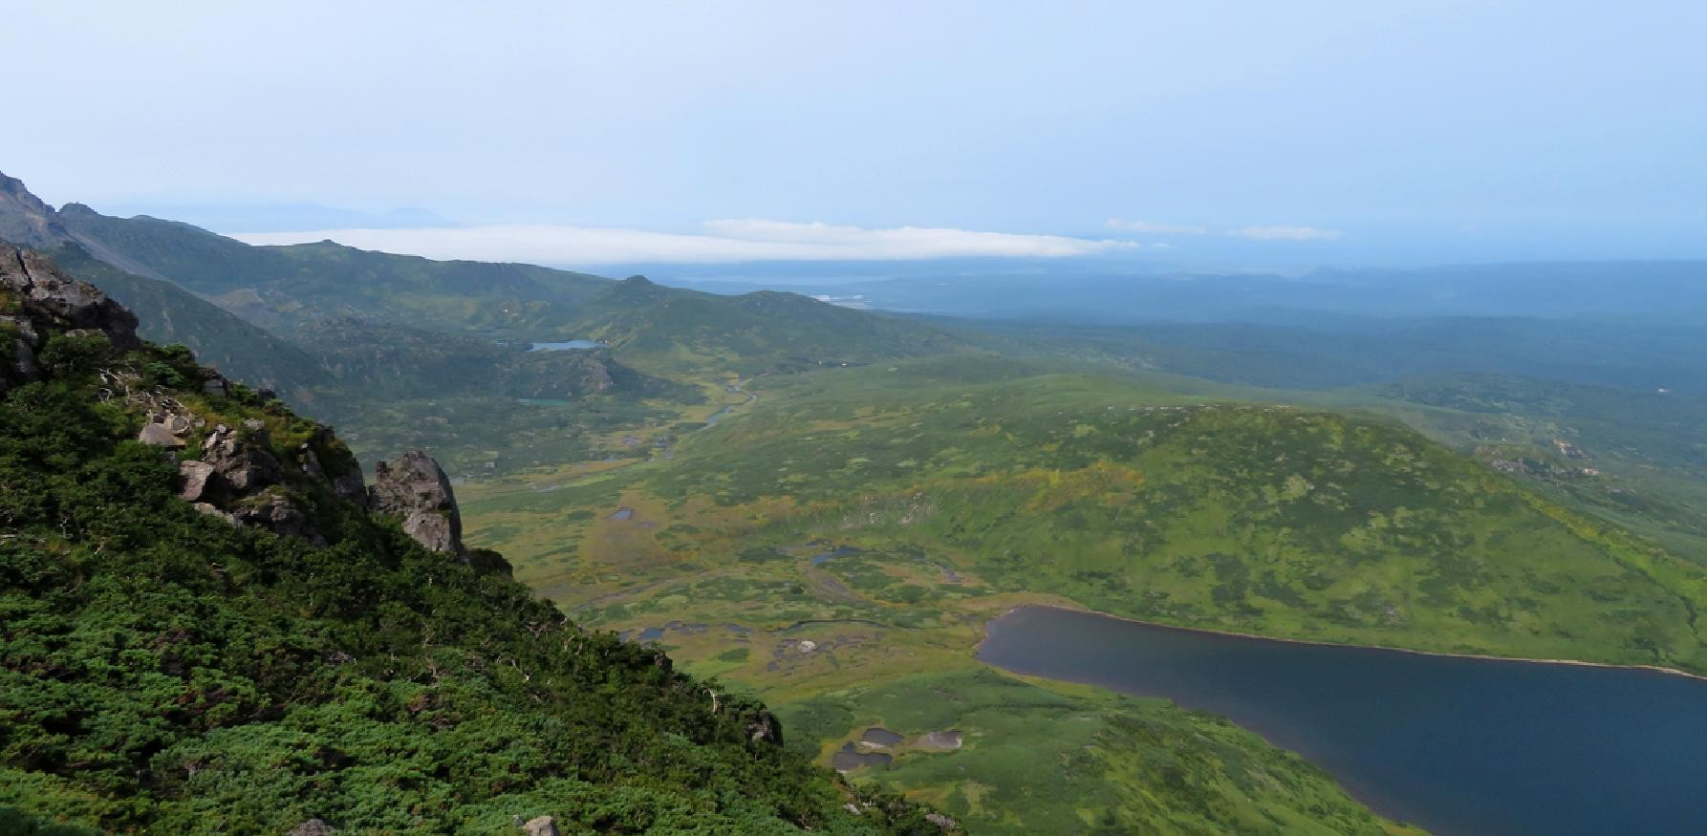
Fig. S1h.

