ДОПОЛНИТЕЛЬНЫЕ МАТЕРИАЛЫ

КОМПЛЕКСЫ ТИОЦИАНАТОВ ЛАНТАНИДОВ (Dy, Er, Yb)

С ТЕТРАМЕТИЛФЕНАНТРОЛИНОМ. СИНТЕЗ, ТЕРМОЛИЗ И SMM СВОЙСТВА

© 2021 г. С. П. Петросянц, К. А. Бабешкин, А. Б. Илюхин, Е. В. Белова,

Н. Н. Ефимов

КООРДИНАЦИОННАЯ ХИМИЯ. 2021. Т. 47. № 4

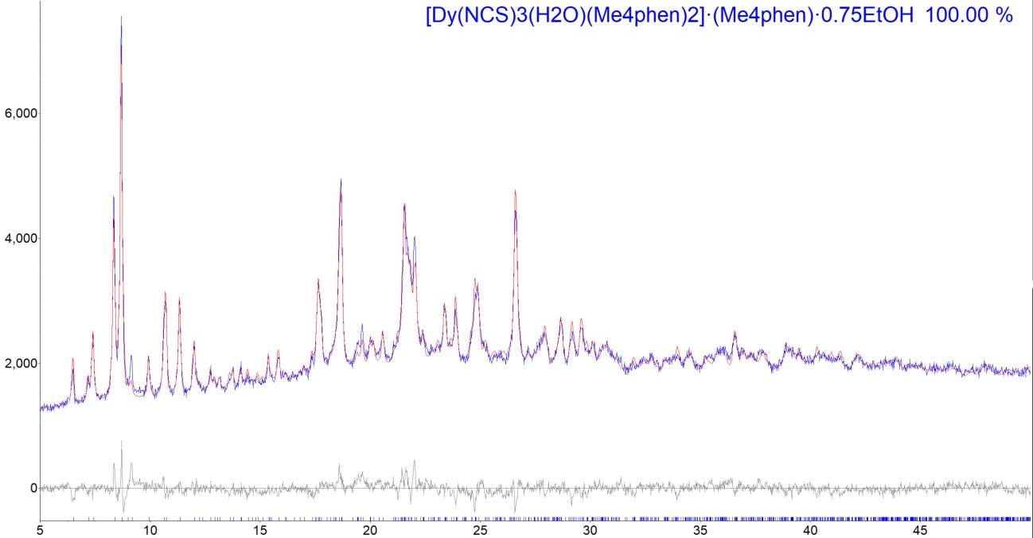

Рис. S1. Результаты полнопрофильного уточнения по Ритвельду для соединения I.

Результаты полнопрофильного уточнения по Ритвельду для соединения I (Dy).

File 1 : G:\Andr\Paper\SP_Ln_NCS_Me4phen\Powder\Dy_NCS_Me4phen_2018_11_08
.raw
Range Number : 1

R-Values

Rexp : 2.18 Rwp : 3.72 Rp : 2.86 GOF : 1.71
Rexp`: 4.86 Rwp`: 8.29 Rp` : 7.50 DW : 0.77

Quantitative Analysis - Rietveld
Phase 1 : "[Dy(NCS)3(H2O)(Me4phen)2]·(Me4phen)·0.75EtOH " 100.000 %

Background
One on X 9200(3700) Chebychev polynomial, Coefficient 0 1110(230)
1 820(240)

2 -520(130)
3 219(65)
4 -41(33)
5 3(18)
6 -11.5(84)
7 52.4(50)

Instrument
Primary radius (mm) 280
Secondary radius (mm) 280
Linear PSD 2Th angular range (°) 2.94
FDS angle (°) 0.2
Beam spill, sample length (mm) 6
Intensity corrected

Corrections
Specimen displacement 0.1111(27)
LP Factor 0

Miscellaneous
Start X 5
Finish X 50

Structure 1
Phase name
[Dy(NCS)3(H2O)(Me4phen)2]·(Me4phen)·0.75EtOH
R-Bragg 1.930
Spacegroup P2(1)/n
Scale 0.00001703(45) Cell Mass 4393.088
Cell Volume (Å^3) 5104.90(95)
Wt% - Rietveld 100.000
Crystallite Size
Cry size Lorentzian (nm) 83.6(12) Crystal Linear Absorption Coeff. (1/cm) 85.217(16) Crystal Density (g/cm^3) 1.42900(27) Preferred Orientation Spherical Harmonics
Order 4
y00 1
y20 -0.062(34)
y22m -0.527(53)
y22p 0.067(12) y40 -0.214(30) y42m -0.216(25) y42p -0.0218(76) y44m -0.055(14) y44p -0.246(31)
Lattice parameters
a | (Å) |  | 13.0480(16)
b | (Å) |  | 16.4683(18)
c | (Å) |  | 24.1435(20)
beta |  | (°) 100.2626(65

)

Site Np x y z Atom Occ Beq
Dy1 | 4 | 0.43173 | 0.60153 | 0.17994 | Dy | 1 | 3
S1 | 4 | 0.79487 | 0.60956 | 0.29545 | S | 0.75 | 4
S1B | 4 | 0.78080 | 0.66090 | 0.30970 | S | 0.25 | 4
S2 | 4 | 0.56118 | 0.84461 | 0.07617 | S | 1 | 4
S3 | 4 | 0.06348 | 0.64310 | 0.07384 | S | 1 | 4
O1 | 4 | 0.40290 | 0.69394 | 0.25104 | O | 1 | 4
H1 | 4 | 0.46090 | 0.70270 | 0.27620 | H | 1 | 6
H2 | 4 | 0.36670 | 0.67220 | 0.27780 | H | 1 | 6
N1 | 4 | 0.59880 | 0.63660 | 0.23205 | N | 1 | 4

N2 | 4 | 0.48140 | 0.71340 | 0.12800 | N | 1 | 4
N3 | 4 | 0.26820 | 0.65090 | 0.13014 | N | 1 | 4
N4 | 4 | 0.30760 | 0.53300 | 0.23461 | N | 1 | 4
N5 | 4 | 0.50160 | 0.47540 | 0.23460 | N | 1 | 4
N6 | 4 | 0.54520 | 0.53740 | 0.11727 | N | 1 | 4
N7 | 4 | 0.34860 | 0.48490 | 0.11649 | N | 1 | 4
N8 | 4 | 0.47650 | 0.59500 | 0.36609 | N | 1 | 4
N9 | 4 | 0.29240 | 0.67360 | 0.34170 | N | 1 | 4
C1 | 4 | 0.68100 | 0.62900 | 0.25910 | C | 0.75 | 4
C1B | 4 | 0.67600 | 0.63900 | 0.26400 | C | 0.25 | 6
C2 | 4 | 0.51380 | 0.76830 | 0.10630 | C | 1 | 4
C3 | 4 | 0.18220 | 0.64980 | 0.10551 | C | 1 | 4
C4 | 4 | 0.21180 | 0.55990 | 0.23340 | C | 1 | 4
H4A | 4 | 0.19540 | 0.61250 | 0.21800 | H | 1 | 6
C5 | 4 | 0.13220 | 0.51680 | 0.25322 | C | 1 | 4
C6 | 4 | 0.15650 | 0.44130 | 0.27854 | C | 1 | 4
C7 | 4 | 0.25990 | 0.41370 | 0.28282 | C | 1 | 4
C8 | 4 | 0.29500 | 0.33840 | 0.31022 | C | 1 | 4
H8A | 4 | 0.24690 | 0.30560 | 0.32580 | H | 1 | 6
C9 | 4 | 0.39400 | 0.31350 | 0.31426 | C | 1 | 4
H9A | 4 | 0.41440 | 0.26410 | 0.33370 | H | 1 | 6
C10 | 4 | 0.47100 | 0.35840 | 0.29033 | C | 1 | 4
C11 | 4 | 0.57610 | 0.33380 | 0.29393 | C | 1 | 4
C12 | 4 | 0.64130 | 0.38040 | 0.26720 | C | 1 | 4
C13 | 4 | 0.59830 | 0.44990 | 0.23762 | C | 1 | 4
H13A | 4 | 0.64270 | 0.48100 | 0.21830 | H | 1 | 6
C14 | 4 | 0.43740 | 0.43050 | 0.26153 | C | 1 | 4
C15 | 4 | 0.33220 | 0.45960 | 0.25921 | C | 1 | 4
C16 | 4 | 0.02400 | 0.55320 | 0.24500 | C | 1 | 4
H16A | 4 | 0.02420 | 0.60580 | 0.22590 | H | 1 | 6
H16B | 4 | 0.00310 | 0.56060 | 0.28200 | H | 1 | 6
H16C | 4 | -0.02540 | 0.51660 | 0.22160 | H | 1 | 6
C17 | 4 | 0.07410 | 0.39280 | 0.30060 | C | 1 | 4
H17A | 4 | 0.10100 | 0.37530 | 0.33960 | H | 1 | 6
H17B | 4 | 0.05590 | 0.34490 | 0.27650 | H | 1 | 6
H17C | 4 | 0.01190 | 0.42650 | 0.30010 | H | 1 | 6
C18 | 4 | 0.61710 | 0.25710 | 0.32560 | C | 1 | 4
H18A | 4 | 0.56980 | 0.24100 | 0.35130 | H | 1 | 6
H18B | 4 | 0.68680 | 0.26750 | 0.34760 | H | 1 | 6
H18C | 4 | 0.62110 | 0.21340 | 0.29830 | H | 1 | 6
C19 | 4 | 0.75310 | 0.36050 | 0.26810 | C | 1 | 4
H19A | 4 | 0.78290 | 0.39920 | 0.24430 | H | 1 | 6
H19B | 4 | 0.75870 | 0.30530 | 0.25350 | H | 1 | 6
H19C | 4 | 0.79140 | 0.36370 | 0.30720 | H | 1 | 6
C20 | 4 | 0.64330 | 0.56150 | 0.11827 | C | 1 | 4
H20A | 4 | 0.66680 | 0.60760 | 0.14080 | H | 1 | 6
C21 | 4 | 0.71430 | 0.52450 | 0.08905 | C | 1 | 4
C22 | 4 | 0.68070 | 0.45940 | 0.05435 | C | 1 | 4
C23 | 4 | 0.57710 | 0.43170 | 0.05178 | C | 1 | 4
C24 | 4 | 0.53300 | 0.36610 | 0.01694 | C | 1 | 4
H24A | 4 | 0.57520 | 0.33860 | -0.00560 | H | 1 | 6
C25 | 4 | 0.43460 | 0.34150 | 0.01474 | C | 1 | 4
H25A | 4 | 0.40880 | 0.29810 | -0.00990 | H | 1 | 6
C26 | 4 | 0.36690 | 0.37840 | 0.04832 | C | 1 | 4
C27 | 4 | 0.26360 | 0.35260 | 0.04847 | C | 1 | 4
C28 | 4 | 0.20450 | 0.39410 | 0.08190 | C | 1 | 4
C29 | 4 | 0.25160 | 0.45970 | 0.11410 | C | 1 | 4
H29A | 4 | 0.20990 | 0.48860 | 0.13620 | H | 1 | 6
C30 | 4 | 0.40680 | 0.44450 | 0.08319 | C | 1 | 4
C31 | 4 | 0.51280 | 0.47190 | 0.08418 | C | 1 | 4
C32 | 4 | 0.82400 | 0.55680 | 0.09630 | C | 1 | 4
H32A | 4 | 0.83000 | 0.60560 | 0.12020 | H | 1 | 6
H32B | 4 | 0.84060 | 0.57050 | 0.05910 | H | 1 | 6
H32C | 4 | 0.87290 | 0.51540 | 0.11450 | H | 1 | 6

H33A | 4 | 0.71500 | 0.38440 | -0.00840 | H | 1 | 6
H33B | 4 | 0.80330 | 0.38370 | 0.04740 | H | 1 | 6
H33C | 4 | 0.79420 | 0.45910 | 0.00460 | H | 1 | 6
C34 | 4 | 0.21850 | 0.28030 | 0.01430 | C | 1 | 4
H34A | 4 | 0.24390 | 0.27930 | -0.02190 | H | 1 | 6
H34B | 4 | 0.14210 | 0.28400 | 0.00700 | H | 1 | 6
H34C | 4 | 0.24010 | 0.23030 | 0.03540 | H | 1 | 6
C35 | 4 | 0.09420 | 0.37350 | 0.08620 | C | 1 | 4
H35A | 4 | 0.06870 | 0.41170 | 0.11200 | H | 1 | 6
H35B | 4 | 0.09140 | 0.31810 | 0.10090 | H | 1 | 6
H35C | 4 | 0.05030 | 0.37710 | 0.04850 | H | 1 | 6
C36 | 4 | 0.56400 | 0.55240 | 0.37790 | C | 1 | 4
H36A | 4 | 0.62160 | 0.57270 | 0.36270 | H | 1 | 6
C37 | 4 | 0.58160 | 0.48210 | 0.40980 | C | 1 | 4
C38 | 4 | 0.49870 | 0.44930 | 0.42980 | C | 1 | 4
C39 | 4 | 0.40160 | 0.49010 | 0.41770 | C | 1 | 4
C40 | 4 | 0.31220 | 0.46150 | 0.43680 | C | 1 | 4
H40A | 4 | 0.31610 | 0.41120 | 0.45650 | H | 1 | 6
C41 | 4 | 0.22030 | 0.50300 | 0.42830 | C | 1 | 4
H41A | 4 | 0.16230 | 0.48210 | 0.44290 | H | 1 | 6
C42 | 4 | 0.21040 | 0.57870 | 0.39714 | C | 1 | 4
C43 | 4 | 0.11670 | 0.62550 | 0.38867 | C | 1 | 4
C44 | 4 | 0.11650 | 0.69660 | 0.35724 | C | 1 | 4
C45 | 4 | 0.20490 | 0.71540 | 0.33470 | C | 1 | 4
H45A | 4 | 0.20180 | 0.76300 | 0.31200 | H | 1 | 6
C46 | 4 | 0.29720 | 0.60550 | 0.37470 | C | 1 | 4
C47 | 4 | 0.39570 | 0.56270 | 0.38590 | C | 1 | 4
C48 | 4 | 0.68920 | 0.44550 | 0.41900 | C | 1 | 4
H48A | 4 | 0.73180 | 0.47360 | 0.39510 | H | 1 | 6
H48B | 4 | 0.68430 | 0.38770 | 0.40890 | H | 1 | 6
H48C | 4 | 0.72170 | 0.45120 | 0.45900 | H | 1 | 6
C49 | 4 | 0.50990 | 0.37200 | 0.46520 | C | 1 | 4
H49A | 4 | 0.46690 | 0.37620 | 0.49480 | H | 1 | 6
H49B | 4 | 0.58320 | 0.36470 | 0.48290 | H | 1 | 6
H49C | 4 | 0.48690 | 0.32540 | 0.44070 | H | 1 | 6
C50 | 4 | 0.02260 | 0.59950 | 0.41310 | C | 1 | 4
H50A | 4 | 0.04290 | 0.59150 | 0.45410 | H | 1 | 6
H50B | 4 | -0.00480 | 0.54840 | 0.39530 | H | 1 | 6
H50C | 4 | -0.03130 | 0.64160 | 0.40570 | H | 1 | 6
C51 | 4 | 0.02090 | 0.75180 | 0.34490 | C | 1 | 4
H51A | 4 | -0.00390 | 0.76390 | 0.38030 | H | 1 | 6
H51B | 4 | -0.03460 | 0.72450 | 0.31850 | H | 1 | 6
H51C | 4 | 0.03970 | 0.80260 | 0.32780 | H | 1 | 6
O2 | 4 | 0.54040 | 0.75280 | 0.34060 | O | 0.75 | 4
H3 | 4 | 0.52580 | 0.70330 | 0.35940 | H | 0.75 | 6
C52 | 4 | 0.64000 | 0.77130 | 0.36300 | C | 0.75 | 4
H52A | 4 | 0.64650 | 0.83120 | 0.36550 | H | 0.75 | 6
H52B | 4 | 0.68540 | 0.75230 | 0.33650 | H | 0.75 | 6
C53 | 4 | 0.68590 | 0.73150 | 0.42840 | C | 0.75 | 4
H53A | 4 | 0.76240 | 0.73350 | 0.43580 | H | 0.75 | 6
H53B | 4 | 0.66290 | 0.67490 | 0.42980 | H | 0.75 | 6
H53C | 4 | 0.65890 | 0.76320 | 0.45730 | H | 0.75 | 6

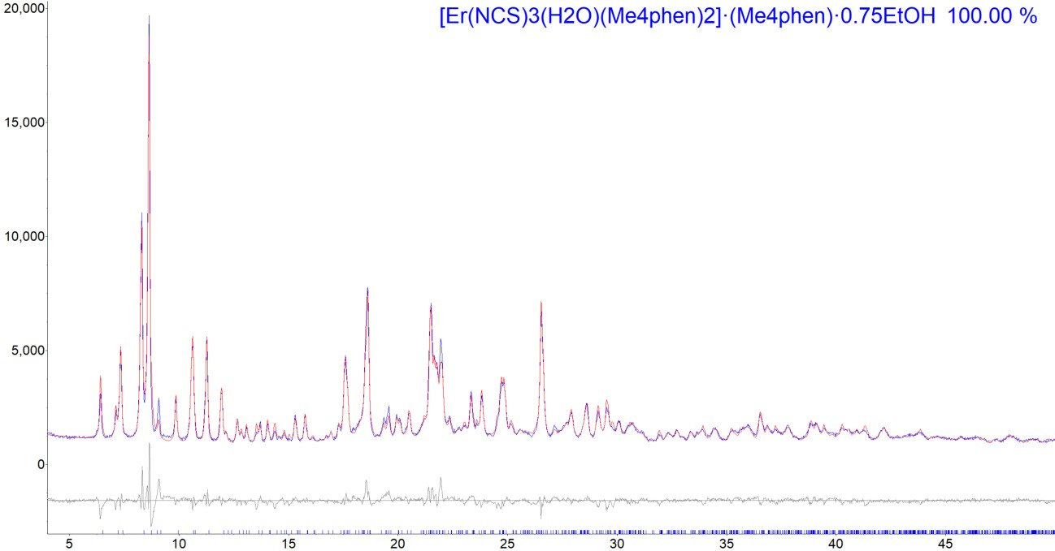

Рис. S2. Результаты полнопрофильного уточнения по Ритвельду для соединения II.

Результаты полнопрофильного уточнения по Ритвельду для соединения II (Er).

File 1 : G:\Andr\Paper\SP_Ln_NCS_Me4phen\Powder\Er_NCS_Me4phen_2018_11_08
.raw_1
Range Number : 1

R-Values

Rexp : 2.44 Rwp : 7.22 Rp : 5.29 GOF : 2.96
Rexp`: 4.02 Rwp`: 11.93 Rp` : 9.31 DW : 0.40

Quantitative Analysis - Rietveld
Phase 1 : "[Er(NCS)3(H2O)(Me4phen)2]·(Me4phen)·0.75EtOH " 100.000 %

Background
One on X 5100(2900)
Chebychev polynomial, | Coefficient | 0 | 640(200)
 |  | 1 | 260(230)
 |  | 2 | -230(130)
 |  | 3 | 63(70)
 |  | 4 | 20(38)
 |  | 5 | -18(22)
 |  | 6 | -17(11)
 |  | 7 | 65.7(69)

Instrument
Primary radius (mm) 280
Secondary radius (mm) 280
Linear PSD 2Th angular range (°) 2.94
FDS angle (°) 0.2
Beam spill, sample length (mm) 10
Intensity corrected

Corrections
Specimen displacement 0.2714623
LP Factor 0

Miscellaneous
Start X 4
Finish X 50

Structure 1
Phase name
[Er(NCS)3(H2O)(Me4phen)2]·(Me4phen)·0.75EtOH
R-Bragg 3.510
Spacegroup P2(1)/n
Scale 0.00002830(64)
Cell Mass 4412.127
Cell Volume (Å^3) 5093.38(54)
Wt% - Rietveld 100.000
Crystallite Size
Cry size Lorentzian (nm) 99.7(12)
Crystal Linear Absorption Coeff. | (1/cm) | 45.7385(49)
Crystal Density (g/cm^3) |  | 1.43844(15)
Preferred Orientation Spherical Harmonics
Order 4 y00 1
y20 -0.118(28) y22m -0.421(49) y22p 0.018(10) y40 -0.126(23) y42m -0.126(20) y42p -0.0413(64) y44m -0.109(13) y44p -0.254(28)
Lattice parameters
a (Å) 13.02888(83)
b (Å) 16.4646(10) c (Å) 24.1272(14) beta (°) 100.2292(47)

Site Np x y z Atom Occ Beq
Er1 | 4 | 0.42802 | 0.60236 | 0.17881 | Er | 1 | 3
S1 | 4 | 0.79487 | 0.60956 | 0.29545 | S | 0.45 | 4
S1B | 4 | 0.78080 | 0.66090 | 0.30970 | S | 0.55 | 4
S2 | 4 | 0.56118 | 0.84461 | 0.07617 | S | 1 | 4
S3 | 4 | 0.06348 | 0.64310 | 0.07384 | S | 1 | 4
O1 | 4 | 0.40290 | 0.69394 | 0.25104 | O | 1 | 4
H1 | 4 | 0.46090 | 0.70270 | 0.27620 | H | 1 | 6
H2 | 4 | 0.36670 | 0.67220 | 0.27780 | H | 1 | 6
N1 | 4 | 0.59880 | 0.63660 | 0.23205 | N | 1 | 4
N2 | 4 | 0.48140 | 0.71340 | 0.12800 | N | 1 | 4
N3 | 4 | 0.26820 | 0.65090 | 0.13014 | N | 1 | 4
N4 | 4 | 0.30760 | 0.53300 | 0.23461 | N | 1 | 4
N5 | 4 | 0.50160 | 0.47540 | 0.23460 | N | 1 | 4
N6 | 4 | 0.54520 | 0.53740 | 0.11727 | N | 1 | 4
N7 | 4 | 0.34860 | 0.48490 | 0.11649 | N | 1 | 4
N8 | 4 | 0.47650 | 0.59500 | 0.36609 | N | 1 | 4
N9 | 4 | 0.29240 | 0.67360 | 0.34170 | N | 1 | 4
C1 | 4 | 0.68100 | 0.62900 | 0.25910 | C | 0.45 | 4
C1B | 4 | 0.67600 | 0.63900 | 0.26400 | C | 0.55 | 6
C2 | 4 | 0.51380 | 0.76830 | 0.10630 | C | 1 | 4
C3 | 4 | 0.18220 | 0.64980 | 0.10551 | C | 1 | 4

H17C | 4 | 0.01190 | 0.42650 | 0.30010 | H | 1 | 6
C18 | 4 | 0.61710 | 0.25710 | 0.32560 | C | 1 | 4
H18A | 4 | 0.56980 | 0.24100 | 0.35130 | H | 1 | 6
H18B | 4 | 0.68680 | 0.26750 | 0.34760 | H | 1 | 6
H18C | 4 | 0.62110 | 0.21340 | 0.29830 | H | 1 | 6
C19 | 4 | 0.75310 | 0.36050 | 0.26810 | C | 1 | 4
H19A | 4 | 0.78290 | 0.39920 | 0.24430 | H | 1 | 6
H19B | 4 | 0.75870 | 0.30530 | 0.25350 | H | 1 | 6
H19C | 4 | 0.79140 | 0.36370 | 0.30720 | H | 1 | 6
C20 | 4 | 0.64330 | 0.56150 | 0.11827 | C | 1 | 4
H20A | 4 | 0.66680 | 0.60760 | 0.14080 | H | 1 | 6
C21 | 4 | 0.71430 | 0.52450 | 0.08905 | C | 1 | 4
C22 | 4 | 0.68070 | 0.45940 | 0.05435 | C | 1 | 4
C23 | 4 | 0.57710 | 0.43170 | 0.05178 | C | 1 | 4
C24 | 4 | 0.53300 | 0.36610 | 0.01694 | C | 1 | 4
H24A | 4 | 0.57520 | 0.33860 | -0.00560 | H | 1 | 6
C25 | 4 | 0.43460 | 0.34150 | 0.01474 | C | 1 | 4
H25A | 4 | 0.40880 | 0.29810 | -0.00990 | H | 1 | 6
C26 | 4 | 0.36690 | 0.37840 | 0.04832 | C | 1 | 4
C27 | 4 | 0.26360 | 0.35260 | 0.04847 | C | 1 | 4
C28 | 4 | 0.20450 | 0.39410 | 0.08190 | C | 1 | 4
C29 | 4 | 0.25160 | 0.45970 | 0.11410 | C | 1 | 4
H29A | 4 | 0.20990 | 0.48860 | 0.13620 | H | 1 | 6
C30 | 4 | 0.40680 | 0.44450 | 0.08319 | C | 1 | 4
C31 | 4 | 0.51280 | 0.47190 | 0.08418 | C | 1 | 4
C32 | 4 | 0.82400 | 0.55680 | 0.09630 | C | 1 | 4
H32A | 4 | 0.83000 | 0.60560 | 0.12020 | H | 1 | 6
H32B | 4 | 0.84060 | 0.57050 | 0.05910 | H | 1 | 6
H32C | 4 | 0.87290 | 0.51540 | 0.11450 | H | 1 | 6
C33 | 4 | 0.75480 | 0.41800 | 0.02160 | C | 1 | 4
H33A | 4 | 0.71500 | 0.38440 | -0.00840 | H | 1 | 6
H33B | 4 | 0.80330 | 0.38370 | 0.04740 | H | 1 | 6
H33C | 4 | 0.79420 | 0.45910 | 0.00460 | H | 1 | 6
C34 | 4 | 0.21850 | 0.28030 | 0.01430 | C | 1 | 4
H34A | 4 | 0.24390 | 0.27930 | -0.02190 | H | 1 | 6
H34B | 4 | 0.14210 | 0.28400 | 0.00700 | H | 1 | 6
H34C | 4 | 0.24010 | 0.23030 | 0.03540 | H | 1 | 6
C35 | 4 | 0.09420 | 0.37350 | 0.08620 | C | 1 | 4
H35A | 4 | 0.06870 | 0.41170 | 0.11200 | H | 1 | 6
H35B | 4 | 0.09140 | 0.31810 | 0.10090 | H | 1 | 6
H35C | 4 | 0.05030 | 0.37710 | 0.04850 | H | 1 | 6

H49C | 4 | 0.48690 | 0.32540 | 0.44070 | H | 1 | 6
C50 | 4 | 0.02260 | 0.59950 | 0.41310 | C | 1 | 4
H50A | 4 | 0.04290 | 0.59150 | 0.45410 | H | 1 | 6
H50B | 4 | -0.00480 | 0.54840 | 0.39530 | H | 1 | 6
H50C | 4 | -0.03130 | 0.64160 | 0.40570 | H | 1 | 6
C51 | 4 | 0.02090 | 0.75180 | 0.34490 | C | 1 | 4
H51A | 4 | -0.00390 | 0.76390 | 0.38030 | H | 1 | 6
H51B | 4 | -0.03460 | 0.72450 | 0.31850 | H | 1 | 6
H51C | 4 | 0.03970 | 0.80260 | 0.32780 | H | 1 | 6
O2 | 4 | 0.54040 | 0.75280 | 0.34060 | O | 0.75 | 4
H3 | 4 | 0.52580 | 0.70330 | 0.35940 | H | 0.75 | 6
C52 | 4 | 0.64000 | 0.77130 | 0.36300 | C | 0.75 | 4
H52A | 4 | 0.64650 | 0.83120 | 0.36550 | H | 0.75 | 6
H52B | 4 | 0.68540 | 0.75230 | 0.33650 | H | 0.75 | 6
C53 | 4 | 0.68590 | 0.73150 | 0.42840 | C | 0.75 | 4
H53A | 4 | 0.76240 | 0.73350 | 0.43580 | H | 0.75 | 6
H53B | 4 | 0.66290 | 0.67490 | 0.42980 | H | 0.75 | 6
H53C | 4 | 0.65890 | 0.76320 | 0.45730 | H | 0.75 | 6

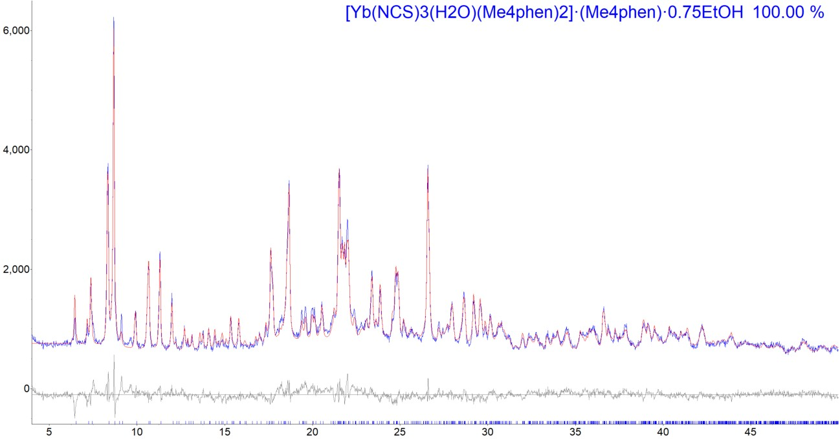

Рис. S3. Результаты полнопрофильного уточнения по Ритвельду для соединения III.

Результаты полнопрофильного уточнения по Ритвельду для соединения III (Yb).

File 1 : G:\Andr\Paper\SP_Ln_NCS_Me4phen\Powder\Yb_NCS_Me4phen_2018_11_08
.raw_1
Range Number : 1

R-Values

Rexp : 3.22 Rwp : 6.35 Rp : 4.95 GOF : 1.97
Rexp`: 5.05 Rwp`: 9.98 Rp` : 8.48 DW : 0.64

Quantitative Analysis - Rietveld
Phase 1 : "[Yb(NCS)3(H2O)(Me4phen)2]·(Me4phen)·0.75EtOH " 100.000 %

Background
One on X 5200(1500)
Chebychev polynomial, | Coefficient | 0 | 310(100)
 |  | 1 | 330(120)
 |  | 2 | -264(64)
 |  | 3 | 127(36)
 |  | 4 | -28(20)
 |  | 5 | 11(11)
 |  | 6 | -27.7(58)
 |  | 7 | 61.5(36)

Instrument
Primary radius (mm) 280
Secondary radius (mm) 280
Linear PSD 2Th angular range (°) 2.94
FDS angle (°) 0.3
Beam spill, sample length (mm) 8
Intensity corrected

Corrections
Specimen displacement 0.1920(20)
LP Factor 0

Miscellaneous
Start X 4
Finish X 50

Structure 1
Phase name
[Yb(NCS)3(H2O)(Me4phen)2]·(Me4phen)·0.75EtOH
R-Bragg 3.269
Spacegroup P2(1)/n
Scale 0.00001334(35)
Cell Mass 4435.244
Cell Volume (Å^3) 5082.58(65)
Wt% - Rietveld 100.000
Crystallite Size
Cry size Lorentzian (nm) 118.3(20)
Crystal Linear Absorption Coeff. | (1/cm) | 49.4191(63)
Crystal Density (g/cm^3) |  | 1.44905(19)
Preferred Orientation Spherical Harmonics
Order 4 y00 1
y20 -0.123(33) y22m -0.564(52) y22p 0.044(13) y40 -0.068(26) y42m -0.078(23) y42p -0.0424(80) y44m -0.059(14) y44p -0.299(29)
Lattice parameters
a | (Å) |  | 13.0087(10)
b | (Å) |  | 16.4611(13)
c | (Å) |  | 24.1151(15)
beta |  | (°) 100.1846(47

)

Site Np x y z Atom Occ Beq
Yb1 | 4 | 0.42544 | 0.60144 | 0.17754 | Yb | 1 | 3
S1 | 4 | 0.79487 | 0.60956 | 0.29545 | S | 0.35 | 4
S1B | 4 | 0.78080 | 0.66090 | 0.30970 | S | 0.65 | 4
S2 | 4 | 0.56118 | 0.84461 | 0.07617 | S | 1 | 4
S3 | 4 | 0.06348 | 0.64310 | 0.07384 | S | 1 | 4
O1 | 4 | 0.40290 | 0.69394 | 0.25104 | O | 1 | 4
H1 | 4 | 0.46090 | 0.70270 | 0.27620 | H | 1 | 6
H2 | 4 | 0.36670 | 0.67220 | 0.27780 | H | 1 | 6
N1 | 4 | 0.59880 | 0.63660 | 0.23205 | N | 1 | 4
N2 | 4 | 0.48140 | 0.71340 | 0.12800 | N | 1 | 4
N3 | 4 | 0.26820 | 0.65090 | 0.13014 | N | 1 | 4
N4 | 4 | 0.30760 | 0.53300 | 0.23461 | N | 1 | 4
N5 | 4 | 0.50160 | 0.47540 | 0.23460 | N | 1 | 4
N6 | 4 | 0.54520 | 0.53740 | 0.11727 | N | 1 | 4
N7 | 4 | 0.34860 | 0.48490 | 0.11649 | N | 1 | 4
N8 | 4 | 0.47650 | 0.59500 | 0.36609 | N | 1 | 4
N9 | 4 | 0.29240 | 0.67360 | 0.34170 | N | 1 | 4
C1 | 4 | 0.68100 | 0.62900 | 0.25910 | C | 0.35 | 4
C1B | 4 | 0.67600 | 0.63900 | 0.26400 | C | 0.65 | 6
C2 | 4 | 0.51380 | 0.76830 | 0.10630 | C | 1 | 4
C3 | 4 | 0.18220 | 0.64980 | 0.10551 | C | 1 | 4

H17C | 4 | 0.01190 | 0.42650 | 0.30010 | H | 1 | 6
C18 | 4 | 0.61710 | 0.25710 | 0.32560 | C | 1 | 4
H18A | 4 | 0.56980 | 0.24100 | 0.35130 | H | 1 | 6
H18B | 4 | 0.68680 | 0.26750 | 0.34760 | H | 1 | 6
H18C | 4 | 0.62110 | 0.21340 | 0.29830 | H | 1 | 6
C19 | 4 | 0.75310 | 0.36050 | 0.26810 | C | 1 | 4
H19A | 4 | 0.78290 | 0.39920 | 0.24430 | H | 1 | 6
H19B | 4 | 0.75870 | 0.30530 | 0.25350 | H | 1 | 6
H19C | 4 | 0.79140 | 0.36370 | 0.30720 | H | 1 | 6
C20 | 4 | 0.64330 | 0.56150 | 0.11827 | C | 1 | 4
H20A | 4 | 0.66680 | 0.60760 | 0.14080 | H | 1 | 6
C21 | 4 | 0.71430 | 0.52450 | 0.08905 | C | 1 | 4
C22 | 4 | 0.68070 | 0.45940 | 0.05435 | C | 1 | 4
C23 | 4 | 0.57710 | 0.43170 | 0.05178 | C | 1 | 4
C24 | 4 | 0.53300 | 0.36610 | 0.01694 | C | 1 | 4
H24A | 4 | 0.57520 | 0.33860 | -0.00560 | H | 1 | 6
C25 | 4 | 0.43460 | 0.34150 | 0.01474 | C | 1 | 4
H25A | 4 | 0.40880 | 0.29810 | -0.00990 | H | 1 | 6
C26 | 4 | 0.36690 | 0.37840 | 0.04832 | C | 1 | 4
C27 | 4 | 0.26360 | 0.35260 | 0.04847 | C | 1 | 4
C28 | 4 | 0.20450 | 0.39410 | 0.08190 | C | 1 | 4
C29 | 4 | 0.25160 | 0.45970 | 0.11410 | C | 1 | 4
H29A | 4 | 0.20990 | 0.48860 | 0.13620 | H | 1 | 6
C30 | 4 | 0.40680 | 0.44450 | 0.08319 | C | 1 | 4
C31 | 4 | 0.51280 | 0.47190 | 0.08418 | C | 1 | 4
C32 | 4 | 0.82400 | 0.55680 | 0.09630 | C | 1 | 4
H32A | 4 | 0.83000 | 0.60560 | 0.12020 | H | 1 | 6
H32B | 4 | 0.84060 | 0.57050 | 0.05910 | H | 1 | 6
H32C | 4 | 0.87290 | 0.51540 | 0.11450 | H | 1 | 6
C33 | 4 | 0.75480 | 0.41800 | 0.02160 | C | 1 | 4
H33A | 4 | 0.71500 | 0.38440 | -0.00840 | H | 1 | 6
H33B | 4 | 0.80330 | 0.38370 | 0.04740 | H | 1 | 6
H33C | 4 | 0.79420 | 0.45910 | 0.00460 | H | 1 | 6
C34 | 4 | 0.21850 | 0.28030 | 0.01430 | C | 1 | 4
H34A | 4 | 0.24390 | 0.27930 | -0.02190 | H | 1 | 6
H34B | 4 | 0.14210 | 0.28400 | 0.00700 | H | 1 | 6
H34C | 4 | 0.24010 | 0.23030 | 0.03540 | H | 1 | 6
C35 | 4 | 0.09420 | 0.37350 | 0.08620 | C | 1 | 4
H35A | 4 | 0.06870 | 0.41170 | 0.11200 | H | 1 | 6
H35B | 4 | 0.09140 | 0.31810 | 0.10090 | H | 1 | 6
H35C | 4 | 0.05030 | 0.37710 | 0.04850 | H | 1 | 6

H49C | 4 | 0.48690 | 0.32540 | 0.44070 | H | 1 | 6
C50 | 4 | 0.02260 | 0.59950 | 0.41310 | C | 1 | 4
H50A | 4 | 0.04290 | 0.59150 | 0.45410 | H | 1 | 6
H50B | 4 | -0.00480 | 0.54840 | 0.39530 | H | 1 | 6
H50C | 4 | -0.03130 | 0.64160 | 0.40570 | H | 1 | 6
C51 | 4 | 0.02090 | 0.75180 | 0.34490 | C | 1 | 4
H51A | 4 | -0.00390 | 0.76390 | 0.38030 | H | 1 | 6
H51B | 4 | -0.03460 | 0.72450 | 0.31850 | H | 1 | 6
H51C | 4 | 0.03970 | 0.80260 | 0.32780 | H | 1 | 6
O2 | 4 | 0.54040 | 0.75280 | 0.34060 | O | 0.75 | 4
H3 | 4 | 0.52580 | 0.70330 | 0.35940 | H | 0.75 | 6
C52 | 4 | 0.64000 | 0.77130 | 0.36300 | C | 0.75 | 4
H52A | 4 | 0.64650 | 0.83120 | 0.36550 | H | 0.75 | 6
H52B | 4 | 0.68540 | 0.75230 | 0.33650 | H | 0.75 | 6
C53 | 4 | 0.68590 | 0.73150 | 0.42840 | C | 0.75 | 4
H53A | 4 | 0.76240 | 0.73350 | 0.43580 | H | 0.75 | 6
H53B | 4 | 0.66290 | 0.67490 | 0.42980 | H | 0.75 | 6
H53C | 4 | 0.65890 | 0.76320 | 0.45730 | H | 0.75 | 6

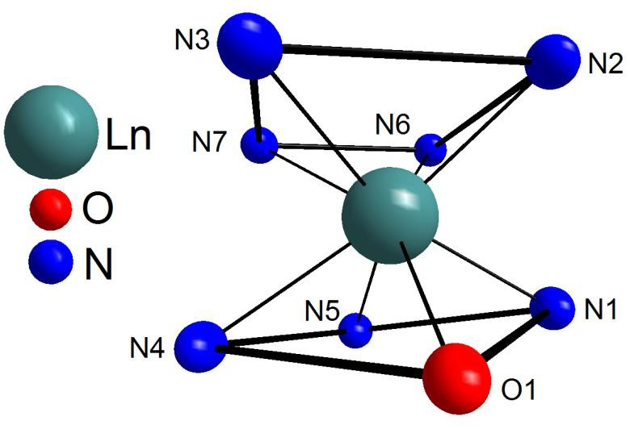Рис. S4. Координационное окружение иона Ln3+ в комплексах I–III.

χ', см3/моль
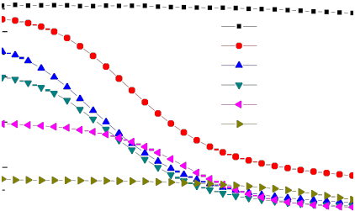6

5

4

3

2

1

0

T=2 K

H=0 Э H=500 Э H=1000 Э H=1500 Э H=2500 Э H=5000 Э

1.4

1.2

1.0

0.8

0.6

0.4

0.2

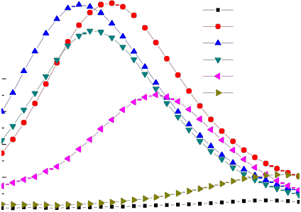0.0
χ'', см3/моль

T=2 K
H=0 Э H=500 Э H=1000 Э H=1500 Э H=2500 Э H=5000 Э

10 100 1000 10000
ν, Гц
10 100 1000 10000
ν, Гц

Рис. S5. Частотные зависимости действительной χ'(слева) и мнимой χ'' (справа) компонент динамической магнитной восприимчивости образца комплекса I при различных значениях напряженности внешнего магнитного поля, T = 2 K.

χ', см3/моль
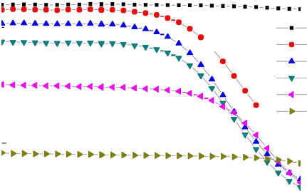3

T=2 K
H=0 Э

1.0
χ'', см3/моль

T=2 K
H=0 Э

H=500 Э
2 H=1000 Э
H=1500 Э
0.8 H=500 Э
H=1000 Э

H=2500 Э
H=5000 Э

1
0.6

0.4
H=1500 Э
H=2500 Э
H=5000 Э

0.2

0
10 100 1000 10000
ν, Гц
0.0
10 100 1000 10000
ν, Гц

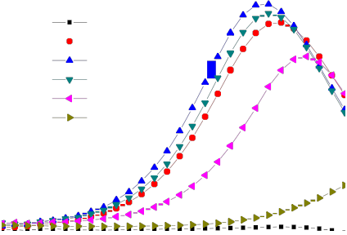Рис. S6. Частотные зависимости действительной χ'(слева) и мнимой χ'' (справа) компонент динамической магнитной восприимчивости образца комплекса II при различных
значениях напряженности внешнего магнитного поля, T = 2 K.

χ', см3/моль
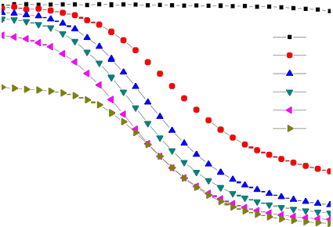0.6

0.4

0.2

T=2 K

H=0 Э H=500 Э H=1000 Э H=1500 Э H=2500 Э H=5000 Э
χ'', см3/моль
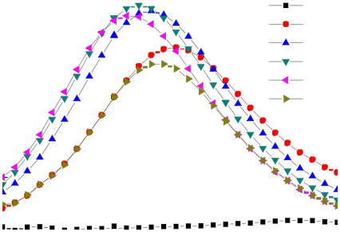0.20

0.16

0.12

0.08

0.04

T=2 K H=0 Э H=500 Э H=1000 Э H=1500 Э H=2500 Э H=5000 Э

0.0
10
0.00

Рис. S7. Частотные зависимости действительной χ'(слева) и мнимой χ'' (справа) компонент динамической магнитной восприимчивости образца комплекса III при различных значениях напряженности внешнего магнитного поля, T = 2 K.
100 | 1000 | 10000 | 10 | 100 | 1000 | 10000
 |  | ν, Гц |  |  |  | ν, Гц

