SUPPORTING INFORMATION

CONFORMATION BEHAVIOR OF THE N1-(DIPHENYLPHOSPHORYL)ACETYL-N4-PHENYL-THIOSEMICARBASIDE IN VARIOUS CRYSTAL ENVIRONMENT

A. I. Samigullina^{1,2}, I. A. Krutov³, E. L. Gavrilova³, A. T. Gubaidullin¹
¹Arbuzov Institute of Organic and Physical Chemistry, Kazan Scientific Center, Russian Academy of Sciences, 8 Arbuzov Street, Kazan 420088, Russian Federation
²A.N. Nesmeyanov Institute of Organoelement Compounds of Russian Academy of Sciences, 28 Vavilov Street, Moscow 119991, Russian Federation
³Kazan National Research Technological University, 68 Karl Marx Street, Kazan 420015, Russian Federation
*E-mail: a_samigullina@iopc.ru

Table of content
1. View of independent molecules of compounds 1–3. Non-hydrogen atoms  are represented by thermal vibration ellipsoids (p = 30%), hydrogen atoms are spheres of arbitrary radius. DMSO molecules for compound 2 and 3 are omitted for clarity | S1
2. The results of search of structural analogs of compound 1–3 from the CCDC | S3
3. The results of DFT optimization for independent molecules of compounds 2 and 3 | S5
4. The analysis of Hirshfeld surfaces for compound 1–3 | S7
5. Supramolecular structure in the crystal 3 | S9

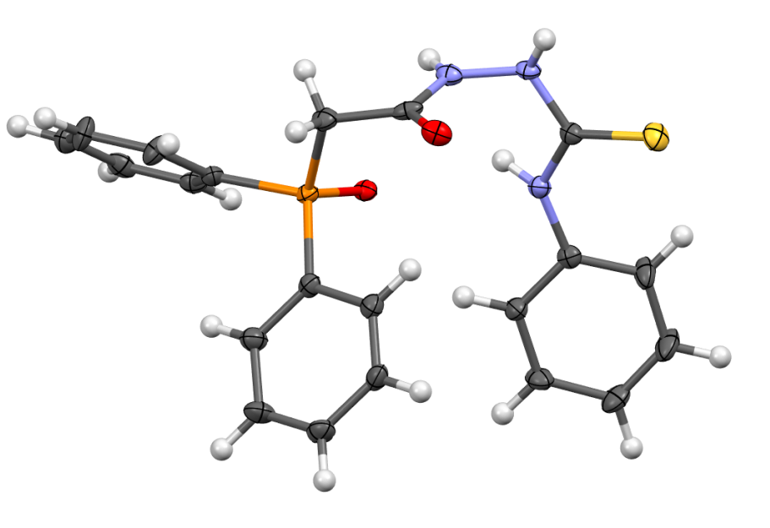
Figure S1. Molecule of compound 1.

(a) (b)
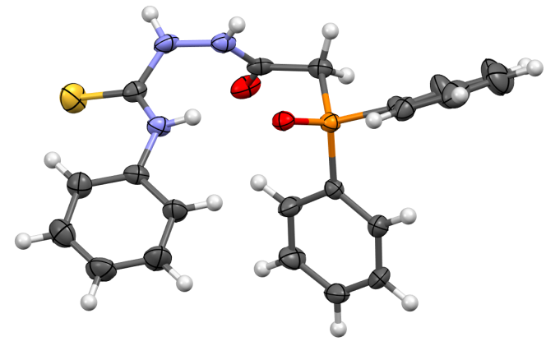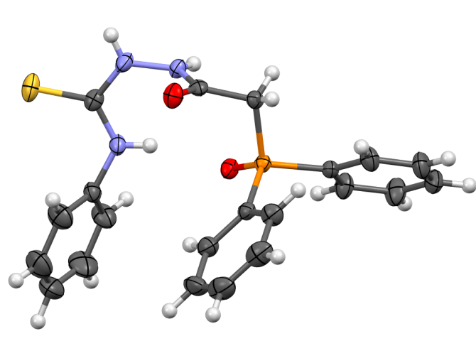
Figure S2. Molecules (a) A and (b) B of compound 2.

(a) (b)
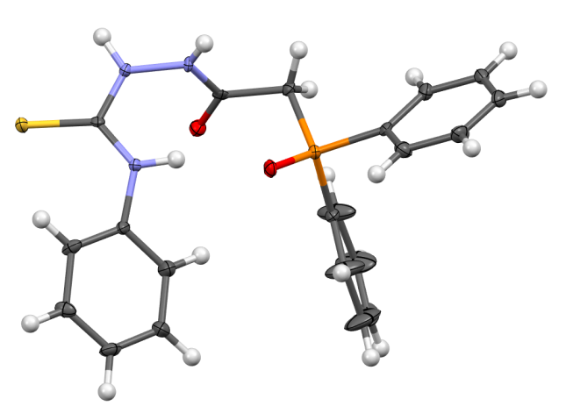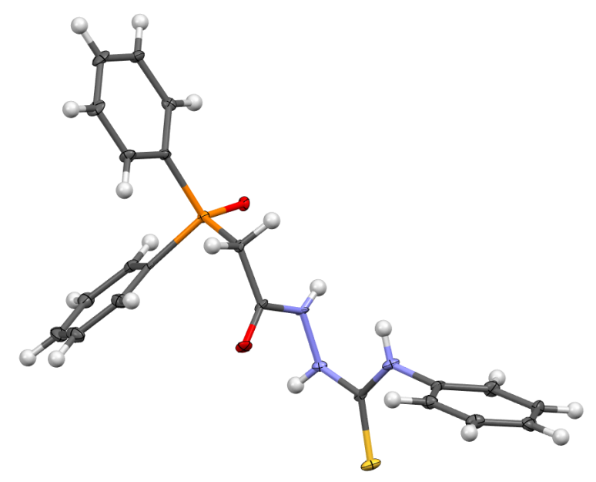

Figure S3. Molecules (a) A and (b) B of compound 3.

Scheme S1. Molecular fragments used for the search for thiosemicarbazide derivatives similar in structure to compounds 1–3. Variable interatomic bonds are showed with dashed lines.

Table S1. Compounds from CSD with a thiosemicarbazide fragment according to scheme S1
 | Code | Solvate | d(H…O), Å | Acceptor | ∠(X–O…H), deg | ∠(N–H…O), deg
1 | REWVIP | DMSO | 2.19 | –P=O | 123.11 | 165.39
2 | CEFWOC | CH₃CN | 2.086 | –C=O | 137.874 | 155.362
 | CEFWOC |  | 2.093 | –C=O | 140.89 | 160.491
 | CEFWOC |  | 2.107 | –C=O | 143.398 | 159.662
 | CEFWOC |  | 2.109 | –C=O | 140.452 | 157.73
 | CEFWOC |  | 2.142 | –C=O | 139.718 | 159.042
 | CEFWOC |  | 2.159 | –C=O | 142.653 | 153.255
3 | CICZEW | H₂O | 2.328 | –C=O | 121.674 | 164.718
4 | CUNJOM | DMF | 2.139 | –C=O | 151.914 | 158.764
 |  |  | 2.177 | –C=O | 149.205 | 148.169
5 | CUNJUS | CH₃OH | 2.272 | –C=O | 127.376 | 163.476
6 | CUNJUS01 | CH₃OH | 2.277 | –C=O | 127.538 | 163.095
7 | CUNKAZ | DMF | 2.223 | –C=O | 133.728 | 151.343
8 | DAHZIW | – | 6.502 | –OCH₃ | 21.323 | 126.318
9 | GAXKEY | – | 2.377 | –SO₂ | 135.541 | 174.429
 |  | – | 4.223 | –SO₂ | 52.458 | 149.974
10 | GAXKIC | – | 2.267 | –SO₂ | 133.239 | 168.593
 |  | – | 4.094 | –SO₂ | 52.134 | 154.641
11 | GEDFUT | DMSO | 2.157 | –C=O | 115.418 | 156.414
 |  | DMSO | 2.1 | –C=O | 115.897 | 158.034
12 | GEDGAA | DMSO | 2.048 | –C=O | 113.808 | 155.609
 |  |  | 2.244 | –C=O | 123.821 | 161.856
 | GEDGAA |  | 2.233 | –C=O | 123.137 | 160.542
 |  |  | 2.131 | –C=O | 117.656 | 156.787
13 | GURHOR | – | 9.277 | –OCH₃ | 34.923 | 94.89
14 | IXONIU | – | 2.276 | –C=O | 126.286 | 159.298
15 | KAYTOU | C₂H₅OH | 2.317 | –OH | 134.438 | 147.628
16 | KEQTOS | CH₃CN | 2.113 | –C=O | 141.353 | 157.521
17 | KIKSON | – | 6.943 | –OCH₃ | 65.718 | 51.92
18 | MATBOB | DMF | 2.229 | –C=O | 136.486 | 158.701
19 | MATBOB02 | DMF | 2.229 | –C=O | 136.083 | 159.013
20 | MATJOJ | DMF | 2.214 | –C=O | 136.964 | 159.899
21 | MATJOJ02 | DMF | 2.217 | –C=O | 136.19 | 160.342
22 | NOBJOG | – | 2.352 | –SO₂ | 144.232 | 152.928
 |  | – | 4.436 | –SO₂ | 46.968 | 131.705
23 | NUCXIU | – | 6.386 | –C=O | 76.528 | 129.428
24 | OREWAL | – | 2.315 | –C=O | 125.05 | 162.041
25 | OREWAL02 | – | 2.321 | –C=O | 124.376 | 162.599
26 | POBWUB | H₂O | 6.423 | –OH | 63.568 | 122.855
27 | QAPPAB | DMF | 2.146 | –C=O | 137.506 | 156.471
28 | QAPPAB02 | DMF | 2.148 | –C=O | 136.818 | 157.597
28 | RIGCIU | – | 5.518 | –OCH₃ | 66.188 | 176.574
 |  | – | 7.51 | –OCH₃ | 15.606 | 137.493
30 | SOLMUC | H₂O | 6.288 | –COOCH₃ | 60.136 | 106.987
31 | UYACUU | – | 2.286 | –C=O | 126.198 | 157.932
32 | ZINDOR | – | 2.403 | –C=O | 117.277 | 152.928

Compound CEFWOC contains six independent molecules in the unit cell. Molecules in CUNJOM, GEDFUT, and GEDGAA contain two thiosemicarbazide fragments per independent molecule. As we can see from Table S1, for seven compounds (highlighted in bold), large O…H distances and interaction angles less than 90° can be noted. This indicates the absence of intramolecular interaction of the type under consideration. In this case, this is due to the fact that the atoms of the main skeleton of the molecule are part of cyclic fragments, which blocks the possibility of free rotation and arrangement of atoms in space.

RESULTS OF DFT OPTIMIZATION

Gas-phase optimization of independent molecules was performed for compound 2 and 3 by the B3LYP method with the 6-31G(d,p) basic set using Gaussian09. The geometry of molecules in crystals was used as a starting model.
(a) (b)

Figure S4. (a) Molecule A of compound 2 in the crystal and (b) the optimized one. Total DFT Energy = –1866.590050. Zero-corrected energy = –1866.213251.

(a) (b)

Figure S5. (a) Molecule B of compound 2 in the crystal and (b) the optimized one. Total DFT Energy = –1866.590050. Zero-corrected energy = –1866.213251.

(a) (b)

Figure S6. (a) Molecule A of compound 3 in the crystal and (b) the optimized one. Total DFT Energy = –1866.590050. Zero-corrected energy = –1866.213250.

(a) (b)

Figure S7. (a) Molecule B of compound 3 in the crystal and (b) the optimized one. Total DFT Energy = –1866.587085. Zero-corrected energy = –1866.210962.

ANALYSIS OF HIRSHFELD'S SURFACES FOR COMPOUND 1–3
Colors on the Hirshfeld surfaces corresponding to intermolecular contacts or their absence are defined by the d_{norm} value, and also range from red ($d_{norm}<0$), when the distance between the contacting pair of atoms is less than the sum of their van der Waals radii, through white ($d_{norm}=0$) to blue ($d_{norm}>0$).
In compound 1, the N²–H²…O¹³ interaction is the main crystal-forming one and is characterized by bigger larger concentric red zone corresponding to a shorter Н…О distance, while N¹–H¹⋅⋅⋅O¹¹ can be considered as a forced contact (Fig. S8a). In crystal 2, both interactions (N^{1А}–H^{1А}⋅⋅⋅O^{11А} and N^{2А}–H^{2А}⋅⋅⋅O^{13А}) are equal in the area of red concentric zones. This can explain the increasing in the unit cell parameter of compound 2, which corresponds to the axis along which the supramolecular structure is oriented.
(a) (b)
Figure S8. Hirshfeld surfaces for (a) molecules of compound 1 and (b) molecule A of compound 2. The color scale corresponding to the $d_{norm}$ value is taken from blue (1.5246) to red (–0.0500). Intermolecular interactions are shown with dashed lines.
Figure S9. Hirshfeld surfaces for B molecules of compound 2. The color scale corresponding to the $d_{norm}$value is taken from blue (1.5246) to red (–0.0500). Intermolecular interactions are shown with dashed lines.

(a) (b)
Figure S10. Hirshfeld surfaces for (a) A and (b) B molecules of compound 3 with molecules participating in directed intermolecular interactions. The color scale corresponding to the $d_{norm}$value is taken from blue (1.2868) to red (–0.0500). Intermolecular interactions are shown with dashed dotted lines.

SUPRAMOLECULAR STRUCTURE IN THE CRYSTAL 3
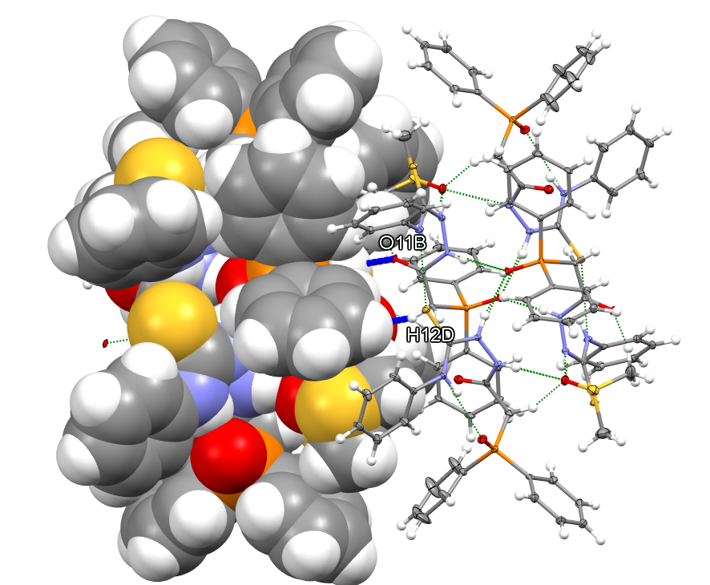
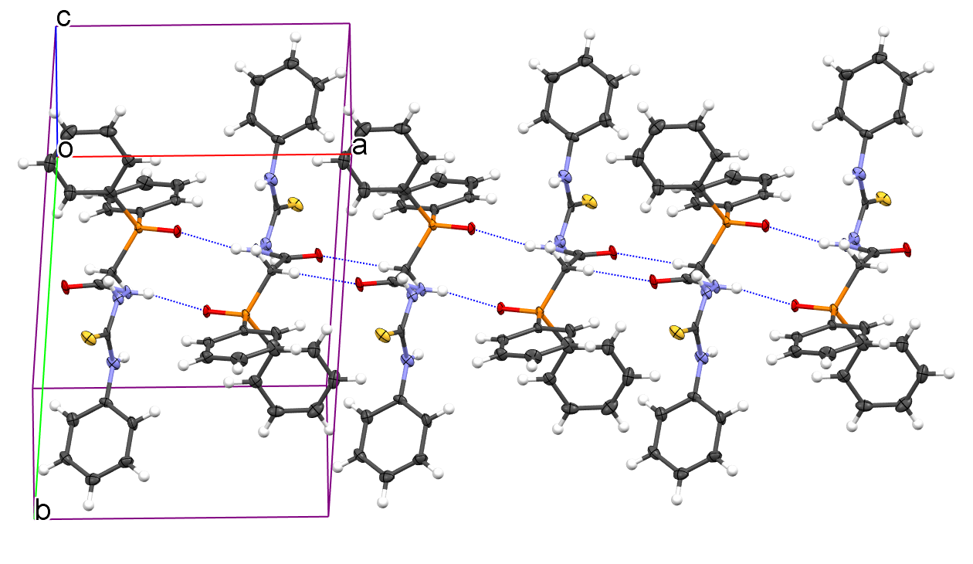
Figure S11. (a) Realization of paired centrosymmetric С^{12B}–H^{12D}⋅⋅⋅O^{11В} interaction between two associates of compound 3 highlighted in blue; (b) one-dimensional motif along the a axis, formed by the participation of B molecules due to interactions of the N–H…O and C–H…O types.

