Supplementary materials for the article
“Factors affecting labeling of NIH 3T3 cells by magnetic nanoparticles”
(Kandarakov et al.)

Fig. S1. Scheme of synthesis and surface modification of MNPs.

Fig. S2. Attenuated total reflection (ATR) spectra of MNPs-1 – MNPs-5 (on the selected sections of spectra curves of MNPs-1 and MNPs-2 baselines were drawn relative to which integrated intensities of analytical bands of O–H and Fe–O vibrations were measured).

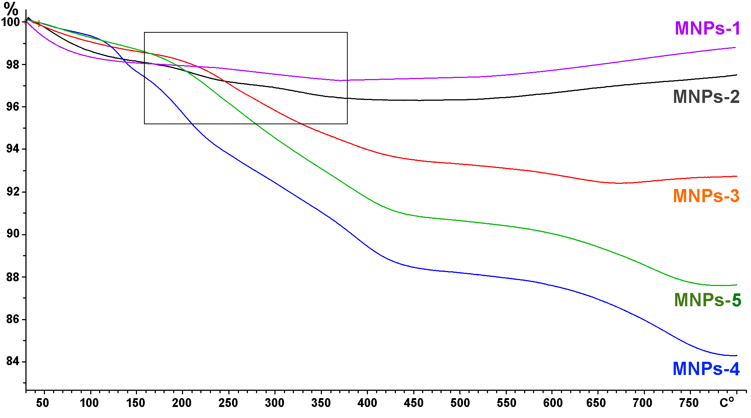

Fig. S3. Thermogravimetric analysis (TGA) data of MNPs-1 – MNPs-5 samples (the selected sections of MNPs-1 and MNPs-2 curves in the temperature range 160-380 °С correspond to weight loss of samples related to the removal of OH groups).

