Figure S1: Mass spectroscopy data for chemically synthesized PrP peptides
Sample ID: 23-61
Sequence: Biotin-KKRPKPGGWNTGGSRYPGQGSPGGNRYPPQGGGGWGQPH
Expected MS: 4242.68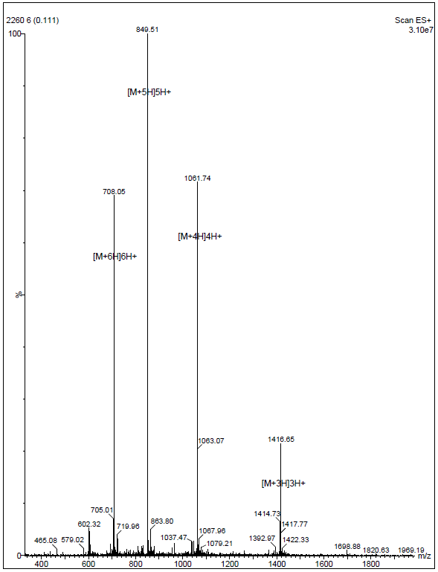

Sample ID: 57-91
Sequence: Biotin-WGQPHGGGWGQPHGGGWGQPHGGGWGQPHGGGWGQ
Expected MS: 3722.96

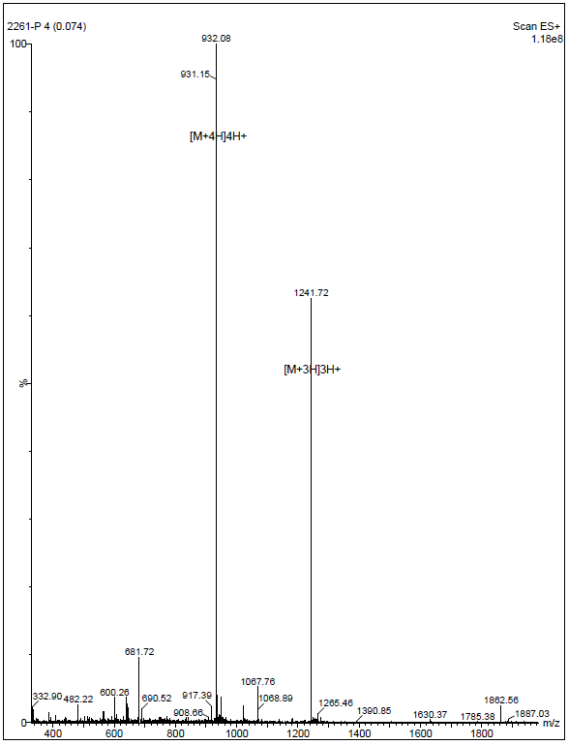

Sample ID: 89-120
Sequence: Biotin-WGQGGGTHSQWNKPSKPKTNMKHMAGAAAAGA
Expected MS: 3489.98

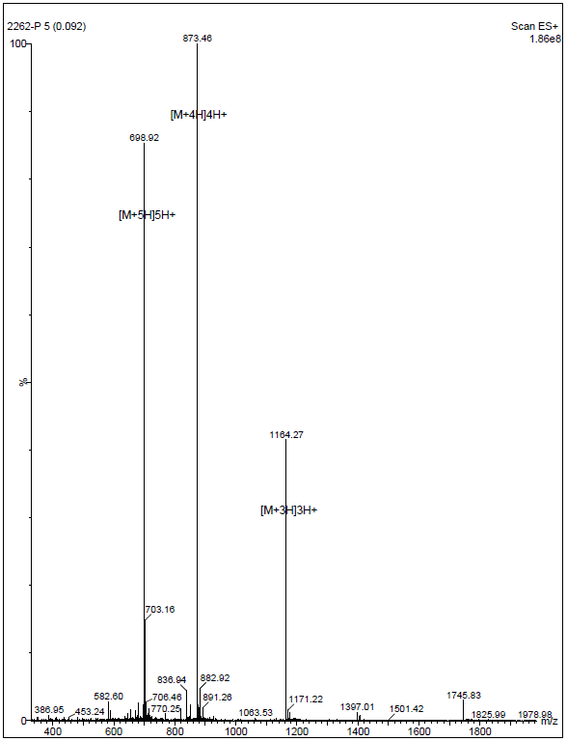

Sample ID: 112-146
Sequence: Biotin-MAGAAAAGAVVGGLGGYMLGSAMSRPIIHFGSDYE
Expected MS: 3612.21

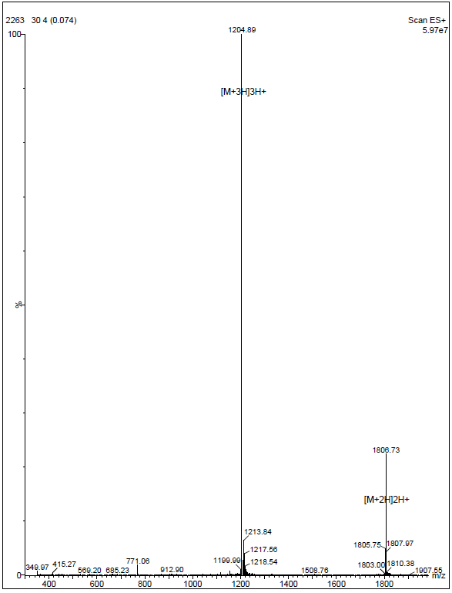

Sample ID: 128-159
Sequence: Biotin-YMLGSAMSRPIIHFGSDYEDRYYRENMHRYPN
Expected MS: 4196.74

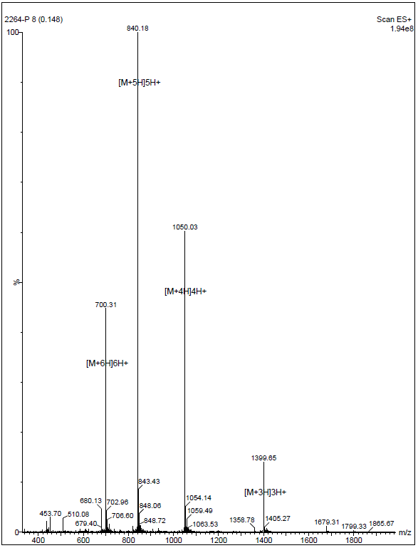

Sample ID: 138-172
Sequence: Biotin-IIHFGSDYEDRYYRENMHRYPNQVYYRPMDEYSNQ
Expected MS: 4777.23

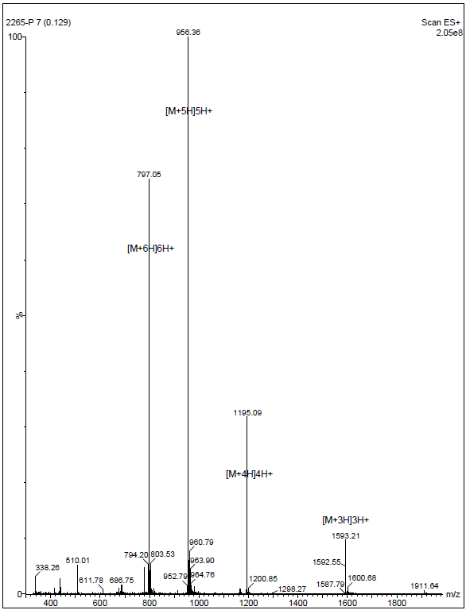

Sample ID: 157-193
Sequence: Biotin-YPNQVYYRPMDEYSNQNNFVHDCVNITIKQHTVTTTT
Expected MS: 4662.18

Sample ID: 169-203
Sequence: Biotin-YSNQNNFVHDCVNITIKQHTVTTTTKGENFTETDV
Expected MS: 4226.63

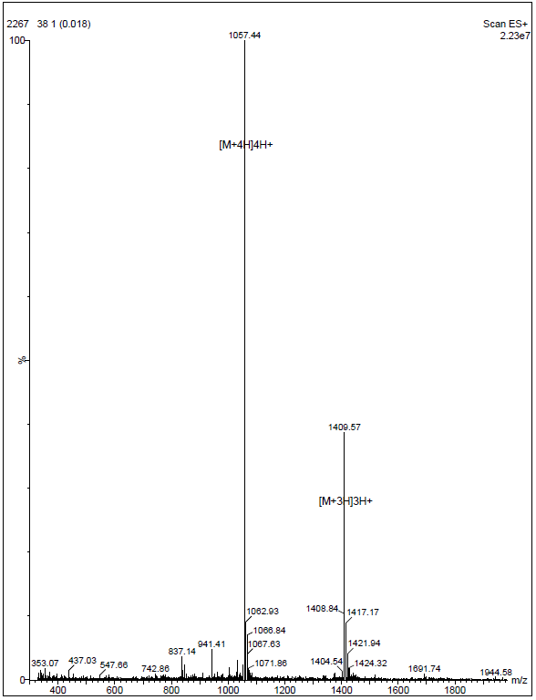
Sample ID: 193-231
Sequence: Biotin-TKGENFTETDVKMMERVVEQMCITQYERESQAYYQRGSS
Expected MS: 4880.47

