**Additional file**

**COMPLEXITY OF DETECTING CRISPR/Cas9-MEDIATED HOMOLOGOUS RECOMBINATION IN ZEBRAFISH**

**Y. Pi1, 2, †, K. Z. He1, †, W. Q. Zhang1, Z. Q. Dong2, 5, F. G. Jiang3,**

**K. J. Jiang4,*, S. Guo1, 2, \*\***

*1State Key Laboratory of Genetic Engineering, School of Life Sciences, Fudan University, Shanghai, 200433China*

*2Department of Bioengineering and Therapeutic Sciences, Programs in Human Genetics and*

*Biological Sciences, University of California, San Francisco, CA 94143-2811 USA*

*3Department of Molecular and Cell Biology, University of California, Berkeley, CA 94720 USA*

*4East China Sea Fisheries Research Institute, Chinese Academy of Fishery Sciences, Shanghai,*

*200090 China*

*5Huazhong Agricultural University, Wuhan, 430070 China*

*\* e-*[*mail: jiangkj@ecsf.ac.cn*](mailto:jiangkj@ecsf.ac.cn)

*\*\*e-*[*mail: suguo@fudan.edu.cn*](mailto:suguo@fudan.edu.cn)[*, su.guo@ucsf.edu*](mailto:su.guo@ucsf.edu)

**Supplementary Table 1.** The knock-in efficiency test of cas9 protein: gradient injection concentration of *gad* targeting vectors (*gad*-PAM-mutation plasmids).

|  |  |  |  |  |  |
| --- | --- | --- | --- | --- | --- |
|  | **total** | **death** | **deformed** | **normal** | **signal** |
| ***gad* plasmid**  **(50 ng/μl)** | 75 | 13 | 4 | 58 | 0 |
| **Ctl** | 50 | 8 | 0 | 42 | 0 |
| ***gad* plasmid (200 ng/μl) Ctl** | 74  23 | 33  2 | 4  0 | 27  21 | 0  0 |
| ***gad* plasmid (600 ng/μl) Ctl** | 75  50 | 29  13 | 28  6 | 28  31 | 0  0 |

**Supplementary Table 2. The knock-in efficiency test: gradient injection concentration of *gad* targeting vectors (*gad*-PAM-mutation plasmid).**

**Cas9 protein/mRNA *gad* sgRNA *gad-*PAM-mutation plasmid**

50 ng/μl

**Cas9 protein (1100 ng/μl)** *gad* sgRNA-2 (30 ng/μl)

**Cas9 mRNA (600 ng/μl)** *gad* sgRNA-2 (30 ng/μl)

200 ng/μl

600 ng/μl

50 ng/μl

200 ng/μl

600 ng/μl

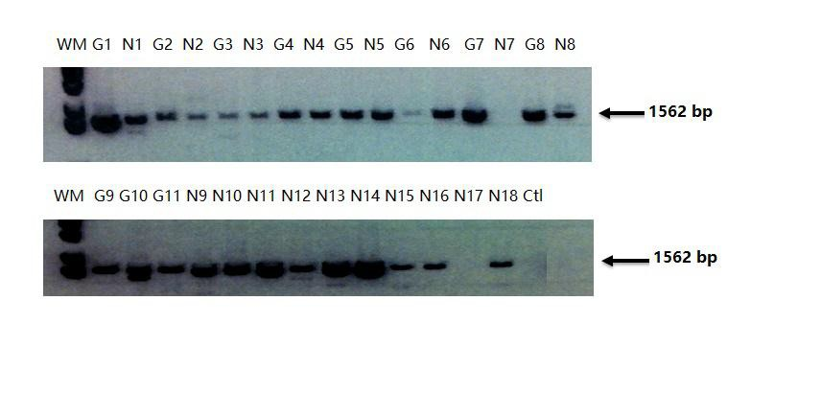

**Supplementary Fig. 1** PCR-inducing artifacts from zebrafish embryos injected with the targeting construct together with the Cas9/sgRNA at 24 hpf. G1~11: the embryos with GFP+ ; N1~18: the embryos with GFP- ; Ctl: control (wild type).

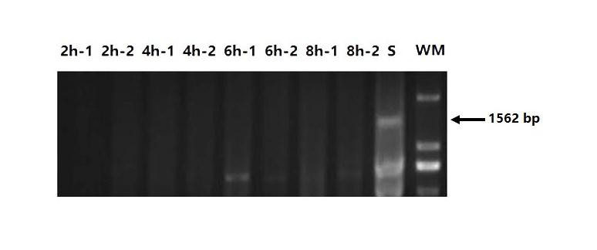

**Supplementary Fig. 2** PCR results from the embryos injected with only the targeting plasmids (50 ng/μl), for which two pools were employed in testing at each time point (2 hpf, 4 hpf, 6 hpf and 8 hpf). S: the embryos with GFP+.

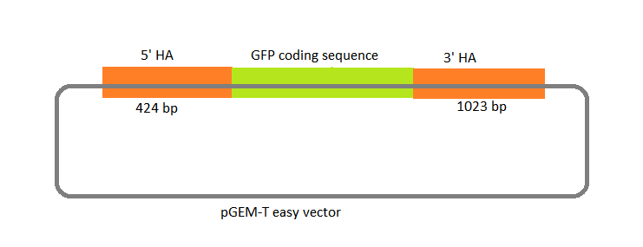

**Supplementary Fig. 3** Construct of *gad* targeting plasmid.