Supporting Material

In vitro and in silico determination of the interaction of artemisinin with human serum albumin.

S. Ginosyan, H. Grabski, S. Tiratsuyan

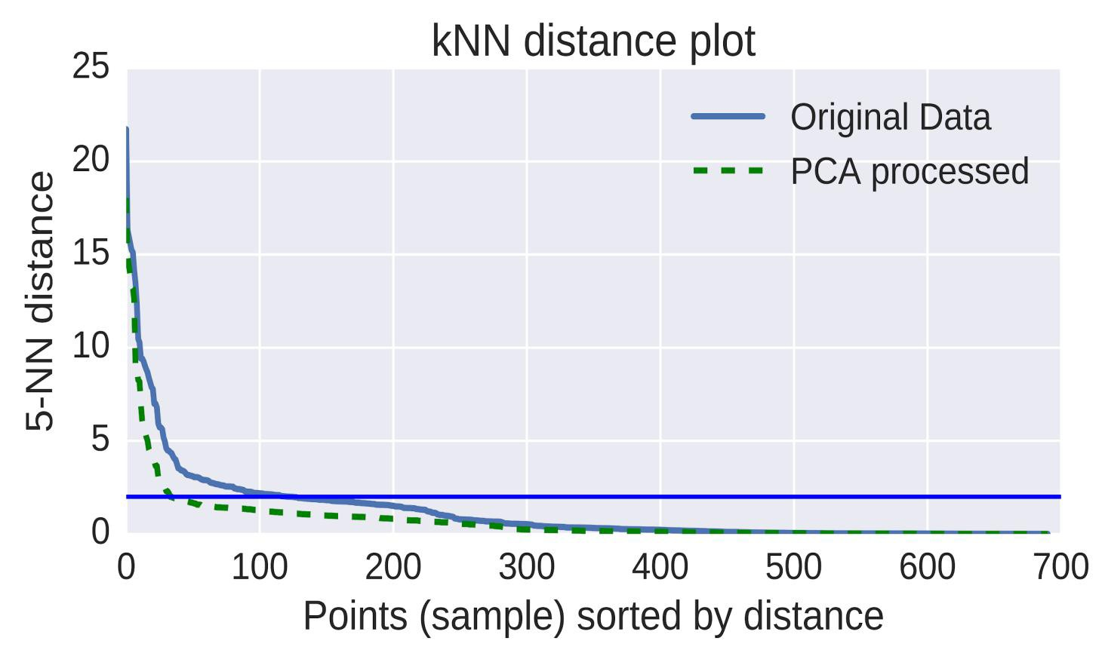
Figure S1. k-Nearest Neighbor distance plot of the center of mass coordinates from the results of multiple docking runs of ART.

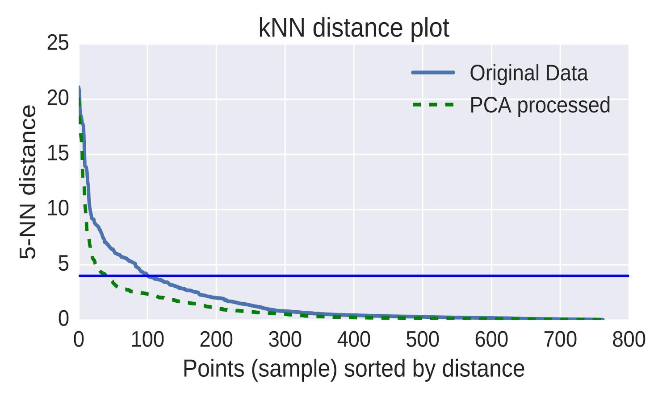
Figure S2. k-Nearest Neighbor distance plot of the center of mass coordinates from the results of multiple docking runs of DEXA.

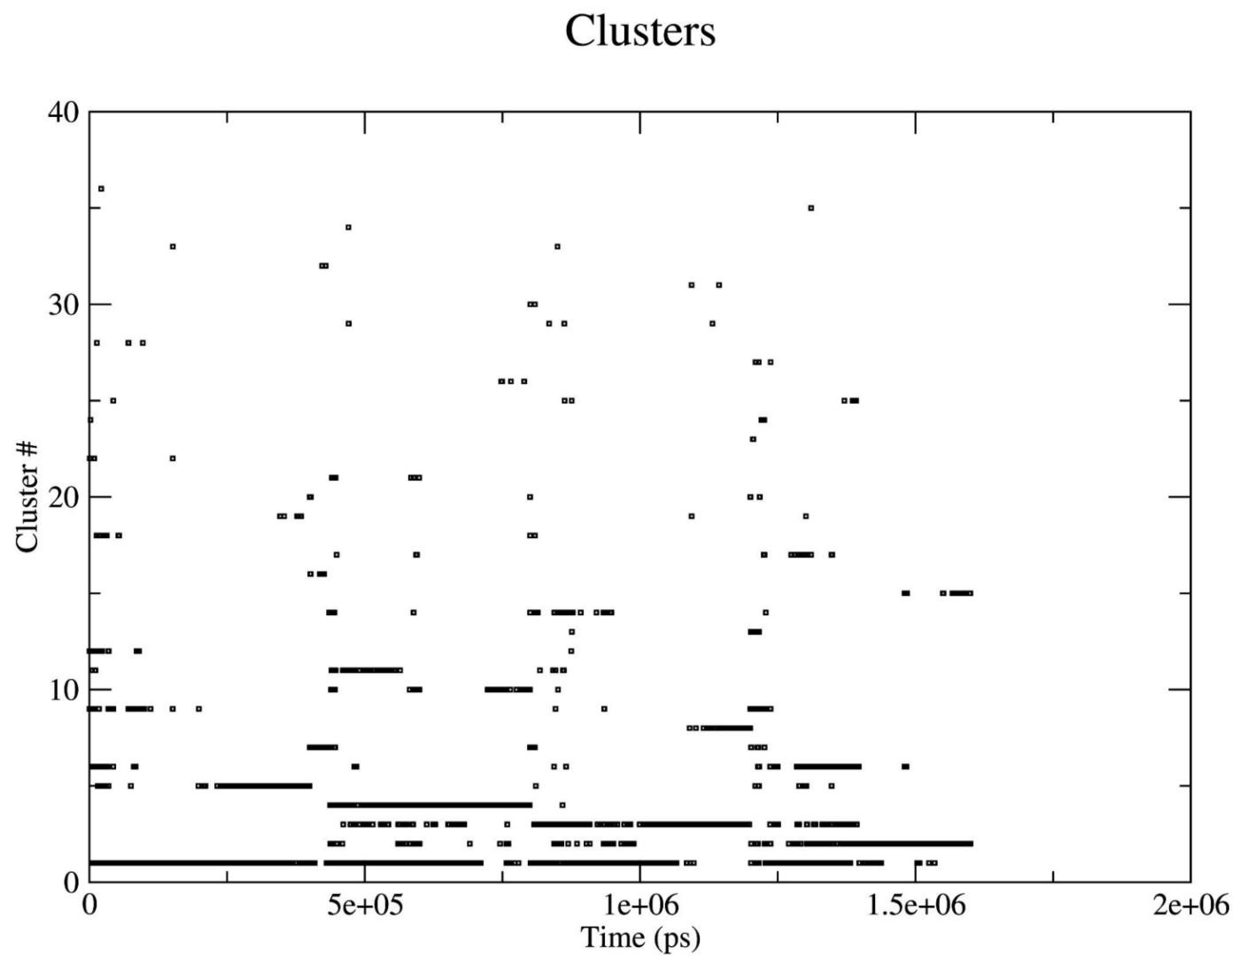

Figure S3. Distribution of HSA conformations over time.

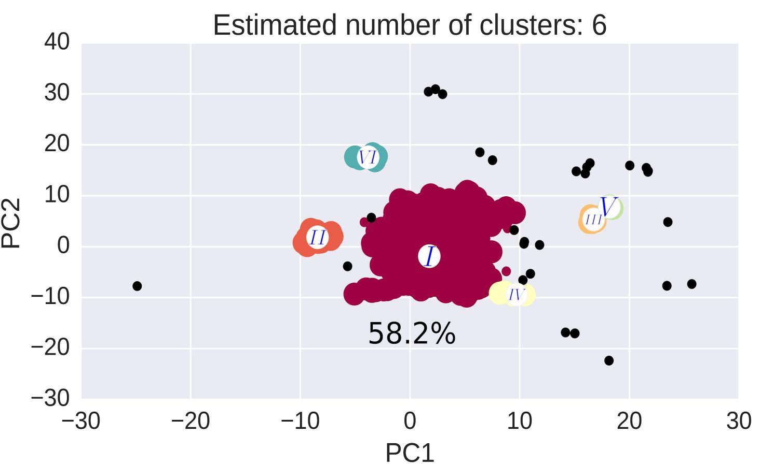
Figure S4. Cluster analysis of the COM data from the docking results of ART with HSA using the DBSCAN algorithm. Roman numerals denote clusters, where the 1st cluster contains 58.2% of docking conformations.

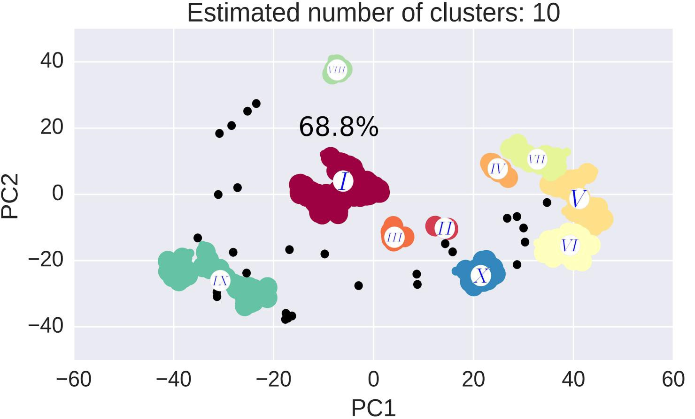

Figure S5. Cluster analysis of the COM data from the docking results of DEXA with HSA using the DBSCAN algorithm. Roman numerals denote clusters, where the 1st cluster contains 68.8% of docking conformations.

