Supplementary
sgRNA LEVEL IS A MAJOR FACTOR AFFECTING CRISPRi KNOCKDOWN EFFICIENCY IN K562 CELLS
Y. Wangª, Y. Xie^{b}, Z. C. Dongª, X. J. Jiangª, P. Gongª, J. Luª, and F. Wan^{a, *}
ª College of Life Sciences, Inner Mongolia Agricultural University, Inner Mongolia, 010010 China
^{b}College of Science, Inner Mongolia Agricultural University, Inner Mongolia, 010010 China
*e-mail: fwan@imau.edu.cn
-------------------------------------------------
Supplementary Table 1. The sequences of primers

Primer set | Primer sequence (5’-3’) | Fragment size
pTRE3G F | ttgaattcTTTACTCCCTATCAGTGAT | 392 bp
pTRE3G R | tagaattcTTTTACGAGGGTAGGAAGT
DPH2 qPCR F | ACCTGGACGGAGTGTACGAG | 100 bp
DPH2 qPCR R | TCTCCCAATAGCTGGTCAGG
UBE4A qPCR F | CAGCTGGAAAGCCTCAAATC | 100 bp
UBE4A qPCR R | GGCATTTGCAAAAGTGTCCT
MMADHC qPCR F | CGAACTATCTTCTCCAGCGG | 114 bp
MMADHC qPCR R | AAGGCTTTGGGATTGACAACC
RPIA qPCR F | GCTGGCTATGCTAGTCGCTT | 85 bp
RPIA qPCR R | GGATTCCCTTGTGCCACTGA
ZNF148 qPCR F | TAATGGGTGGAGTGTCTGGC | 85 bp
ZNF148 qPCR R | TCCTGGTGAGGCATACTTCG
LSM4 qPCR F | AGCATCTGTGGACCGTGAA | 86 bp
LSM4 qPCR R | GGACCCTGAAGAGAAGGCTA
NPEPPS qPCR F | TTCTGTGCTGGTGGGTCATA | 127
NPEPPS qPCR R | CATTCATCTCTGGCTTGTCCA
LIMA1 qPCR F | ATCCCAAGCCACTAAGTCCA | 115
LIMA1 qPCR R | TTCTGACATTCCACGCAGG
Italics indicate restriction endonuclease sites. F: Forward primer, R: Reverse primer.

Supplementary Table 2. The mCherry MFI in four clones

 | K562-dCas9 #B | K562-dCas9 #C | K562-idCas9 #49 | K562-idCas9 #60
1 | 492032.1 | 34448.6 | 21674.1
2 | 389089.4 | 35876.7 | 18261.6 | 761.6
3 | 419680.5 | 32378.1 | 19004.1 | 1087.9
4 | 460097.9 | 1779.7 | 19539.1 | 856.5

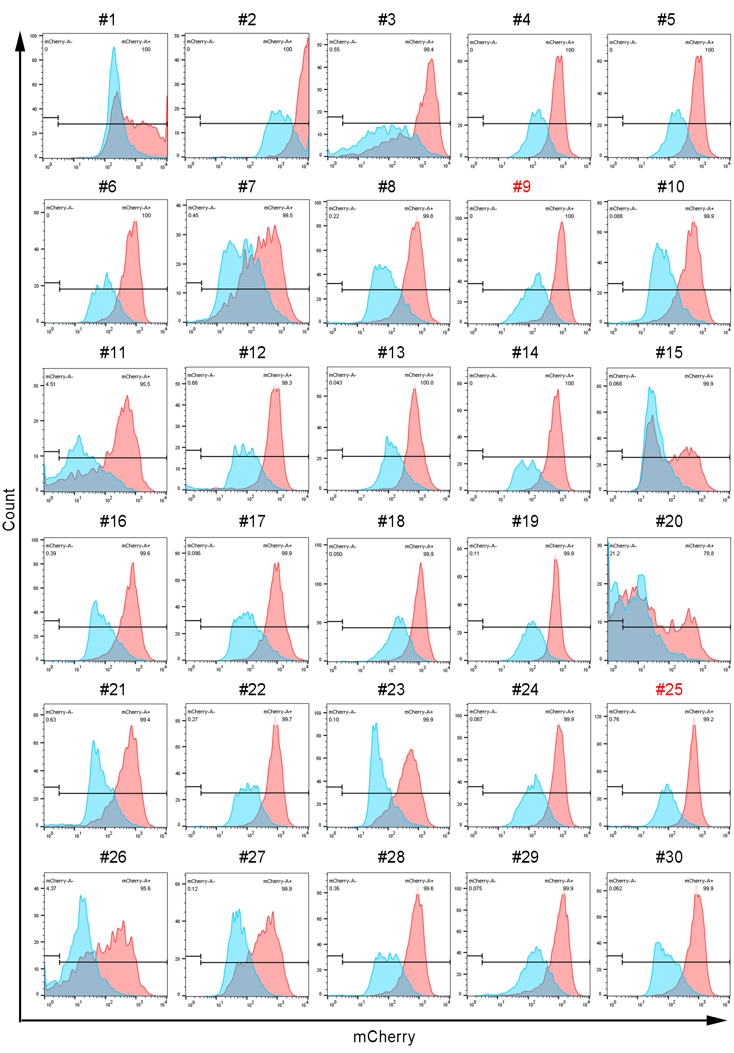
Supplementary Fig. 1. The histogram of #1 to #30 inducible single clones.
The blue peak is the mCherry fluorescent histogram without induction, and the red peak is with 2000 nM doxycycline induction for 48 h.
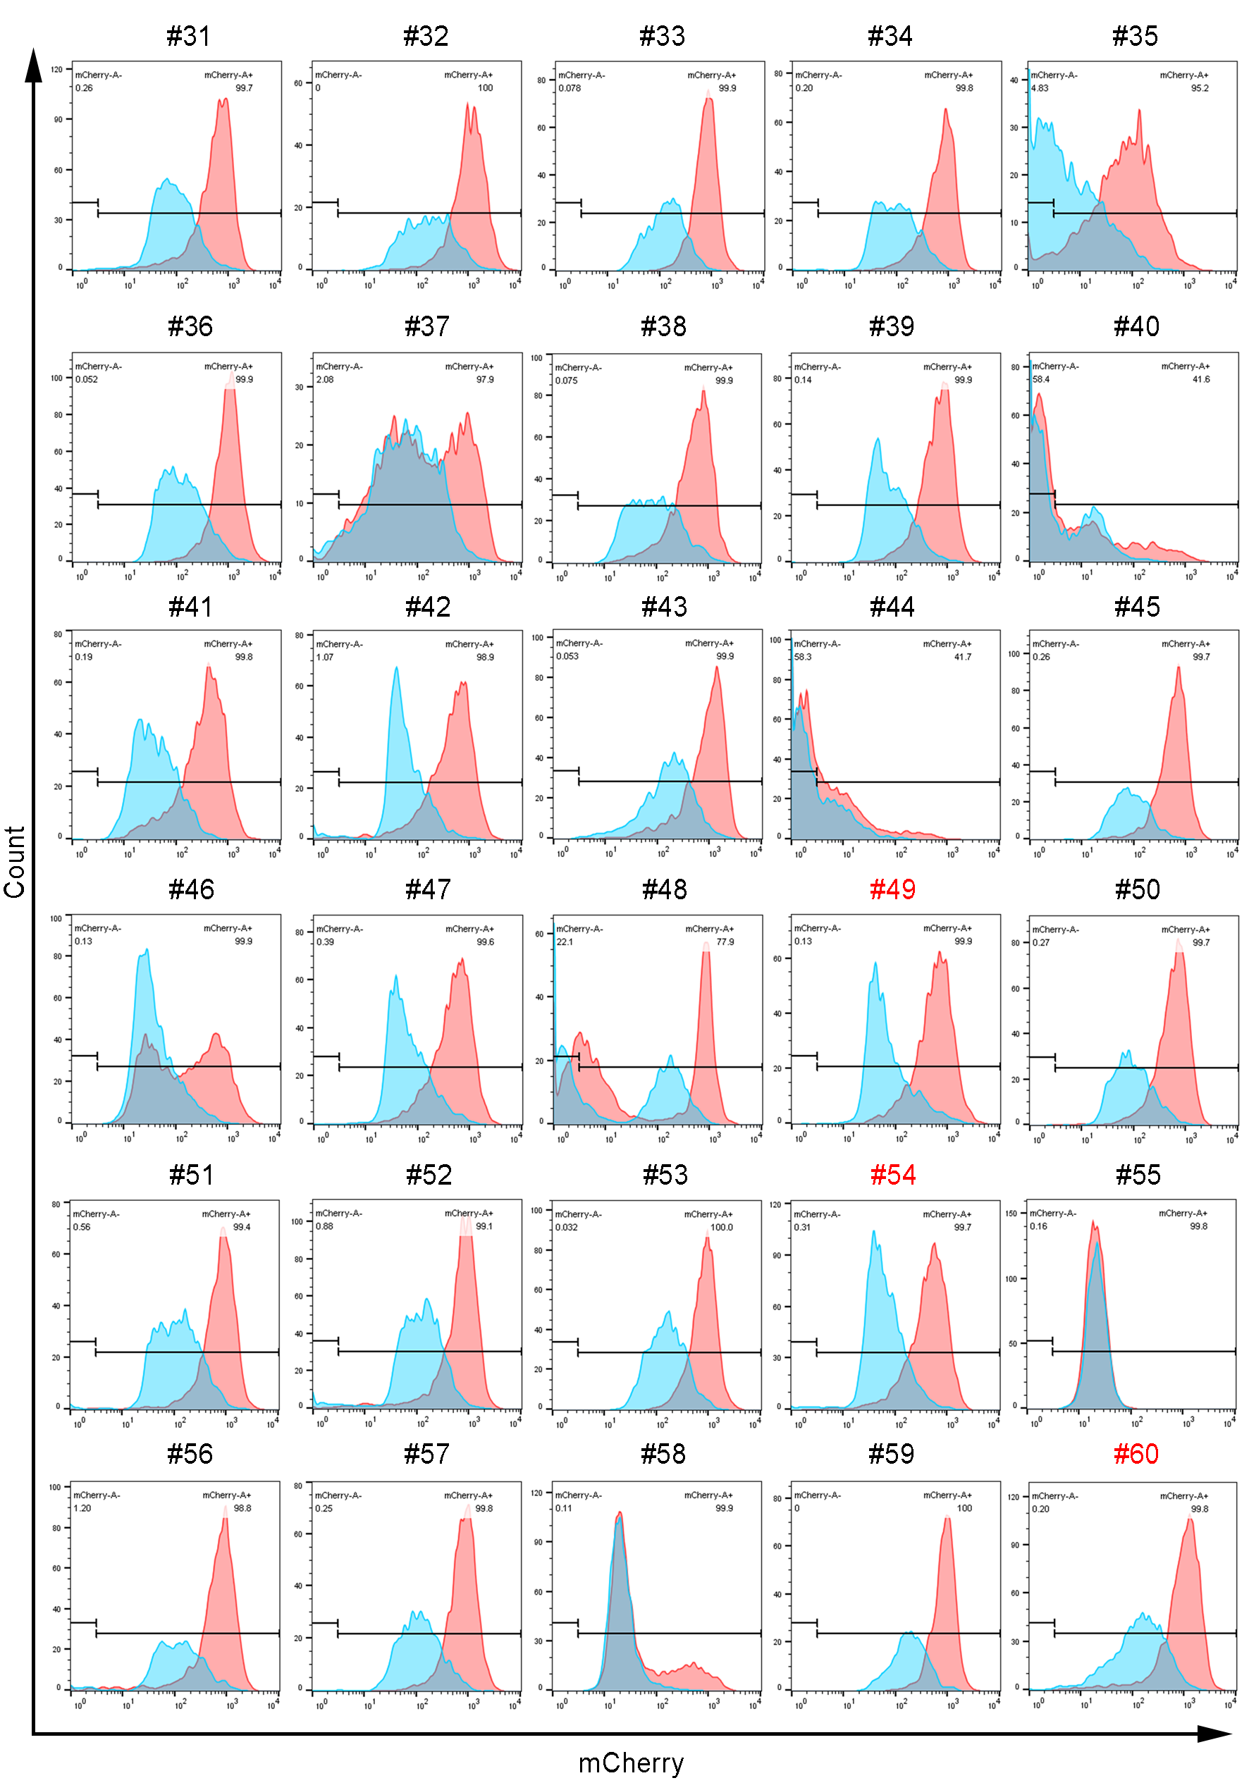
Supplementary Fig. 2. The histogram of #31 to #60 inducible single clones.
The blue peak is the mCherry fluorescent histogram without induction, and the red peak is with 2000 nM doxycycline induction for 48 h.

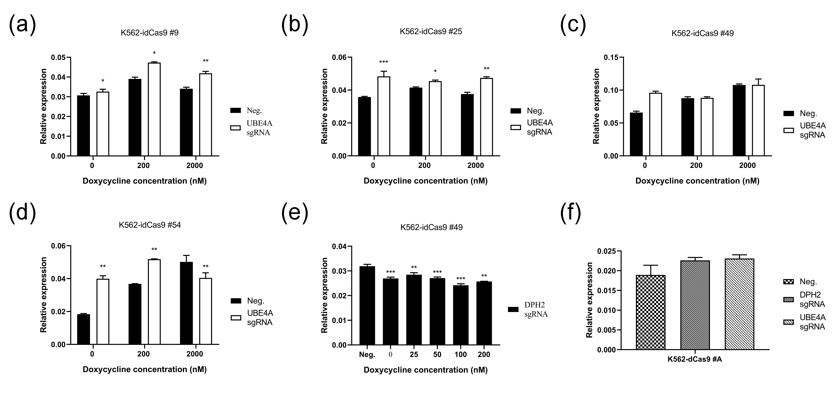
Supplementary Fig. 3. Pilot CRISPRi experiments targeting UBE4A and DPH2 in cell clones. (a) The relative expression level of UBE4A mRNA in K562-idCas9 #9. (b)The relative expression level of UBE4A mRNA in K562-idCas9 #25. (c) The relative expression level of UBE4A mRNA in K562-idCas9 #49. (d)The relative expression level of UBE4A mRNA in K562-idCas9#54. Neg. indicated none sgRNA transduction. (e) The relative expression level of DPH2 mRNA in K562-idCas9 #49. (f) The relative expression level of UBE4A and DPH2 mRNA in K562-dCas9 #A.

