checkCIF/PLATON report

Structure factors have been supplied for datablock(s) seyf63_sq

THIS REPORT IS FOR GUIDANCE ONLY. IF USED AS PART OF A REVIEW PROCEDURE FOR PUBLICATION, IT SHOULD NOT REPLACE THE EXPERTISE OF AN EXPERIENCED CRYSTALLOGRAPHIC REFEREE.

No syntax errors found. CIF dictionary Interpreting this report

Datablock: seyf63_sq

Bond precision: C-C = 0.0248 A Wavelength=0.71073

Cell: | a=13.9136(12) | b=13.9818(13) c=15.1313(16)
 | alpha=113.398(10) | beta=106.248(8) gamma=94.594(7)
Temperature: | 294 K

Calculated Reported Volume 2531.8(5) 2531.8(5) Space group P -1 P -1
Hall group -P 1 -P 1
C20 H20 Ge4 O32, 2(C36 H24 C20 H20 Ge4 O32, 2(C36 H24

Moiety formula
Cu N6), 8(H2 O) [+
solvent]

Cu N6), 8(H2 O)

C92 H84 Cu2 Ge4 N12 O40 [+
Sum formula
solvent] C92 H84 Cu2 Ge4 N12 O40
Mr 2415.25 2415.15
Dx,g cm-3 1.584 1.584
Z 1 1
Mu (mm-1) 1.680 1.680
F000 1226.0 1226.0
F000’ 1227.82
h,k,lmax 17,17,18 17,17,18
Nref 9971 9958
Tmin,Tmax 0.451,0.715 0.098,1.000
Tmin’ 0.361

Correction method= # Reported T Limits: Tmin=0.098 Tmax=1.000
AbsCorr = MULTI-SCAN

Data completeness= 0.999 Theta(max)= 25.998

R(reflections)= 0.1081( 3217) wR2(reflections)= 0.2444( 9958) S = 0.951 Npar= 670

The following ALERTS were generated. Each ALERT has the format
test-name_ALERT_alert-type_alert-level.
Click on the hyperlinks for more details of the test.

Alert level B
RINTA01_ALERT_3_B The value of Rint is greater than 0.18
Rint given 0.188
PLAT020_ALERT_3_B The Value of Rint is Greater Than 0.12 ......... 0.188 Report PLAT026_ALERT_3_B Ratio Observed / Unique Reflections (too) Low .. 32% Check PLAT341_ALERT_3_B Low Bond Precision on C-C Bonds ............... 0.02477 Ang. PLAT417_ALERT_2_B Short Inter D-H..H-D H16A ..H17B . 1.94 Ang.
1-x,-y,1-z = 2_656 Check PLAT910_ALERT_3_B Missing # of FCF Reflection(s) Below Theta(Min). 13 Note PLAT990_ALERT_1_B Deprecated .res/.hkl Input Style SQUEEZE Job ... ! Note

Alert level  PLAT082_ALERT_2_C | C  High R | 1 Value | .................................. |  |  |  |  | 0.11 | Report
PLAT213_ALERT_2_C | Atom C | 6 | has ADP max/min Ratio ..... |  |  |  |  | 3.2 | prolat
PLAT213_ALERT_2_C | Atom C | 7 | has ADP max/min Ratio ..... |  |  |  |  | 3.5 | prolat
PLAT234_ALERT_4_C | Large | Hirshfeld |  | Difference | O2 | --C1 | . | 0.20 | Ang.
PLAT234_ALERT_4_C | Large | Hirshfeld |  | Difference | O3 | --C1 | . | 0.19 | Ang.
PLAT234_ALERT_4_C | Large | Hirshfeld |  | Difference | O8 | --C5 | . | 0.18 | Ang.
PLAT234_ALERT_4_C | Large | Hirshfeld |  | Difference | O9 | --C6 | . | 0.21 | Ang.
PLAT234_ALERT_4_C | Large | Hirshfeld |  | Difference | O10 | --C6 | . | 0.18 | Ang.
PLAT234_ALERT_4_C | Large | Hirshfeld |  | Difference | Cu1 | --N3 | . | 0.16 | Ang.
PLAT234_ALERT_4_C | Large | Hirshfeld |  | Difference | Cu1 | --N5 | . | 0.19 | Ang.
PLAT234_ALERT_4_C | Large | Hirshfeld |  | Difference | N1 | --C11 | . | 0.21 | Ang.
PLAT234_ALERT_4_C | Large | Hirshfeld |  | Difference | N2 | --C22 | . | 0.22 | Ang.
PLAT234_ALERT_4_C | Large | Hirshfeld |  | Difference | N3 | --C23 | . | 0.19 | Ang.
PLAT234_ALERT_4_C | Large | Hirshfeld |  | Difference | C14 | --C16 | . | 0.25 | Ang.
PLAT234_ALERT_4_C | Large | Hirshfeld |  | Difference | C16 | --C17 | . | 0.23 | Ang.
PLAT234_ALERT_4_C | Large | Hirshfeld |  | Difference | C18 | --C19 | . | 0.17 | Ang.
PLAT234_ALERT_4_C | Large | Hirshfeld |  | Difference | C18 | --C20 | . | 0.21 | Ang.
PLAT234_ALERT_4_C | Large | Hirshfeld |  | Difference | C20 | --C21 | . | 0.21 | Ang.
PLAT234_ALERT_4_C | Large | Hirshfeld |  | Difference | C21 | --C22 | . | 0.21 | Ang.
PLAT234_ALERT_4_C | Large | Hirshfeld |  | Difference | C29 | --C30 | . | 0.23 | Ang.
PLAT234_ALERT_4_C | Large | Hirshfeld |  | Difference | C30 | --C31 | . | 0.23 | Ang.
PLAT234_ALERT_4_C | Large | Hirshfeld |  | Difference | C38 | --C39 | . | 0.19 | Ang.
PLAT234_ALERT_4_C | Large | Hirshfeld |  | Difference | C42 | --C43 | . | 0.22 | Ang.
PLAT234_ALERT_4_C | Large | Hirshfeld |  | Difference | C42 | --C44 | . | 0.22 | Ang.
PLAT234_ALERT_4_C | Large | Hirshfeld |  | Difference | C44 | --C45 | . | 0.24 | Ang.
PLAT241_ALERT_2_C High ’MainMol’ Ueq as Compared to Neighbors of C17 Check
PLAT242_ALERT_2_C Low ’MainMol’ Ueq as Compared to Neighbors of C6 Check PLAT260_ALERT_2_C Large Average Ueq of Residue Including O17 0.115 Check PLAT260_ALERT_2_C Large Average Ueq of Residue Including O18 0.109 Check PLAT260_ALERT_2_C Large Average Ueq of Residue Including O19 0.123 Check PLAT260_ALERT_2_C Large Average Ueq of Residue Including O20 0.106 Check PLAT790_ALERT_4_C Centre of Gravity not Within Unit Cell: Resd. # 1 Note
C20 H20 Ge4 O32
PLAT906_ALERT_3_C Large K Value in the Analysis of Variance ...... 51.845 Check PLAT906_ALERT_3_C Large K Value in the Analysis of Variance ...... 3.848 Check PLAT906_ALERT_3_C Large K Value in the Analysis of Variance ...... 11.245 Check PLAT906_ALERT_3_C Large K Value in the Analysis of Variance ...... 2.797 Check PLAT906_ALERT_3_C Large K Value in the Analysis of Variance ...... 5.678 Check PLAT906_ALERT_3_C Large K Value in the Analysis of Variance ...... 2.058 Check PLAT906_ALERT_3_C Large K Value in the Analysis of Variance ...... 3.359 Check PLAT906_ALERT_3_C Large K Value in the Analysis of Variance ...... 2.195 Check

Alert level G
PLAT005_ALERT_5_G No Embedded Refinement Details Found in the CIF Please Do ! PLAT007_ALERT_5_G Number of Unrefined Donor-H Atoms .............. 12 Report PLAT606_ALERT_4_G VERY LARGE Solvent Accessible VOID(S) in Structure ! Info PLAT790_ALERT_4_G Centre of Gravity not Within Unit Cell: Resd. # 2 Note
C36 H24 Cu N6
PLAT790_ALERT_4_G Centre of Gravity not Within Unit Cell: Resd. # 5 Note
H2 O
PLAT790_ALERT_4_G Centre of Gravity not Within Unit Cell: Resd. # 6 Note
H2 O
PLAT793_ALERT_4_G Model has Chirality at C2 (Centro SPGR) S Verify PLAT793_ALERT_4_G Model has Chirality at C3 (Centro SPGR) S Verify PLAT793_ALERT_4_G Model has Chirality at C4 (Centro SPGR) R Verify PLAT793_ALERT_4_G Model has Chirality at C7 (Centro SPGR) R Verify PLAT793_ALERT_4_G Model has Chirality at C8 (Centro SPGR) R Verify PLAT793_ALERT_4_G Model has Chirality at C9 (Centro SPGR) S Verify PLAT794_ALERT_5_G Tentative Bond Valency for Cu1 (I) . 1.18 Info PLAT869_ALERT_4_G ALERTS Related to the Use of SQUEEZE Suppressed ! Info PLAT913_ALERT_3_G Missing # of Very Strong Reflections in FCF .... 1 Note PLAT961_ALERT_5_G Dataset Contains no Negative Intensities ....... Please Check PLAT978_ALERT_2_G Number C-C Bonds with Positive Residual Density. 0 Info

0 ALERT level A = Most likely a serious problem - resolve or explain
7 ALERT level B = A potentially serious problem, consider carefully
40 ALERT level C = Check. Ensure it is not caused by an omission or oversight
17 ALERT level G = General information/check it is not something unexpected

1 ALERT type 1 CIF construction/syntax error, inconsistent or missing data
11 ALERT type 2 Indicator that the structure model may be wrong or deficient
14 ALERT type 3 Indicator that the structure quality may be low
34 ALERT type 4 Improvement, methodology, query or suggestion
4 ALERT type 5 Informative message, check

It is advisable to attempt to resolve as many as possible of the alerts in all categories. Often the minor alerts point to easily fixed oversights, errors and omissions in your CIF or refinement strategy, so attention to these fine details can be worthwhile. In order to resolve some of the more serious problems it may be necessary to carry out additional measurements or structure refinements. However, the purpose of your study may justify the reported deviations and the more
serious of these should normally be commented upon in the discussion or experimental section of a paper or in the "special_details" fields of the CIF. checkCIF was carefully designed to identify outliers and unusual parameters, but every test has its limitations and alerts that are not important
in a particular case may appear. Conversely, the absence of alerts does not guarantee there are no aspects of the results needing attention. It is up to the individual to critically assess their own results and, if necessary, seek expert advice.

Publication of your CIF in IUCr journals

A basic structural check has been run on your CIF. These basic checks will be run on all CIFs submitted for publication in IUCr journals (Acta Crystallographica, Journal of Applied Crystallography, Journal of Synchrotron Radiation); however, if you intend to submit to Acta Crystallographica Section C or E or IUCrData, you should make sure that full publication checks are run on the final version of your CIF prior to submission.

Publication of your CIF in other journals

Please refer to the Notes for Authors of the relevant journal for any special instructions relating to
CIF submission.

PLATON version of 22/04/2020; check.def file version of 09/03/2020

Datablock sey -
- - - - NOMO
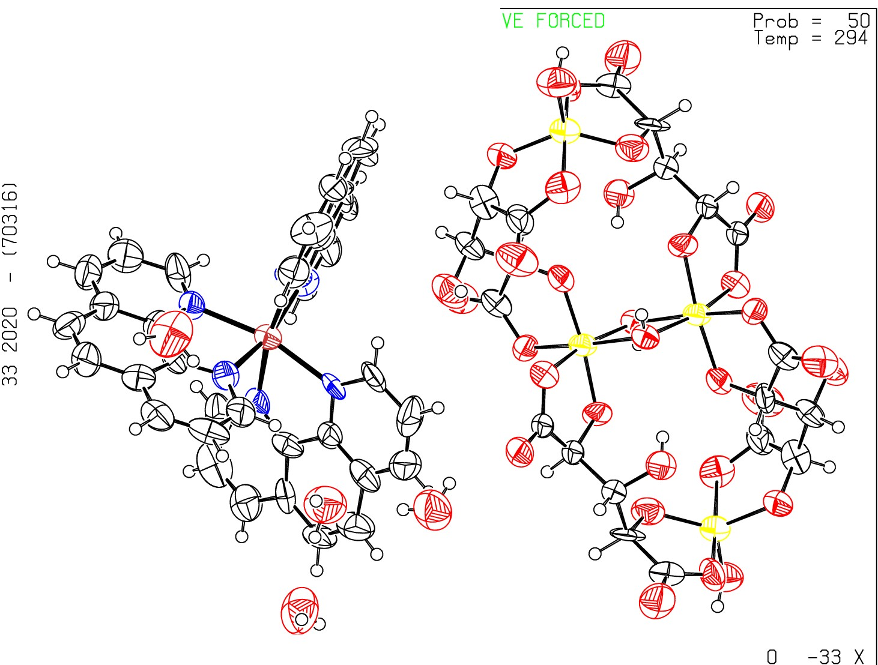f63 sq - ellipsoid plot

>-
......
I

t'­ N
C...D...

t'­ N
L
Q_
CI
I
:z:
0
f­
CI
_j
o_

z -77

se f63_s

p -1

R = 0. 11 RES=

