checkCIF/PLATON report

Structure factors have been supplied for datablock(s) 1487_0m_a

THIS REPORT IS FOR GUIDANCE ONLY. IF USED AS PART OF A REVIEW PROCEDURE FOR PUBLICATION, IT SHOULD NOT REPLACE THE EXPERTISE OF AN EXPERIENCED CRYSTALLOGRAPHIC REFEREE.

No syntax errors found. CIF dictionary Interpreting this report

Datablock: 1487_0m_a

Bond precision: C-C = 0.0033 A Wavelength=0.71073

Cell: | a=10.268(3) | b=10.442(5) | c=10.873(3)
 | alpha=79.95(2) | beta=66.827(12) | gamma=73.585(16)
Temperature: | 293 K

Calculated Reported Volume 1025.4(7) 1025.4(6) Space group P -1 P -1
Hall group -P 1 -P 1
Moiety formula 2(C20 H20 P), Cl6 Hf Cl6 Hf, 2(C20 H20 P) Sum formula C40 H40 Cl6 Hf P2 C40 H40 Cl6 Hf P2
Mr 973.85 973.85
Dx,g cm-3 1.577 1.577
Z 1 1
Mu (mm-1) | 3.040 | 3.040
F000 | 484.0 | 484.0
F000’ | 484.63
h,k,lmax | 17,18,18 | 17,17,18
Nref | 11073 | 11001
Tmin,Tmax | 0.421,0.544 | 0.473,0.581
Tmin’ | 0.410

Correction method= # Reported T Limits: Tmin=0.473 Tmax=0.581
AbsCorr = MULTI-SCAN

Data completeness= 0.993 Theta(max)= 37.870
R(reflections)= 0.0313( 9243) wR2(reflections)= 0.0601( 11001) S = 1.020 Npar= 224

The following ALERTS were generated. Each ALERT has the format
test-name_ALERT_alert-type_alert-level.
Click on the hyperlinks for more details of the test.

Alert level B
PLAT973_ALERT_2_B Check Calcd Positive Resid. Density on Hf1 1.61 eA-3

Alert level C
ABSTY02_ALERT_1_C An _exptl_absorpt_correction_type has been given without a literature citation. This should be contained in the
_exptl_absorpt_process_details field. Absorption correction given as multi-scan
PLAT244_ALERT_4_C Low | ’Solvent’ Ueq as Compared to Neighbors of | Hf1 | Check
PLAT910_ALERT_3_C Missi | ng # of FCF Reflection(s) Below Theta(Min). | 8 | Note
Alert level G
PLAT012_ALERT_1_G No _shelx_res_checksum Found in CIF ...... Please Check PLAT042_ALERT_1_G Calc. and Reported MoietyFormula Strings Differ Please Check PLAT199_ALERT_1_G Reported _cell_measurement_temperature ..... (K) 293 Check PLAT200_ALERT_1_G Reported _diffrn_ambient_temperature ..... (K) 293 Check PLAT794_ALERT_5_G Tentative Bond Valency for Hf1 (IV) . 3.34 Info PLAT912_ALERT_4_G Missing # of FCF Reflections Above STh/L= 0.600 63 Note PLAT933_ALERT_2_G Number of OMIT Records in Embedded .res File ... 2 Note PLAT978_ALERT_2_G Number C-C Bonds with Positive Residual Density. 10 Info

0 ALERT level A = Most likely a serious problem - resolve or explain
1 ALERT level B = A potentially serious problem, consider carefully
3 ALERT level C = Check. Ensure it is not caused by an omission or oversight
8 ALERT level G = General information/check it is not something unexpected

5 ALERT type 1 CIF construction/syntax error, inconsistent or missing data
3 ALERT type 2 Indicator that the structure model may be wrong or deficient
1 ALERT type 3 Indicator that the structure quality may be low
2 ALERT type 4 Improvement, methodology, query or suggestion
1 ALERT type 5 Informative message, check

It is advisable to attempt to resolve as many as possible of the alerts in all categories. Often the minor alerts point to easily fixed oversights, errors and omissions in your CIF or refinement strategy, so attention to these fine details can be worthwhile. In order to resolve some of the more serious problems it may be necessary to carry out additional measurements or structure refinements. However, the purpose of your study may justify the reported deviations and the more
serious of these should normally be commented upon in the discussion or experimental section of a paper or in the "special_details" fields of the CIF. checkCIF was carefully designed to identify outliers and unusual parameters, but every test has its limitations and alerts that are not important
in a particular case may appear. Conversely, the absence of alerts does not guarantee there are no aspects of the results needing attention. It is up to the individual to critically assess their own results and, if necessary, seek expert advice.

Publication of your CIF in IUCr journals

A basic structural check has been run on your CIF. These basic checks will be run on all CIFs submitted for publication in IUCr journals (Acta Crystallographica, Journal of Applied Crystallography, Journal of Synchrotron Radiation); however, if you intend to submit to Acta Crystallographica Section C or E or IUCrData, you should make sure that full publication checks are run on the final version of your CIF prior to submission.

Publication of your CIF in other journals

Please refer to the Notes for Authors of the relevant journal for any special instructions relating to
CIF submission.

PLATON version of 17/03/2019; check.def file version of 04/03/2019

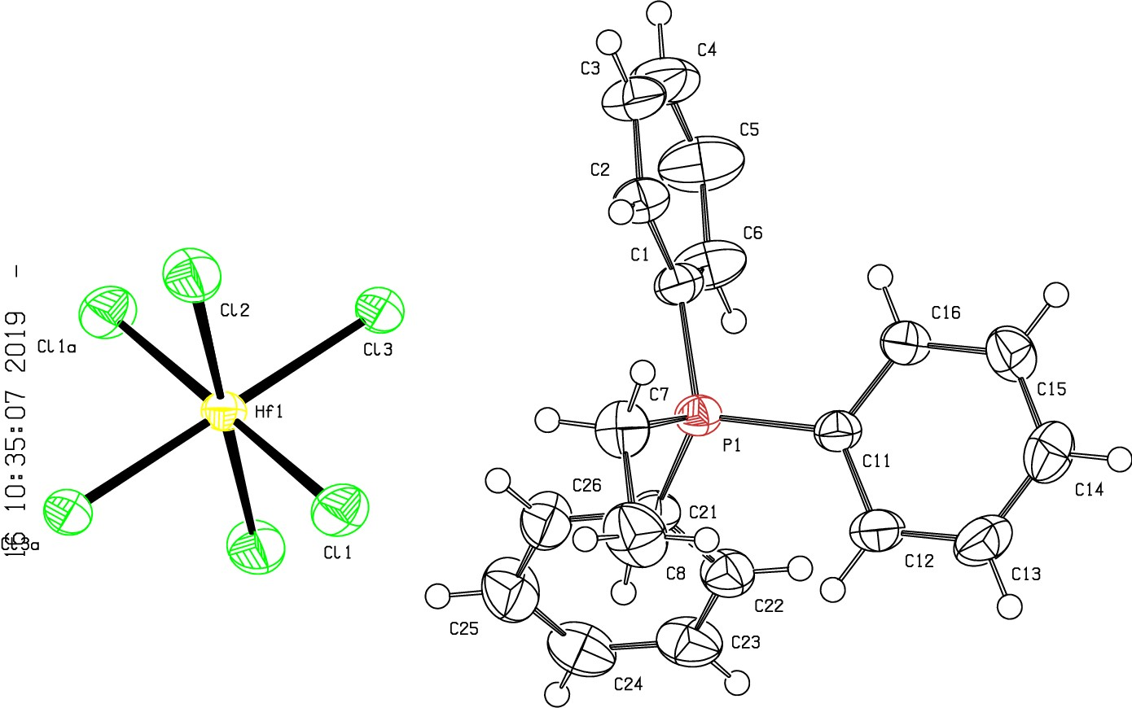Datablock 1487_0m_a- ellipsoid plot

>­
(Y)
tD

tD
(Y)
0
r-
NOMOVE FORCED Prob
Temp
50
293

L CL2a
Q_
CI
I
:z:
0
f-
CI
_j
o_

z -140 1487 Om a p -1 R 0.03 RES= 0 171 X

