checkCIF/PLATON report

Structure factors have been supplied for datablock(s) 1028_0m_a

THIS REPORT IS FOR GUIDANCE ONLY. IF USED AS PART OF A REVIEW PROCEDURE FOR PUBLICATION, IT SHOULD NOT REPLACE THE EXPERTISE OF AN EXPERIENCED CRYSTALLOGRAPHIC REFEREE.

No syntax errors found. CIF dictionary Interpreting this report

Datablock: 1028_0m_a

Bond precision: C-C = 0.0093 A Wavelength=0.71073

Cell: | a=8.986(7) | b=12.322(10) | c=14.076(13)
 | alpha=99.15(4) | beta=91.82(4) | gamma=100.28(4)
Temperature: | 293 K

 | Calculated |  |  | Reported
Volume | 1511(2) |  |  | 1511(2)
Space group | P -1 |  |  | P -1
Hall group | -P 1 |  |  | -P 1
Moiety formula | C32 H14 F11 | O4 | Sb | C32 H14 F10 O4 Sb, F
Sum formula | C32 H14 F11 | O4 | Sb | C32 H14 F11 O4 Sb
Mr | 793.19 |  |  | 793.18
Dx,g cm-3 | 1.743 |  |  | 1.743
Z | 2 |  |  | 2
Mu (mm-1) | 1.018 |  |  | 1.018
F000 | 776.0 |  |  | 776.0
F000’ | 775.43
h,k,lmax | 10,14,16 |  |  | 10,14,16
Nref | 5369 |  |  | 5322
Tmin,Tmax | 0.803,0.876 |  |  | 0.785,0.879
Tmin’ | 0.775

Correction method= # Reported T Limits: Tmin=0.785 Tmax=0.879
AbsCorr = MULTI-SCAN

Data completeness= 0.991 Theta(max)= 25.040
R(reflections)= 0.0415( 4272) wR2(reflections)= 0.1063( 5322) S = 1.038 Npar= 442

The following ALERTS were generated. Each ALERT has the format
test-name_ALERT_alert-type_alert-level.
Click on the hyperlinks for more details of the test.

Alert level C
ABSTY02_ALERT_1_C An _exptl_absorpt_correction_type has been given without a literature citation. This should be contained in the
_exptl_absorpt_process_details field. Absorption correction given as multi-scan
PLAT220_ALERT_2_C Non-Solvent Resd 1 C Ueq(max)/Ueq(min) Range 3.2 Ratio PLAT230_ALERT_2_C Hirshfeld Test Diff for F1 --C3 . 6.7 s.u. PLAT230_ALERT_2_C Hirshfeld Test Diff for F4 --C32 . 6.3 s.u. PLAT234_ALERT_4_C Large Hirshfeld Difference C24 --C25 . 0.16 Ang. PLAT241_ALERT_2_C High ’MainMol’ Ueq as Compared to Neighbors of C5 Check PLAT242_ALERT_2_C Low ’MainMol’ Ueq as Compared to Neighbors of C1 Check PLAT242_ALERT_2_C Low ’MainMol’ Ueq as Compared to Neighbors of C3 Check PLAT242_ALERT_2_C Low ’MainMol’ Ueq as Compared to Neighbors of C13 Check PLAT242_ALERT_2_C Low ’MainMol’ Ueq as Compared to Neighbors of C23 Check PLAT242_ALERT_2_C Low ’MainMol’ Ueq as Compared to Neighbors of C32 Check PLAT334_ALERT_2_C Small Aver. Benzene C-C Dist C1 -C6 1.37 Ang. PLAT334_ALERT_2_C Small Aver. Benzene C-C Dist C11 -C16 1.37 Ang. PLAT342_ALERT_3_C Low Bond Precision on C-C Bonds ............... 0.00934 Ang. PLAT910_ALERT_3_C Missing # of FCF Reflection(s) Below Theta(Min). 7 Note PLAT911_ALERT_3_C Missing FCF Refl Between Thmin & STh/L= 0.595 40 Report

Alert level | G
PLAT012_ALERT_1_G | No | _shelx_res_checksum Found in CIF | ...... | Please | Check
PLAT042_ALERT_1_G Calc. and Reported MoietyFormula Strings Differ Please Check
PLAT154_ALERT_1_G The s.u.’s on the Cell Angles are Equal ..(Note) 0.04 Degree PLAT199_ALERT_1_G Reported _cell_measurement_temperature ..... (K) 293 Check PLAT200_ALERT_1_G Reported _diffrn_ambient_temperature ..... (K) 293 Check PLAT300_ALERT_4_G Atom Site Occupancy of F8 Constrained at 0.5 Check PLAT300_ALERT_4_G Atom Site Occupancy of F12 Constrained at 0.5 Check PLAT300_ALERT_4_G Atom Site Occupancy of H42 Constrained at 0.5 Check PLAT300_ALERT_4_G Atom Site Occupancy of H46 Constrained at 0.5 Check PLAT301_ALERT_3_G Main Residue Disorder ..............(Resd 1 ) 2% Note PLAT434_ALERT_2_G Short Inter HL..HL Contact F2 ..F12 2.80 Ang.
1-x,1-y,2-z = 2_667 Check
PLAT434_ALERT_2_G Short Inter HL..HL Contact F7 ..F8 2.84 Ang.
1-x,1-y,1-z = 2_666 Check
PLAT710_ALERT_4_G Delete 1-2-3 or 2-3-4 Linear Torsion Angle ... # 11 Do !
O1 -SB1 -O3 -C47 175.80 1.60 1.555 1.555 1.555 1.555
PLAT710_ALERT_4_G Delete 1-2-3 or 2-3-4 Linear Torsion Angle ... # 28 Do !
O3 -SB1 -O1 -C37 -174.10 1.60 1.555 1.555 1.555 1.555
PLAT909_ALERT_3_G Percentage of I>2sig(I) Data at Theta(Max) Still 57% Note PLAT933_ALERT_2_G Number of OMIT Records in Embedded .res File ... 3 Note PLAT978_ALERT_2_G Number C-C Bonds with Positive Residual Density. 1 Info

0 ALERT level A = Most likely a serious problem - resolve or explain
0 ALERT level B = A potentially serious problem, consider carefully
16 ALERT level C = Check. Ensure it is not caused by an omission or oversight
17 ALERT level G = General information/check it is not something unexpected

6 ALERT type 1 CIF construction/syntax error, inconsistent or missing data
15 ALERT type 2 Indicator that the structure model may be wrong or deficient
5 ALERT type 3 Indicator that the structure quality may be low
7 ALERT type 4 Improvement, methodology, query or suggestion
0 ALERT type 5 Informative message, check

It is advisable to attempt to resolve as many as possible of the alerts in all categories. Often the minor alerts point to easily fixed oversights, errors and omissions in your CIF or refinement strategy, so attention to these fine details can be worthwhile. In order to resolve some of the more serious problems it may be necessary to carry out additional measurements or structure refinements. However, the purpose of your study may justify the reported deviations and the more
serious of these should normally be commented upon in the discussion or experimental section of a paper or in the "special_details" fields of the CIF. checkCIF was carefully designed to identify outliers and unusual parameters, but every test has its limitations and alerts that are not important
in a particular case may appear. Conversely, the absence of alerts does not guarantee there are no aspects of the results needing attention. It is up to the individual to critically assess their own results and, if necessary, seek expert advice.

Publication of your CIF in IUCr journals

A basic structural check has been run on your CIF. These basic checks will be run on all CIFs submitted for publication in IUCr journals (Acta Crystallographica, Journal of Applied Crystallography, Journal of Synchrotron Radiation); however, if you intend to submit to Acta Crystallographica Section C or E or IUCrData, you should make sure that full publication checks are run on the final version of your CIF prior to submission.

Publication of your CIF in other journals

Please refer to the Notes for Authors of the relevant journal for any special instructions relating to
CIF submission.

PLATON version of 07/08/2019; check.def file version of 30/07/2019

Datablock 1028_0m_a- ellipsoid plot

>­
N
r--

CD
(Y")
0
r--

m
0
N
N
0..
...q­
N
r--
0
NOMOVE FORCED Prob
Temp
50
293

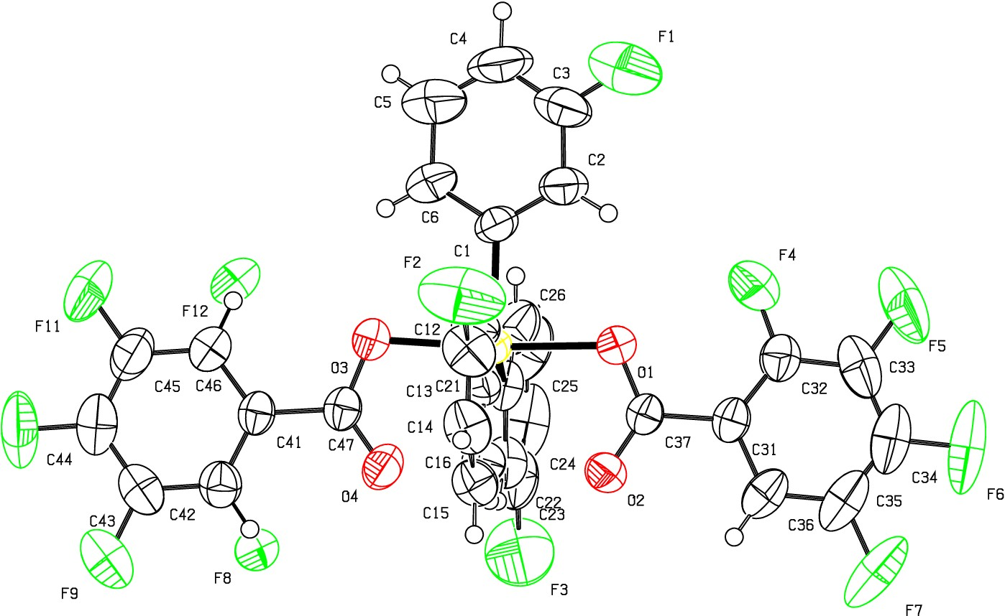If)
FlO
u QJ D I
:z:
0
f­
a:
_j
o_

z -16 1028 Om a P -1 R

0.04

RES= 0 85 X

