Electron supplementary material
for
Structure and stability of copper(II) complexes with cryptand[2.2.2]

© V.A. Isaeva*, G.A. Gamov, V.A. Sharnin
Ivanovo State University of Chemistry and Technology
*E-mail: kvol1969@gmail.com

XYZ-coordinates of optimized structures depicted in the main text (Fig. 2).

Fig. 2a. Free cryptand[2.2.2]
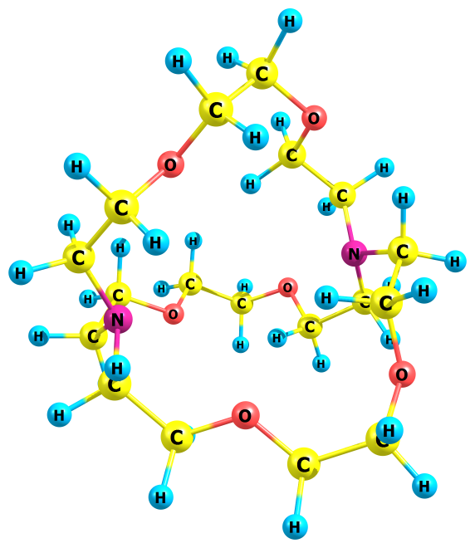
1 0.897344000 -4.027601000 -2.429583000
6 0.329735000 -3.217486000 -1.940737000
1 0.024918000 -3.571889000 -0.945462000
8 1.142014000 -2.060387000 -1.825019000
6 -0.911725000 -2.924586000 -2.767772000
6 2.300844000 -2.287218000 -1.036810000
1 -1.388851000 -3.882167000 -3.002873000
1 -0.623816000 -2.449708000 -3.715783000
8 -1.882979000 -2.148580000 -2.089013000
1 2.892551000 -3.102017000 -1.483779000
1 2.011108000 -2.603322000 -0.025308000
6 3.153766000 -1.025357000 -0.994270000
6 -1.774153000 -0.732305000 -2.282033000
1 3.111711000 -0.580887000 -1.990557000
1 4.208710000 -1.316056000 -0.826251000
7 2.726775000 -0.029128000 -0.007425000
1 -1.968054000 -0.505587000 -3.342410000
1 -0.768547000 -0.392304000 -2.019713000
6 -2.797653000 -0.008967000 -1.417696000
6 3.190841000 1.313000000 -0.372480000
6 3.168459000 -0.395873000 1.341956000
1 -2.839724000 1.019595000 -1.777223000
1 -3.792865000 -0.457442000 -1.586287000
7 -2.445486000 0.027986000 0.002009000
1 4.245492000 1.285089000 -0.707929000
1 3.167101000 1.952278000 0.512452000
6 2.358483000 2.008041000 -1.442784000
1 4.228880000 -0.117801000 1.495465000
1 3.115838000 -1.481052000 1.450828000
6 2.340490000 0.202680000 2.472405000
6 -2.811129000 -1.176619000 0.747440000
6 -2.778913000 1.282084000 0.677304000
1 2.057537000 1.302818000 -2.229480000
1 2.970792000 2.792559000 -1.915622000
8 1.209297000 2.599158000 -0.854646000
1 2.065328000 1.243338000 2.253772000
1 2.946363000 0.205292000 3.392657000
8 1.172289000 -0.576417000 2.680731000
1 -3.800738000 -1.082759000 1.229183000
1 -2.873613000 -2.000986000 0.036351000
6 -1.784117000 -1.582984000 1.794383000
1 -2.834051000 1.078405000 1.746960000
1 -3.763864000 1.673415000 0.366099000
6 -1.730159000 2.370162000 0.494442000
6 0.410204000 3.287276000 -1.803613000
6 0.380139000 -0.087779000 3.752029000
1 -2.000712000 -2.607723000 2.135626000
1 -0.783384000 -1.555035000 1.354666000
8 -1.854176000 -0.700827000 2.921536000
1 -1.909640000 3.175450000 1.224279000
1 -0.735072000 1.948327000 0.660985000
8 -1.819495000 2.921196000 -0.825788000
1 0.098725000 2.603315000 -2.606186000
1 0.992410000 4.104975000 -2.261617000
6 -0.825913000 3.878537000 -1.145511000
1 0.957282000 -0.121890000 4.691789000
1 0.094068000 0.958124000 3.569621000
6 -0.876374000 -0.926015000 3.921329000
1 -0.535475000 4.453497000 -0.255511000
1 -1.282978000 4.572311000 -1.859323000
1 -1.337072000 -0.647038000 4.875275000
1 -0.609274000 -1.990218000 3.974901000

Fig. 2b. Monoprotonated cryptand[2.2.2]
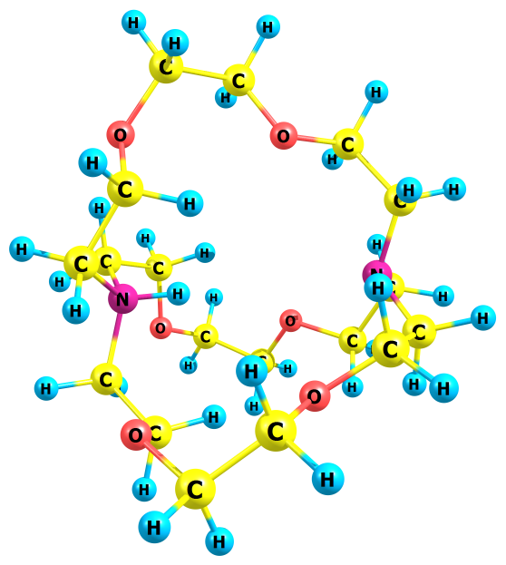
1 0.991513000 -1.608300000 4.449304000
6 0.365126000 -1.219753000 3.632106000
1 0.095076000 -0.182935000 3.881203000
8 1.067652000 -1.263417000 2.398988000
6 -0.886718000 -2.069911000 3.534921000
6 2.308206000 -0.562421000 2.445828000
1 -1.405557000 -2.051471000 4.496222000
1 -0.627939000 -3.109776000 3.306457000
8 -1.811824000 -1.568821000 2.562842000
1 2.914871000 -0.954661000 3.273968000
1 2.126818000 0.502082000 2.645669000
6 3.074727000 -0.771556000 1.149053000
6 -1.688828000 -2.150362000 1.273213000
1 3.009636000 -1.834251000 0.908755000
1 4.142050000 -0.561439000 1.342714000
7 2.594191000 0.010495000 -0.002293000
1 -1.998157000 -3.204572000 1.296917000
1 -0.649775000 -2.108063000 0.926945000
6 -2.602271000 -1.435052000 0.298965000
6 3.071553000 -0.593122000 -1.257637000
6 3.064759000 1.401913000 0.100408000
1 -2.596742000 -1.962872000 -0.651961000
1 -3.623574000 -1.369710000 0.677543000
7 -2.156334000 -0.008298000 0.001897000
1 4.140779000 -0.860048000 -1.178004000
1 2.998270000 0.145851000 -2.057533000
6 2.309421000 -1.825050000 -1.720814000
1 4.132261000 1.472038000 -0.175936000
1 2.995131000 1.724649000 1.140761000
6 2.293298000 2.415323000 -0.730750000
6 -2.611243000 0.959360000 1.087910000
6 -2.610296000 0.445556000 -1.380412000
1 2.135751000 -2.530998000 -0.897719000
1 2.915287000 -2.343181000 -2.477236000
8 1.064052000 -1.440947000 -2.298814000
1 2.118244000 2.056010000 -1.753642000
1 2.893493000 3.333142000 -0.802085000
8 1.048334000 2.715548000 -0.104186000
1 -3.633853000 1.247949000 0.839614000
1 -2.604183000 0.399847000 2.020588000
6 -1.706036000 2.166713000 1.222131000
1 -2.609709000 1.533042000 -1.362077000
1 -3.630415000 0.080164000 -1.508870000
6 -1.699108000 -0.036397000 -2.490709000
6 0.363811000 -2.534786000 -2.872433000
6 0.340641000 3.757386000 -0.759684000
1 -2.020167000 2.711943000 2.123044000
1 -0.665078000 1.852478000 1.359857000
8 -1.833059000 2.992506000 0.073839000
1 -2.013729000 0.469475000 -3.414124000
1 -0.660328000 0.246141000 -2.284530000
8 -1.817409000 -1.444461000 -2.632256000
1 0.100253000 -3.268554000 -2.096473000
1 0.989096000 -3.046892000 -3.619357000
6 -0.893247000 -2.032111000 -3.555429000
1 0.961566000 4.663243000 -0.830453000
1 0.074397000 3.453275000 -1.782716000
6 -0.914610000 4.090537000 0.023046000
1 -0.641076000 -1.313839000 -4.343463000
1 -1.410072000 -2.876687000 -4.017175000
1 -1.437747000 4.910548000 -0.474487000
1 -0.659469000 4.414285000 1.038219000
1 -1.128989000 -0.004181000 0.001264000

Fig. 2c. Bis-protonated cryptand[2.2.2]
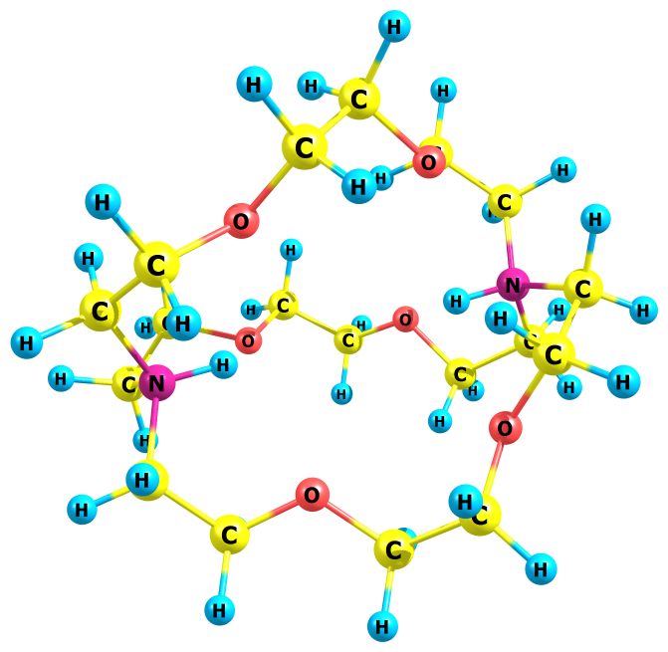
1 -0.928498000 -3.144583000 -3.068662000
6 -0.398166000 -2.399728000 -2.459676000
1 -0.010039000 -1.612753000 -3.117913000
8 -1.338563000 -1.820664000 -1.487854000
6 0.718890000 -3.079705000 -1.703954000
6 -2.623629000 -1.427403000 -2.047159000
1 1.268438000 -3.755940000 -2.370132000
1 0.301446000 -3.657314000 -0.870532000
8 1.656002000 -2.070564000 -1.189948000
1 -3.051611000 -2.239221000 -2.651015000
1 -2.510146000 -0.544043000 -2.689979000
6 -3.536696000 -1.181052000 -0.859940000
6 2.304951000 -2.442298000 0.064923000
1 -3.541571000 -2.069139000 -0.225977000
1 -4.561212000 -0.959962000 -1.172262000
7 -3.063365000 -0.005981000 0.000268000
1 2.764884000 -3.435900000 -0.006706000
1 1.554511000 -2.450805000 0.864304000
6 3.387920000 -1.411146000 0.357834000
6 -3.537924000 -0.164507000 1.447439000
6 -3.540310000 1.325258000 -0.587019000
1 3.613754000 -1.425673000 1.423702000
1 4.303300000 -1.595684000 -0.208130000
7 2.916955000 0.003173000 -0.007250000
1 -4.562046000 -0.546465000 1.411217000
1 -3.544030000 0.828275000 1.900151000
6 -2.624374000 -1.069252000 2.254084000
1 -4.566887000 1.479715000 -0.242971000
1 -3.540579000 1.221825000 -1.673284000
6 -2.634907000 2.480853000 -0.201722000
6 3.354112000 0.395079000 -1.425173000
6 3.372346000 1.036691000 1.032260000
1 -2.509568000 -2.066937000 1.809256000
1 -3.052517000 -1.187919000 3.258799000
8 -1.340020000 -0.387027000 2.316353000
1 -2.522254000 2.591674000 0.885244000
1 -3.069390000 3.408607000 -0.598461000
8 -1.347660000 2.205928000 -0.823102000
1 4.272565000 0.976901000 -1.323782000
1 3.565382000 -0.520824000 -1.976344000
6 2.255133000 1.165386000 -2.145075000
1 3.582545000 1.969170000 0.509368000
1 4.294025000 0.654649000 1.475803000
6 2.285442000 1.282821000 2.071342000
6 -0.394180000 -0.950211000 3.292212000
6 -0.411029000 3.340368000 -0.816631000
1 2.694174000 1.706961000 -2.992369000
1 1.484332000 0.480083000 -2.517336000
8 1.648343000 2.086886000 -1.188050000
1 2.738397000 1.725574000 2.967221000
1 1.523983000 1.966574000 1.677993000
8 1.656931000 0.000017000 2.378022000
1 -0.005967000 -1.908127000 2.924867000
1 -0.920013000 -1.118950000 4.241934000
6 0.722155000 0.043318000 3.511908000
1 -0.943600000 4.244473000 -1.142209000
1 -0.026109000 3.499777000 0.198092000
6 0.709566000 3.047608000 -1.786245000
1 0.303266000 1.051925000 3.609545000
1 1.275005000 -0.206096000 4.425734000
1 1.258702000 3.968427000 -2.017022000
1 0.295402000 2.634595000 -2.713598000
1 1.888046000 -0.007555000 0.003640000
1 -2.027317000 -0.004747000 0.000860000

Fig. 2d. Mononuclear complex of copper(II) with cryptand[2.2.2]
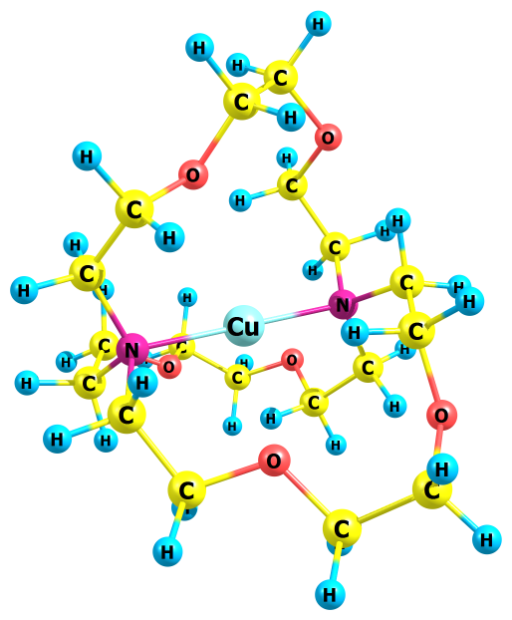
1 0.907653000 4.759333000 0.870759000
6 0.804618000 3.887281000 0.207843000
1 1.799899000 3.578623000 -0.138566000
8 0.179764000 2.782456000 0.942024000
6 -0.093460000 4.223006000 -0.969383000
6 0.814654000 2.436788000 2.203141000
1 0.349256000 5.037564000 -1.550234000
1 -1.086786000 4.535679000 -0.622705000
8 -0.207299000 3.090889000 -1.879271000
1 0.878444000 3.328512000 2.843353000
1 1.834959000 2.069915000 2.025167000
6 -0.076306000 1.409321000 2.879110000
6 -1.341663000 2.192981000 -1.631425000
1 -1.107207000 1.755116000 2.781006000
1 0.160643000 1.359076000 3.953295000
7 0.004089000 -0.000536000 2.316875000
1 -2.253902000 2.663107000 -2.026680000
1 -1.455135000 2.038667000 -0.553244000
6 -1.124875000 0.877161000 -2.350222000
6 -1.175374000 -0.776066000 2.880485000
6 1.266571000 -0.635035000 2.877065000
1 -2.040275000 0.286720000 -2.284037000
1 -0.916303000 1.062711000 -3.413481000
7 -0.003567000 -0.000120000 -1.797049000
1 -1.247648000 -0.547961000 3.955328000
1 -0.959731000 -1.841579000 2.779683000
6 -2.512384000 -0.516667000 2.208564000
1 1.106899000 -0.813862000 3.951798000
1 2.081249000 0.084824000 2.776390000
6 1.709872000 -1.921059000 2.201776000
6 1.315207000 0.532304000 -2.353987000
6 -0.203626000 -1.408732000 -2.352571000
1 -2.705970000 0.550790000 2.034491000
1 -3.314692000 -0.909918000 2.849458000
8 -2.496817000 -1.235234000 0.945060000
1 0.882116000 -2.622122000 2.026646000
1 2.452054000 -2.420834000 2.840920000
8 2.323540000 -1.545053000 0.938871000
1 1.369025000 0.258192000 -3.417173000
1 1.261379000 1.620332000 -2.288280000
6 2.564783000 0.063340000 -1.637590000
1 0.765625000 -1.906306000 -2.289500000
1 -0.471025000 -1.318813000 -3.415056000
6 -1.232914000 -2.255839000 -1.632829000
6 -3.768508000 -1.246867000 0.214744000
6 2.966296000 -2.639254000 0.203936000
1 3.426934000 0.618444000 -2.035018000
1 2.489759000 0.239216000 -0.559332000
8 2.775406000 -1.368035000 -1.884742000
1 -1.184812000 -3.280184000 -2.030097000
1 -1.039774000 -2.278727000 -0.555196000
8 -2.578363000 -1.722230000 -1.876280000
1 -4.000862000 -0.230388000 -0.129648000
1 -4.572776000 -1.595308000 0.879796000
6 -3.613133000 -2.190981000 -0.964101000
1 3.672446000 -3.163204000 0.865273000
1 2.200676000 -3.347772000 -0.139155000
6 3.701957000 -2.030758000 -0.976555000
1 -3.386064000 -3.207908000 -0.619296000
1 -4.541481000 -2.214400000 -1.542517000
1 4.184696000 -2.822045000 -1.557694000
1 4.470060000 -1.325870000 -0.633376000
29 0.000237000 -0.000790000 0.248098000

Fig. 2e. Protonated complex of copper(II) with cryptand[2.2.2]
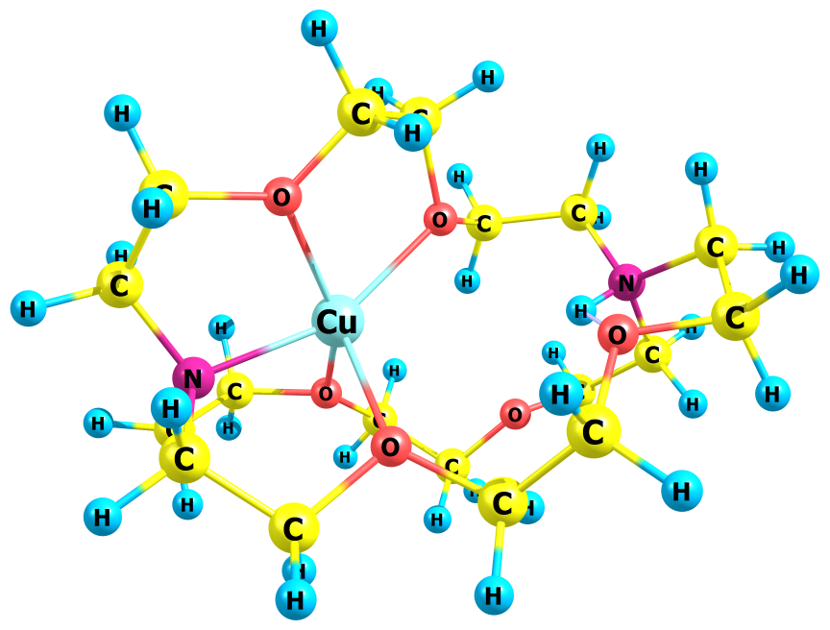
1 0.890542000 4.034216000 -0.561277000
6 0.290606000 3.125079000 -0.673424000
1 -0.140927000 3.111246000 -1.678876000
8 1.227440000 1.967257000 -0.549748000
6 -0.756830000 3.084357000 0.422284000
6 2.648439000 2.207650000 -0.952515000
1 -1.291146000 4.042356000 0.439163000
1 -0.287623000 2.938373000 1.398486000
8 -1.707889000 1.976417000 0.250032000
1 2.844202000 3.282934000 -0.970075000
1 2.787313000 1.806296000 -1.961456000
6 3.499494000 1.521139000 0.102810000
6 -3.038233000 2.327938000 -0.267260000
1 3.387172000 2.040803000 1.056118000
1 4.561267000 1.552976000 -0.172400000
7 3.061491000 0.082987000 0.294240000
1 -2.975593000 2.598107000 -1.329050000
1 -3.449970000 3.185152000 0.277722000
6 -3.932260000 1.118136000 -0.024854000
6 3.132358000 -0.339125000 1.745560000
6 3.845456000 -0.865354000 -0.595898000
1 -4.139153000 1.014644000 1.042035000
1 -4.881509000 1.215171000 -0.559840000
7 -3.268043000 -0.184467000 -0.465223000
1 4.080529000 0.009098000 2.176823000
1 3.129421000 -1.429410000 1.784709000
6 1.962885000 0.189288000 2.553215000
1 4.852666000 -1.011301000 -0.184004000
1 3.945142000 -0.393165000 -1.576762000
6 3.118867000 -2.197013000 -0.734204000
6 -2.980113000 -0.258096000 -1.960035000
6 -4.021739000 -1.409540000 0.080044000
1 1.936665000 1.283418000 2.609371000
1 2.020642000 -0.212253000 3.569961000
8 0.720803000 -0.290992000 1.904560000
1 3.134865000 -2.813884000 0.168585000
1 3.508986000 -2.774896000 -1.577259000
8 1.722100000 -1.804477000 -1.024326000
1 -3.192949000 -1.275563000 -2.292891000
1 -3.670258000 0.404471000 -2.491305000
6 -1.537216000 0.135971000 -2.274658000
1 -3.771827000 -2.253471000 -0.563895000
1 -5.098506000 -1.231635000 0.030437000
6 -3.532522000 -1.673310000 1.506516000
6 -0.482219000 -0.188271000 2.782889000
6 0.686777000 -2.792797000 -1.370641000
1 -1.353864000 0.044464000 -3.350710000
1 -1.311757000 1.147085000 -1.951413000
8 -0.566955000 -0.719340000 -1.542269000
1 -3.976451000 -0.991908000 2.242369000
1 -3.763669000 -2.703562000 1.795712000
8 -2.081296000 -1.452143000 1.434306000
1 -1.045338000 0.697309000 2.475744000
1 -0.132292000 -0.059889000 3.812589000
6 -1.338822000 -1.434487000 2.704594000
1 1.136271000 -3.618539000 -1.931071000
1 0.236857000 -3.165784000 -0.446203000
6 -0.285262000 -2.019946000 -2.235223000
1 -0.737307000 -2.346090000 2.762646000
1 -2.045878000 -1.428187000 3.543473000
1 -1.219869000 -2.572873000 -2.361362000
1 0.145807000 -1.783088000 -3.212745000
1 -2.358217000 -0.247944000 0.042741000
29 1.086207000 -0.068545000 -0.327409000

Fig. 2f. Mononuclear complex of copper(II) with cryptand[2.2.2] (alternative)
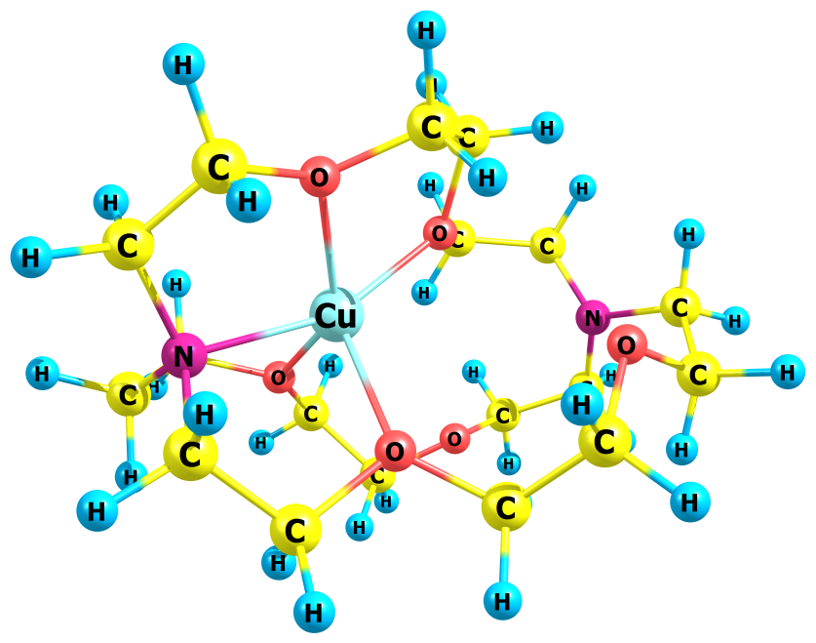
1 0.920755000 4.121206000 -0.217717000
6 0.284370000 3.240962000 -0.361517000
1 -0.244110000 3.339372000 -1.314845000
8 1.178617000 2.052916000 -0.445627000
6 -0.658832000 3.096093000 0.821154000
6 2.571548000 2.268436000 -0.905992000
1 -1.183593000 4.049312000 0.975440000
1 -0.091354000 2.870170000 1.728157000
8 -1.611691000 2.004030000 0.656370000
1 2.801801000 3.337767000 -0.903571000
1 2.654111000 1.893130000 -1.931672000
6 3.461162000 1.524332000 0.080554000
6 -2.913327000 2.394105000 0.090192000
1 3.391771000 2.010486000 1.056383000
1 4.511553000 1.560330000 -0.236697000
7 3.013912000 0.089619000 0.241663000
1 -2.778688000 2.758152000 -0.937838000
1 -3.335923000 3.214919000 0.684118000
6 -3.871419000 1.206753000 0.144853000
6 3.122907000 -0.364342000 1.677670000
6 3.761371000 -0.842132000 -0.688216000
1 -4.066083000 0.967273000 1.193575000
1 -4.831501000 1.549794000 -0.288320000
7 -3.398619000 -0.012430000 -0.519352000
1 4.042852000 0.034841000 2.125504000
1 3.194182000 -1.453373000 1.687943000
6 1.905735000 0.051470000 2.485774000
1 4.768676000 -1.039399000 -0.297060000
1 3.864365000 -0.336850000 -1.652441000
6 2.994495000 -2.145515000 -0.886152000
6 -3.014682000 0.064440000 -1.917263000
6 -3.912859000 -1.285269000 0.006241000
1 1.803981000 1.139913000 2.573649000
1 1.967329000 -0.378096000 3.491230000
8 0.735124000 -0.493634000 1.783226000
1 2.924282000 -2.756350000 0.020147000
1 3.433512000 -2.741807000 -1.692035000
8 1.649763000 -1.708787000 -1.284177000
1 -3.259172000 -0.880513000 -2.413675000
1 -3.593505000 0.839636000 -2.451041000
6 -1.532599000 0.407921000 -2.148590000
1 -3.740409000 -2.068373000 -0.737302000
1 -5.004802000 -1.231004000 0.162708000
6 -3.281602000 -1.715382000 1.323683000
6 -0.493503000 -0.676039000 2.610685000
6 0.542927000 -2.672423000 -1.441452000
1 -1.304073000 0.430940000 -3.222684000
1 -1.280227000 1.360377000 -1.695480000
8 -0.610353000 -0.545198000 -1.499518000
1 -3.345331000 -0.907418000 2.063919000
1 -3.814144000 -2.589925000 1.720451000
8 -1.872393000 -2.075672000 1.110719000
1 -1.182287000 0.130957000 2.345363000
1 -0.198097000 -0.587004000 3.661863000
6 -1.090659000 -2.048665000 2.343228000
1 0.872447000 -3.518741000 -2.051763000
1 0.223970000 -3.009868000 -0.451163000
6 -0.538296000 -1.875983000 -2.146328000
1 -0.298808000 -2.793766000 2.228366000
1 -1.717213000 -2.350824000 3.193765000
1 -1.502396000 -2.378714000 -2.044068000
1 -0.297380000 -1.719828000 -3.203503000
29 0.986672000 -0.036167000 -0.356033000

Fig. 2g. Bis-nuclear complex of copper(II) with cryptand[2.2.2]
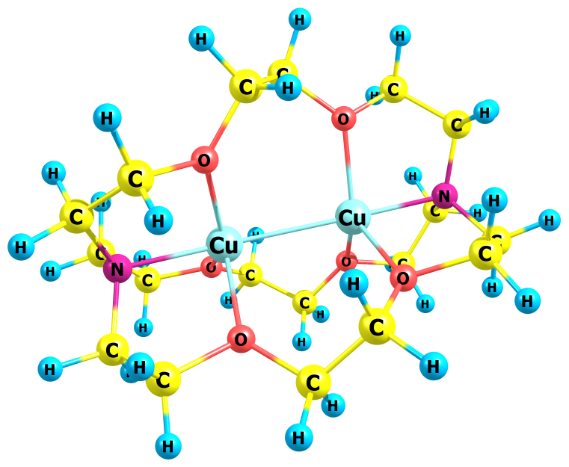
1 -0.966119000 -1.599787000 3.704758000
6 -0.451127000 -1.364659000 2.766436000
1 -0.073740000 -2.293534000 2.327927000
8 -1.466486000 -0.777327000 1.840515000
6 0.646385000 -0.368851000 3.052920000
6 -2.856828000 -1.305950000 2.020981000
1 1.223356000 -0.726424000 3.912658000
1 0.248710000 0.623061000 3.283777000
8 1.582968000 -0.222028000 1.897970000
1 -3.064125000 -1.401584000 3.091130000
1 -2.915975000 -2.294827000 1.556582000
6 -3.791411000 -0.277373000 1.405373000
6 3.036061000 -0.325116000 2.245033000
1 -3.749142000 0.653547000 1.972691000
1 -4.828978000 -0.644369000 1.440362000
7 -3.430139000 0.022331000 -0.032242000
1 3.297791000 -1.383902000 2.326642000
1 3.211554000 0.156644000 3.211688000
6 3.812688000 0.419358000 1.169899000
6 -3.818462000 1.412122000 -0.484111000
6 -3.861569000 -1.061560000 -0.995889000
1 3.651834000 1.492731000 1.275511000
1 4.890736000 0.231656000 1.291041000
7 3.406957000 0.020281000 -0.229958000
1 -4.873109000 1.594331000 -0.223803000
1 -3.735375000 1.450671000 -1.572752000
6 -2.937937000 2.470231000 0.153483000
1 -4.882426000 -0.844479000 -1.346102000
1 -3.891337000 -2.009330000 -0.455265000
6 -2.914051000 -1.158682000 -2.177472000
6 3.810515000 -1.379122000 -0.646504000
6 3.732467000 1.055117000 -1.283191000
1 -3.071105000 2.577197000 1.233246000
1 -3.092727000 3.439097000 -0.330327000
8 -1.514165000 2.039395000 -0.097861000
1 -2.915389000 -0.282780000 -2.832615000
1 -3.126193000 -2.053831000 -2.769113000
8 -1.535911000 -1.295666000 -1.578022000
1 4.068719000 -1.350168000 -1.707126000
1 4.705306000 -1.684940000 -0.088777000
6 2.690556000 -2.392856000 -0.417093000
1 3.493688000 0.616555000 -2.255265000
1 4.814552000 1.266157000 -1.271741000
6 2.956186000 2.340624000 -1.073772000
6 -0.478979000 3.079385000 0.182434000
6 -0.504598000 -1.919789000 -2.460614000
1 2.889277000 -3.317457000 -0.966590000
1 2.515199000 -2.629123000 0.633748000
8 1.441293000 -1.762469000 -0.958342000
1 3.297594000 2.949353000 -0.232911000
1 2.971032000 2.942162000 -1.987419000
8 1.519471000 1.952239000 -0.785513000
1 -0.051742000 2.884360000 1.170416000
1 -0.988900000 4.049041000 0.206883000
6 0.557044000 3.096427000 -0.911559000
1 -1.028683000 -2.615413000 -3.126021000
1 -0.034247000 -1.138941000 -3.066005000
6 0.480711000 -2.694423000 -1.629171000
1 0.115874000 3.043845000 -1.910230000
1 1.146365000 4.015896000 -0.821121000
1 1.079012000 -3.336037000 -2.286837000
1 -0.006895000 -3.305701000 -0.864589000
29 -1.361114000 0.040572000 -0.089377000
29 1.325755000 0.076862000 -0.212076000

Fig. 2h. Bis-nuclear complex of copper(II) with cryptand[2.2.2] (alternative)
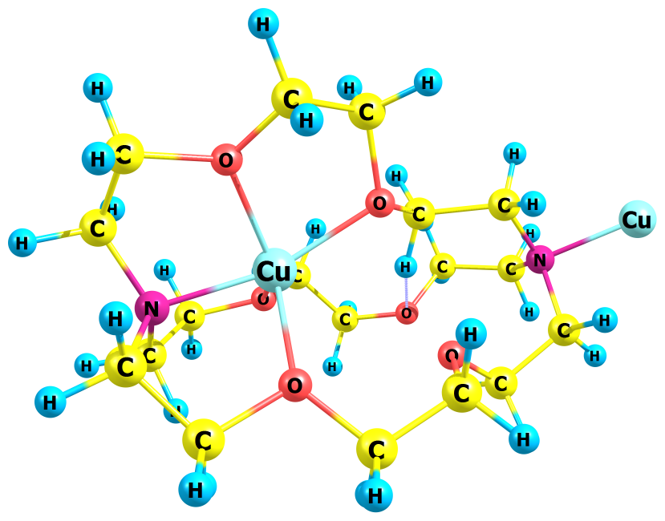
1 1.096372000 3.864730000 -0.902222000
6 0.532846000 2.975672000 -0.602441000
1 0.110841000 2.529443000 -1.505544000
8 1.528981000 1.985162000 -0.050467000
6 -0.545995000 3.358199000 0.414791000
6 2.895751000 2.586726000 0.075828000
1 -0.974455000 4.326003000 0.117756000
1 -0.134638000 3.455083000 1.421257000
8 -1.617192000 2.360601000 0.521931000
1 2.822935000 3.507123000 0.663942000
1 3.255897000 2.837815000 -0.926300000
6 3.760984000 1.583996000 0.805643000
6 -2.714727000 2.467877000 -0.444783000
1 3.422789000 1.474202000 1.836441000
1 4.805563000 1.933305000 0.831351000
7 3.728869000 0.216913000 0.155783000
1 -2.343752000 2.325325000 -1.467585000
1 -3.154223000 3.472514000 -0.390856000
6 -3.830920000 1.470846000 -0.105845000
6 4.225318000 -0.879669000 1.079872000
6 4.426905000 0.174272000 -1.203607000
1 -4.279192000 1.738310000 0.854238000
1 -4.591878000 1.625821000 -0.882006000
7 -3.534939000 -0.044599000 -0.021350000
1 5.235147000 -0.608410000 1.425581000
1 4.309618000 -1.800123000 0.500921000
6 3.294322000 -1.080748000 2.252820000
1 5.514129000 0.178318000 -1.036092000
1 4.166390000 1.083090000 -1.747832000
6 3.991573000 -1.051011000 -1.986795000
6 -2.548573000 -0.644047000 -1.009628000
6 -3.404459000 -0.563463000 1.405138000
1 3.293905000 -0.256310000 2.971881000
1 3.556207000 -2.001621000 2.785419000
8 1.926156000 -1.224696000 1.683059000
1 4.350169000 -2.004486000 -1.590408000
1 4.261317000 -0.971609000 -3.044781000
8 2.500228000 -1.007165000 -1.876661000
1 -2.424653000 -1.693847000 -0.733755000
1 -3.008288000 -0.595060000 -2.003675000
6 -1.136410000 0.040702000 -1.100690000
1 -3.460317000 -1.656647000 1.357915000
1 -4.271151000 -0.196798000 1.967647000
6 -2.139865000 -0.156717000 2.191403000
6 0.957210000 -1.657421000 2.753554000
6 1.667647000 -2.125745000 -2.396042000
1 -1.062645000 0.617688000 -2.027315000
1 -0.991297000 0.673409000 -0.227311000
8 0.009413000 -0.891308000 -1.099019000
1 -2.000583000 0.924731000 2.172684000
1 -2.258224000 -0.500870000 3.226015000
8 -0.954959000 -0.736737000 1.575355000
1 0.894224000 -0.850164000 3.489977000
1 1.386779000 -2.551820000 3.219144000
6 -0.384391000 -1.964545000 2.144092000
1 2.019800000 -2.398299000 -3.397707000
1 1.763798000 -2.981551000 -1.721263000
6 0.279328000 -1.537570000 -2.446582000
1 -0.296898000 -2.689082000 1.329302000
1 -1.038910000 -2.380315000 2.920188000
1 -0.480718000 -2.308782000 -2.602343000
1 0.200111000 -0.757124000 -3.208862000
29 1.770881000 -0.200736000 -0.222482000
29 -5.362328000 -0.848960000 -0.522716000

