Supplementary materials 1
COMPARATIVE SPECIES-SPECIFIC CHARACTERISTICS OF LIPIDS AND THEIR DYNAMICS DURING EMBRYOGENESIS AND EARLY POSTEMBRIONAL DEVELOPMENT OF ATLANTIC SALMON (SALMO SALAR L.) AND BROWN TROUT (SALMO TRUTTA L.)
Viktor P. Voronin, Svetlana A. Murzina, Svetlana N. Pekkoeva, Zinaida A. Nefedova,
Tatjana R. Ruokolainen, Michail A. Ruchiev, Nina N. Nemova

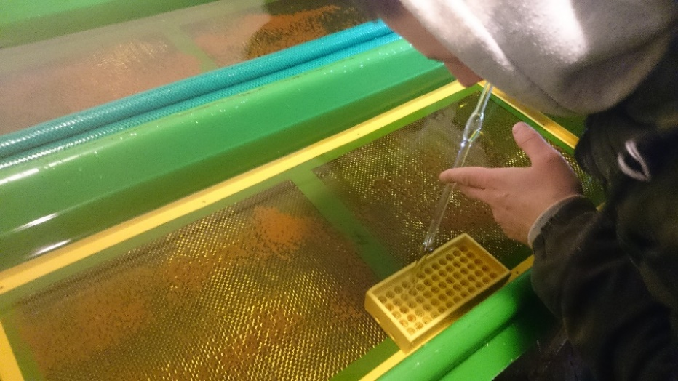
а)
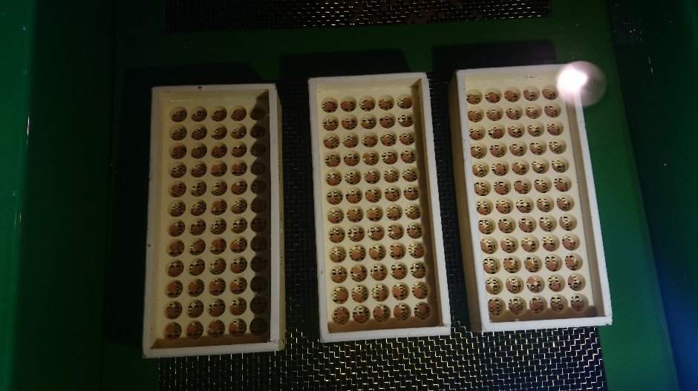
b)
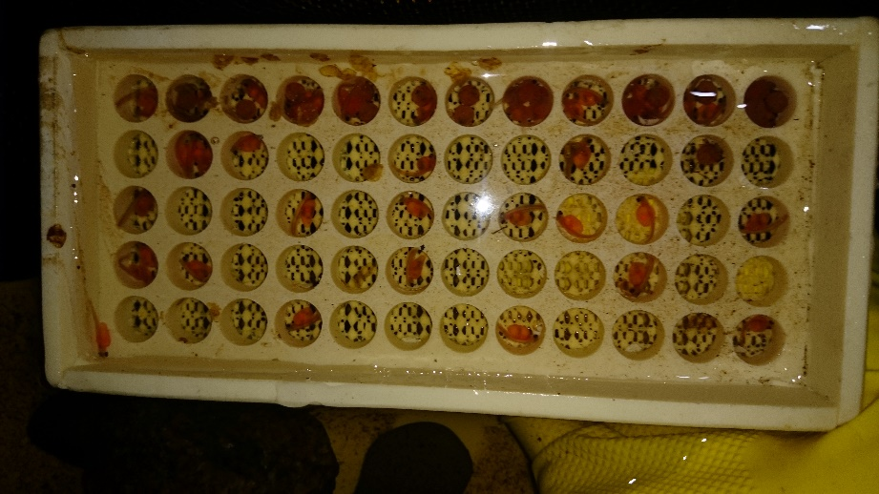
c)

Incubation of Atlantic salmon (Salmo salar L.) and brown trout (Salmo trutta L.) eggs at the fish farm in Suistamo (Republic of Karelia). Authors: Efremov D.A., Ruch'ev M.A. a) Transfer of fertilized eggs to incubation trays; b) Embryonic development of Atlantic salmon (Salmo salar L.) and brown trout (Salmo trutta L.) under factory conditions; c) Avelin

–––––––––––––––––––––––––––––––––––––––––––––––––––––––––––––––––––––––––––––
Correlation tables and correlograms of total lipids and lipid classes for Atlantic salmon (Salmo salar L.) and Brown trout (Salmo trutta L.) at different stages of embryonic and early postembryonic development

Graph Explanations: TL – total lipids, PL – phospholipids, DAG – diacylglycerol, Chol – cholesterol, FFA – free fatty acids, TAG – triacylglycerols, Sterol esters – sterol esters.
The lower left corner of the graph describes the correlations between the lipid components - the fill color (blue and red) and the direction of filling the “circle” (clockwise and counterclockwise) determine the direction of correlation (positive correlation and negative correlation, respectively). Color saturation indicates the degree of correlation (according to Pearson).
The upper right corner describes the distribution of lipid components (red line) and their confidence interval (ellipse).
Below the graph is a table of the correlation matrix with numerical values.

Correlation tables and correlograms for Atlantic salmon (Salmo salar L.):
1. General correlation for all stages of development

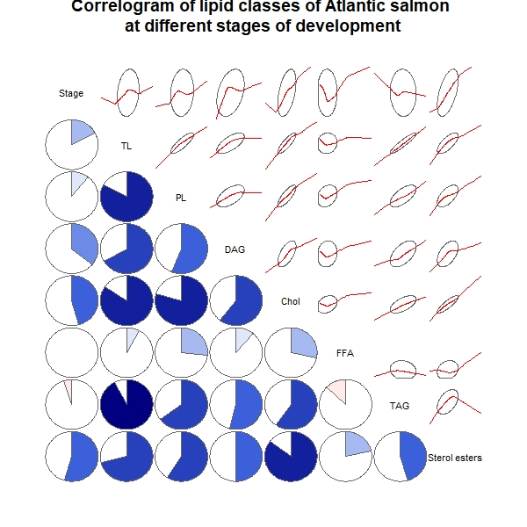
 | Stage | TL | PL | DAG | Chol | FFA | TAG | Sterol esters
Stage | 1 | 0.1696 | 0.107 | 0.3591 | 0.4611 | -0.0009626 | -0.04809 | 0.5456
TL | 0.1696 | 1 | 0.83 | 0.6642 | 0.8418 | 0.07791 | 0.9232 | 0.7116
PL | 0.107 | 0.83 | 1 | 0.5596 | 0.7943 | 0.27 | 0.6453 | 0.5886
DAG | 0.3591 | 0.6642 | 0.5596 | 1 | 0.6027 | 0.1133 | 0.5402 | 0.5024
Chol | 0.4611 | 0.8418 | 0.7943 | 0.6027 | 1 | 0.2846 | 0.5956 | 0.8531
FFA | -0.0009626 | 0.07791 | 0.27 | 0.1133 | 0.2846 | 1 | -0.1286 | 0.2161
TAG | -0.04809 | 0.9232 | 0.6453 | 0.5402 | 0.5956 | -0.1286 | 1 | 0.4553
Sterol esters | 0.5456 | 0.7116 | 0.5886 | 0.5024 | 0.8531 | 0.2161 | 0.4553 | 1

2. Correlation matrix for unfertilized eggs

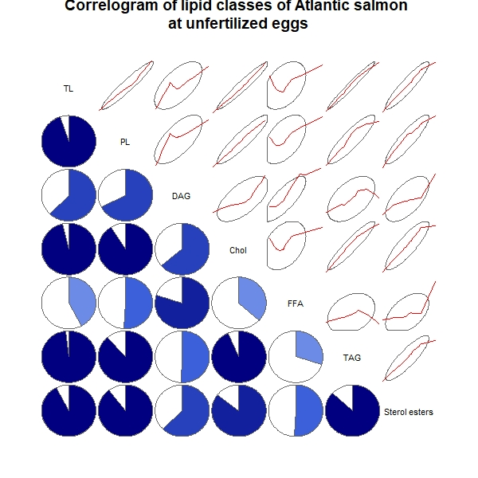
 | TL | PL | DAG | Chol | FFA | TAG | Sterol esters
TL | 1 | 0.9495 | 0.6211 | 0.9636 | 0.4235 | 0.981 | 0.9228
PL | 0.9495 | 1 | 0.6757 | 0.9118 | 0.511 | 0.8831 | 0.8951
DAG | 0.6211 | 0.6757 | 1 | 0.6385 | 0.7977 | 0.5057 | 0.6226
Chol | 0.9636 | 0.9118 | 0.6385 | 1 | 0.3688 | 0.9357 | 0.8539
FFA | 0.4235 | 0.511 | 0.7977 | 0.3688 | 1 | 0.2999 | 0.5059
TAG | 0.981 | 0.8831 | 0.5057 | 0.9357 | 0.2999 | 1 | 0.8695
Sterol esters | 0.9228 | 0.8951 | 0.6226 | 0.8539 | 0.5059 | 0.8695 | 1

3. Correlation matrix for fertilized eggs

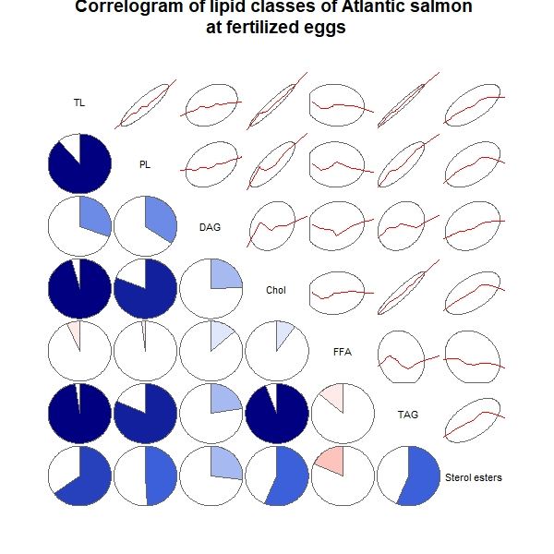
 | TL | PL | DAG | Chol | FFA | TAG | Sterol esters
TL | 1 | 0.8868 | 0.3092 | 0.9589 | -0.06441 | 0.9798 | 0.6491
PL | 0.8868 | 1 | 0.3468 | 0.8086 | -0.01978 | 0.8157 | 0.4928
DAG | 0.3092 | 0.3468 | 1 | 0.2463 | 0.1352 | 0.2238 | 0.2681
Chol | 0.9589 | 0.8086 | 0.2463 | 1 | 0.09742 | 0.9422 | 0.5628
FFA | -0.06441 | -0.01978 | 0.1352 | 0.09742 | 1 | -0.1346 | -0.1822
TAG | 0.9798 | 0.8157 | 0.2238 | 0.9422 | -0.1346 | 1 | 0.5632
Sterol esters | 0.6491 | 0.4928 | 0.2681 | 0.5628 | -0.1822 | 0.5632 | 1

4. Correlation matrix for blastula

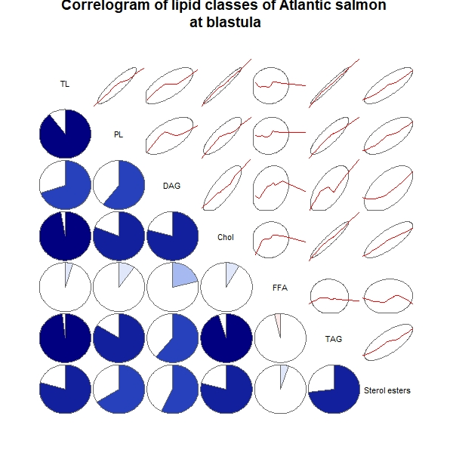
 | TL | PL | DAG | Chol | FFA | TAG | Sterol esters
TL | 1 | 0.8984 | 0.6963 | 0.9718 | 0.04785 | 0.9828 | 0.7955
PL | 0.8984 | 1 | 0.6046 | 0.811 | 0.1008 | 0.8399 | 0.6601
DAG | 0.6963 | 0.6046 | 1 | 0.7893 | 0.2138 | 0.6155 | 0.5749
Chol | 0.9718 | 0.811 | 0.7893 | 1 | 0.08278 | 0.9505 | 0.7908
FFA | 0.04785 | 0.1008 | 0.2138 | 0.08278 | 1 | -0.0383 | 0.05411
TAG | 0.9828 | 0.8399 | 0.6155 | 0.9505 | -0.0383 | 1 | 0.7283
Sterol esters | 0.7955 | 0.6601 | 0.5749 | 0.7908 | 0.05411 | 0.7283 | 1

5. Correlation matrix for gastrula

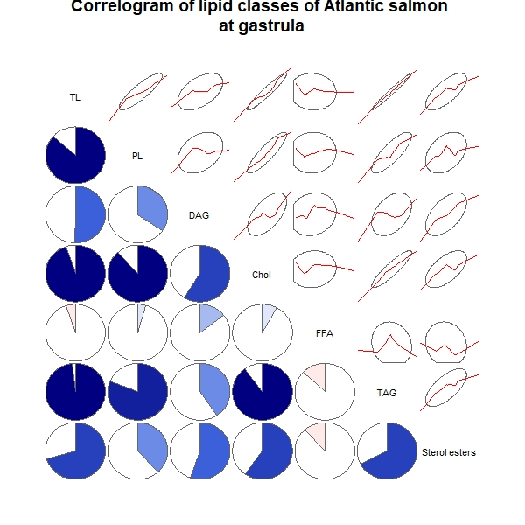
 | TL | PL | DAG | Chol | FFA | TAG | Sterol esters
TL | 1 | 0.8672 | 0.504 | 0.9494 | -0.0531 | 0.9834 | 0.7076
PL | 0.8672 | 1 | 0.3452 | 0.8809 | 0.04315 | 0.8109 | 0.3833
DAG | 0.504 | 0.3452 | 1 | 0.5893 | 0.1441 | 0.4073 | 0.5524
Chol | 0.9494 | 0.8809 | 0.5893 | 1 | 0.0796 | 0.8997 | 0.598
FFA | -0.0531 | 0.04315 | 0.1441 | 0.0796 | 1 | -0.126 | -0.1145
TAG | 0.9834 | 0.8109 | 0.4073 | 0.8997 | -0.126 | 1 | 0.6735
Sterol esters | 0.7076 | 0.3833 | 0.5524 | 0.598 | -0.1145 | 0.6735 | 1

6. Correlation matrix for organogenesis

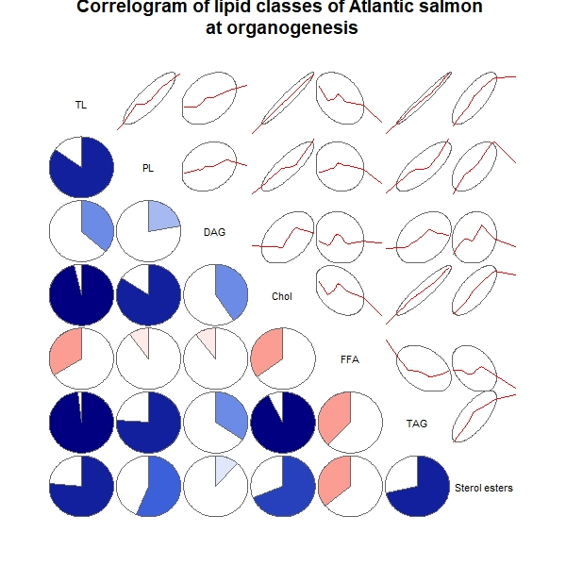
 | TL | PL | DAG | Chol | FFA | TAG | Sterol esters
TL | 1 | 0.8507 | 0.3657 | 0.962 | -0.3367 | 0.9816 | 0.7643
PL | 0.8507 | 1 | 0.2242 | 0.8425 | -0.1014 | 0.7627 | 0.5645
DAG | 0.3657 | 0.2242 | 1 | 0.4087 | -0.106 | 0.3444 | 0.1151
Chol | 0.962 | 0.8425 | 0.4087 | 1 | -0.3517 | 0.9245 | 0.6916
FFA | -0.3367 | -0.1014 | -0.106 | -0.3517 | 1 | -0.3763 | -0.3603
TAG | 0.9816 | 0.7627 | 0.3444 | 0.9245 | -0.3763 | 1 | 0.7156
Sterol esters | 0.7643 | 0.5645 | 0.1151 | 0.6916 | -0.3603 | 0.7156 | 1

7. Correlation matrix for eye pigmentation

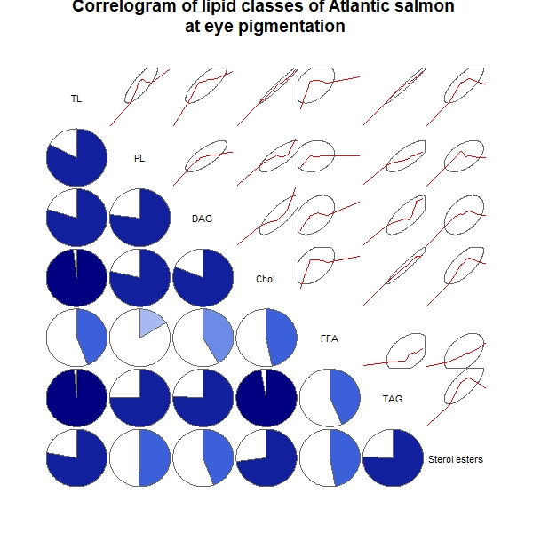
 | TL | PL | DAG | Chol | FFA | TAG | Sterol esters
TL | 1 | 0.8269 | 0.7977 | 0.981 | 0.4411 | 0.9871 | 0.7819
PL | 0.8269 | 1 | 0.7674 | 0.7841 | 0.1613 | 0.7518 | 0.5043
DAG | 0.7977 | 0.7674 | 1 | 0.8125 | 0.4197 | 0.7561 | 0.4458
Chol | 0.981 | 0.7841 | 0.8125 | 1 | 0.4684 | 0.9713 | 0.7281
FFA | 0.4411 | 0.1613 | 0.4197 | 0.4684 | 1 | 0.4383 | 0.4686
TAG | 0.9871 | 0.7518 | 0.7561 | 0.9713 | 0.4383 | 1 | 0.7539
Sterol esters | 0.7819 | 0.5043 | 0.4458 | 0.7281 | 0.4686 | 0.7539 | 1

8. Correlation matrix for pre-hatching embryo

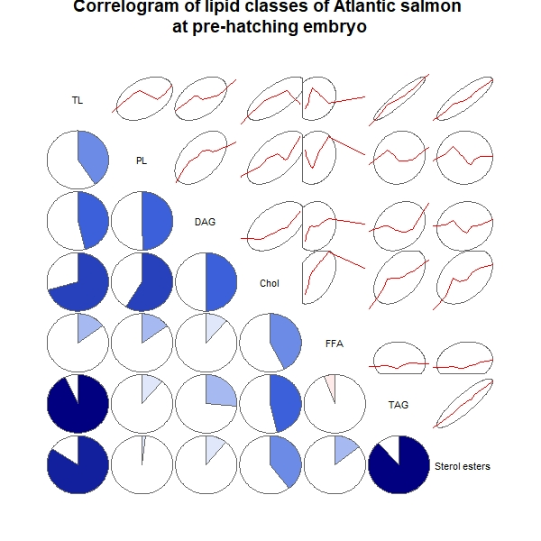
 | TL | PL | DAG | Chol | FFA | TAG | Sterol esters
TL | 1 | 0.4038 | 0.4633 | 0.7079 | 0.1488 | 0.9323 | 0.8428
PL | 0.4038 | 1 | 0.4969 | 0.5902 | 0.1534 | 0.1137 | 0.01861
DAG | 0.4633 | 0.4969 | 1 | 0.5004 | 0.1142 | 0.2636 | 0.1092
Chol | 0.7079 | 0.5902 | 0.5004 | 1 | 0.4252 | 0.463 | 0.3991
FFA | 0.1488 | 0.1534 | 0.1142 | 0.4252 | 1 | -0.0571 | 0.1451
TAG | 0.9323 | 0.1137 | 0.2636 | 0.463 | -0.0571 | 1 | 0.8838
Sterol esters | 0.8428 | 0.01861 | 0.1092 | 0.3991 | 0.1451 | 0.8838 | 1

9. Correlation matrix for alevin

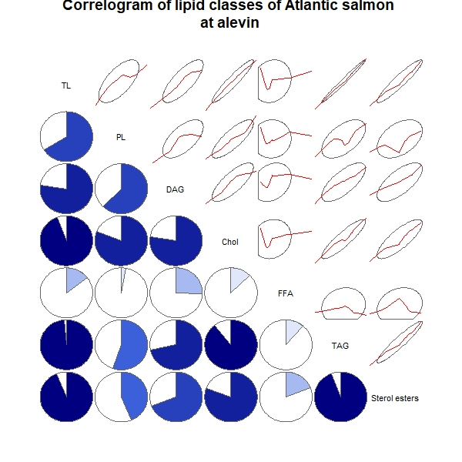
 | TL | PL | DAG | Chol | FFA | TAG | Sterol esters
TL | 1 | 0.661 | 0.7713 | 0.9418 | 0.1434 | 0.9878 | 0.9367
PL | 0.661 | 1 | 0.6237 | 0.809 | 0.03005 | 0.5547 | 0.4371
DAG | 0.7713 | 0.6237 | 1 | 0.776 | 0.2574 | 0.7164 | 0.6905
Chol | 0.9418 | 0.809 | 0.776 | 1 | 0.1281 | 0.8897 | 0.8075
FFA | 0.1434 | 0.03005 | 0.2574 | 0.1281 | 1 | 0.1149 | 0.1915
TAG | 0.9878 | 0.5547 | 0.7164 | 0.8897 | 0.1149 | 1 | 0.9431
Sterol esters | 0.9367 | 0.4371 | 0.6905 | 0.8075 | 0.1915 | 0.9431 | 1

Correlation tables and correlograms for Brown trout (Salmo trutta L.):
1. General correlation for all stages of development

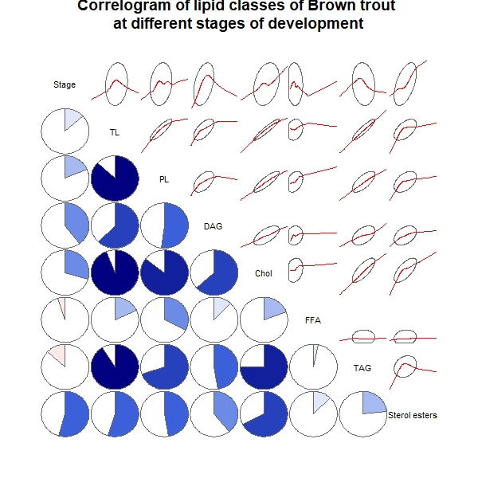
 | Stage | TL | PL | DAG | Chol | FFA | TAG | Sterol esters
Stage | 1 | 0.1328 | 0.1825 | 0.3984 | 0.2961 | -0.05326 | -0.1308 | 0.5435
TL | 0.1328 | 1 | 0.8715 | 0.6209 | 0.9417 | 0.184 | 0.9116 | 0.5479
PL | 0.1825 | 0.8715 | 1 | 0.5232 | 0.856 | 0.3256 | 0.6972 | 0.4733
DAG | 0.3984 | 0.6209 | 0.5232 | 1 | 0.6343 | 0.1189 | 0.4733 | 0.3932
Chol | 0.2961 | 0.9417 | 0.856 | 0.6343 | 1 | 0.1933 | 0.7531 | 0.6758
FFA | -0.05326 | 0.184 | 0.3256 | 0.1189 | 0.1933 | 1 | 0.03361 | 0.1215
TAG | -0.1308 | 0.9116 | 0.6972 | 0.4733 | 0.7531 | 0.03361 | 1 | 0.2315
Sterol esters | 0.5435 | 0.5479 | 0.4733 | 0.3932 | 0.6758 | 0.1215 | 0.2315 | 1

2. Correlation matrix for unfertilized eggs

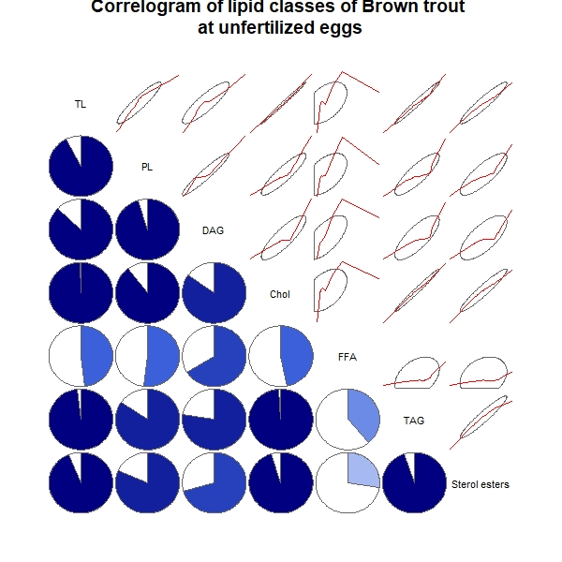
 | TL | PL | DAG | Chol | FFA | TAG | Sterol esters
TL | 1 | 0.9246 | 0.8698 | 0.9955 | 0.4815 | 0.9821 | 0.9414
PL | 0.9246 | 1 | 0.9515 | 0.8953 | 0.5205 | 0.8433 | 0.8132
DAG | 0.8698 | 0.9515 | 1 | 0.8478 | 0.6619 | 0.7743 | 0.7072
Chol | 0.9955 | 0.8953 | 0.8478 | 1 | 0.469 | 0.9865 | 0.9485
FFA | 0.4815 | 0.5205 | 0.6619 | 0.469 | 1 | 0.3853 | 0.2753
TAG | 0.9821 | 0.8433 | 0.7743 | 0.9865 | 0.3853 | 1 | 0.9504
Sterol esters | 0.9414 | 0.8132 | 0.7072 | 0.9485 | 0.2753 | 0.9504 | 1

3. Correlation matrix for fertilized eggs

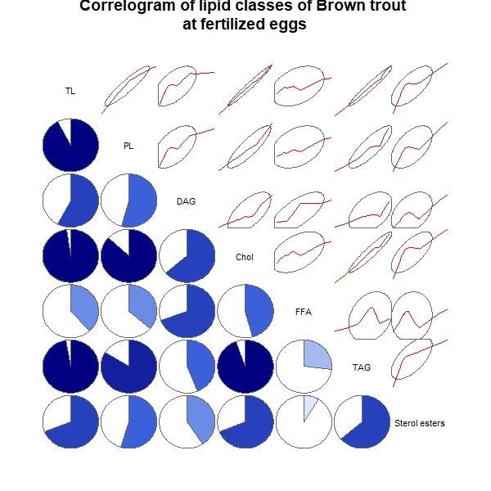
 | TL | PL | DAG | Chol | FFA | TAG | Sterol esters
TL | 1 | 0.9228 | 0.5789 | 0.9799 | 0.3833 | 0.9709 | 0.6911
PL | 0.9228 | 1 | 0.5438 | 0.867 | 0.3631 | 0.8387 | 0.5461
DAG | 0.5789 | 0.5438 | 1 | 0.6404 | 0.6949 | 0.4407 | 0.4084
Chol | 0.9799 | 0.867 | 0.6404 | 1 | 0.4623 | 0.9444 | 0.6923
FFA | 0.3833 | 0.3631 | 0.6949 | 0.4623 | 1 | 0.2669 | 0.08743
TAG | 0.9709 | 0.8387 | 0.4407 | 0.9444 | 0.2669 | 1 | 0.6405
Sterol esters | 0.6911 | 0.5461 | 0.4084 | 0.6923 | 0.08743 | 0.6405 | 1

4. Correlation matrix for blastula

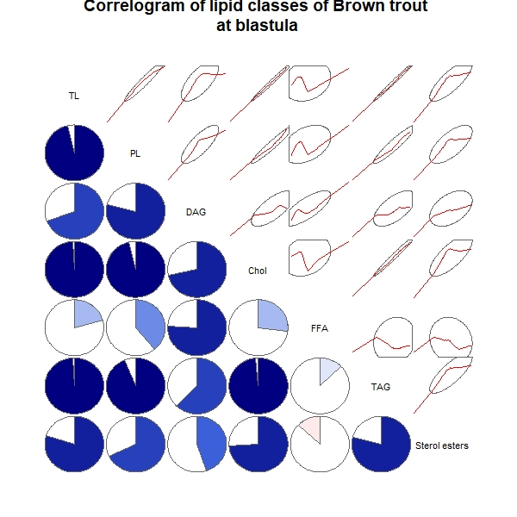
 | TL | PL | DAG | Chol | FFA | TAG | Sterol esters
TL | 1 | 0.9629 | 0.6913 | 0.9915 | 0.205 | 0.9938 | 0.8025
PL | 0.9629 | 1 | 0.7869 | 0.9639 | 0.3879 | 0.9382 | 0.6797
DAG | 0.6913 | 0.7869 | 1 | 0.7162 | 0.7578 | 0.6229 | 0.4473
Chol | 0.9915 | 0.9639 | 0.7162 | 1 | 0.2729 | 0.9851 | 0.7393
FFA | 0.205 | 0.3879 | 0.7578 | 0.2729 | 1 | 0.1285 | -0.1302
TAG | 0.9938 | 0.9382 | 0.6229 | 0.9851 | 0.1285 | 1 | 0.7887
Sterol esters | 0.8025 | 0.6797 | 0.4473 | 0.7393 | -0.1302 | 0.7887 | 1

5. Correlation matrix for gastrula

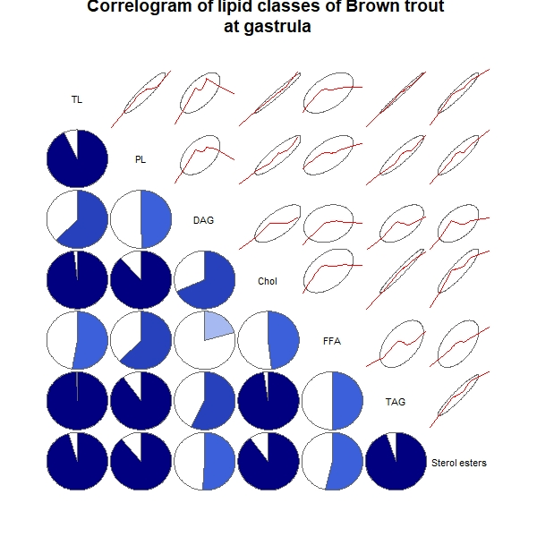
 | TL | PL | DAG | Chol | FFA | TAG | Sterol esters
TL | 1 | 0.9285 | 0.6237 | 0.9834 | 0.5277 | 0.994 | 0.953
PL | 0.9285 | 1 | 0.4933 | 0.8808 | 0.6212 | 0.9006 | 0.8864
DAG | 0.6237 | 0.4933 | 1 | 0.6865 | 0.2085 | 0.5715 | 0.5107
Chol | 0.9834 | 0.8808 | 0.6865 | 1 | 0.4838 | 0.9762 | 0.9004
FFA | 0.5277 | 0.6212 | 0.2085 | 0.4838 | 1 | 0.4969 | 0.5382
TAG | 0.994 | 0.9006 | 0.5715 | 0.9762 | 0.4969 | 1 | 0.9497
Sterol esters | 0.953 | 0.8864 | 0.5107 | 0.9004 | 0.5382 | 0.9497 | 1

6. Correlation matrix for organogenesis

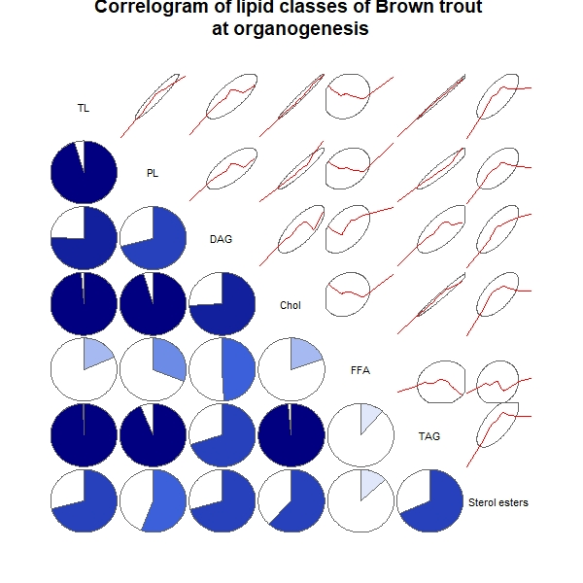
 | TL | PL | DAG | Chol | FFA | TAG | Sterol esters
TL | 1 | 0.9551 | 0.754 | 0.9874 | 0.1874 | 0.9948 | 0.7125
PL | 0.9551 | 1 | 0.7064 | 0.9523 | 0.3107 | 0.9385 | 0.5588
DAG | 0.754 | 0.7064 | 1 | 0.7411 | 0.4929 | 0.7011 | 0.7041
Chol | 0.9874 | 0.9523 | 0.7411 | 1 | 0.1937 | 0.9859 | 0.6186
FFA | 0.1874 | 0.3107 | 0.4929 | 0.1937 | 1 | 0.1109 | 0.1294
TAG | 0.9948 | 0.9385 | 0.7011 | 0.9859 | 0.1109 | 1 | 0.6833
Sterol esters | 0.7125 | 0.5588 | 0.7041 | 0.6186 | 0.1294 | 0.6833 | 1

7. Correlation matrix for eye pigmentation

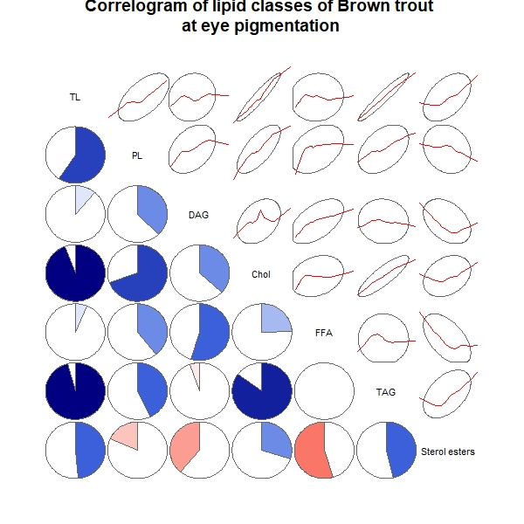
 | TL | PL | DAG | Chol | FFA | TAG | Sterol esters
TL | 1 | 0.5903 | 0.1113 | 0.9453 | 0.06324 | 0.958 | 0.4843
PL | 0.5903 | 1 | 0.3785 | 0.6968 | 0.3921 | 0.4296 | -0.1831
DAG | 0.1113 | 0.3785 | 1 | 0.3698 | 0.5493 | -0.05375 | -0.3865
Chol | 0.9453 | 0.6968 | 0.3698 | 1 | 0.2472 | 0.849 | 0.2974
FFA | 0.06324 | 0.3921 | 0.5493 | 0.2472 | 1 | -0.0004518 | -0.5507
TAG | 0.958 | 0.4296 | -0.05375 | 0.849 | -0.0004518 | 1 | 0.4637
Sterol esters | 0.4843 | -0.1831 | -0.3865 | 0.2974 | -0.5507 | 0.4637 | 1

8. Correlation matrix for pre-hatching embryo

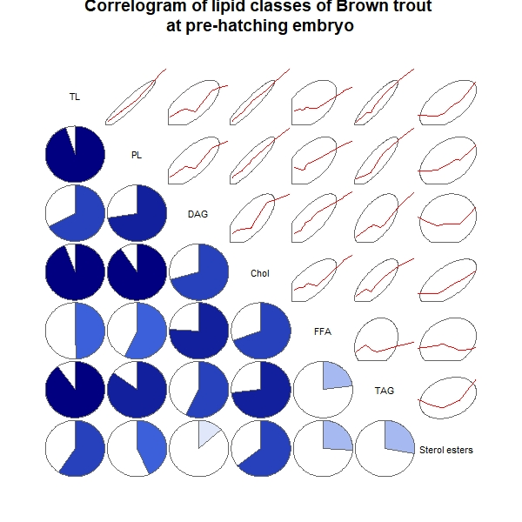
 | TL | PL | DAG | Chol | FFA | TAG | Sterol esters
TL | 1 | 0.9505 | 0.6725 | 0.9422 | 0.4956 | 0.902 | 0.5905
PL | 0.9505 | 1 | 0.7222 | 0.9049 | 0.5673 | 0.8513 | 0.4345
DAG | 0.6725 | 0.7222 | 1 | 0.7051 | 0.7578 | 0.5741 | 0.1331
Chol | 0.9422 | 0.9049 | 0.7051 | 1 | 0.6953 | 0.7342 | 0.6465
FFA | 0.4956 | 0.5673 | 0.7578 | 0.6953 | 1 | 0.2295 | 0.2587
TAG | 0.902 | 0.8513 | 0.5741 | 0.7342 | 0.2295 | 1 | 0.2812
Sterol esters | 0.5905 | 0.4345 | 0.1331 | 0.6465 | 0.2587 | 0.2812 | 1

9. Correlation matrix for alevin

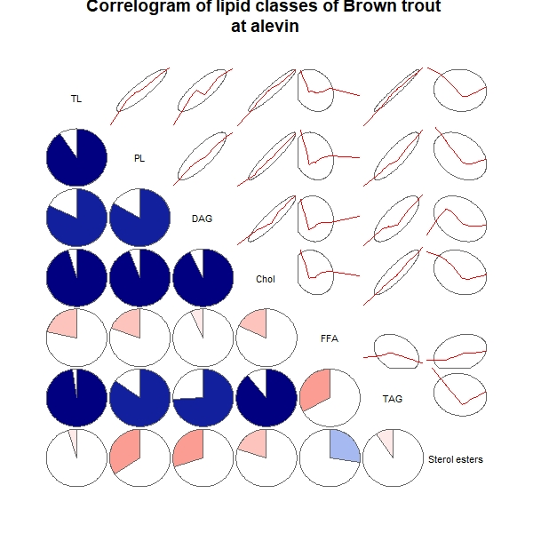
 | TL | PL | DAG | Chol | FFA | TAG | Sterol esters
TL | 1 | 0.9053 | 0.8181 | 0.9519 | -0.2182 | 0.9764 | -0.04615
PL | 0.9053 | 1 | 0.8335 | 0.9429 | -0.1947 | 0.85 | -0.346
DAG | 0.8181 | 0.8335 | 1 | 0.9274 | -0.06694 | 0.7433 | -0.2973
Chol | 0.9519 | 0.9429 | 0.9274 | 1 | -0.1814 | 0.8905 | -0.1999
FFA | -0.2182 | -0.1947 | -0.06694 | -0.1814 | 1 | -0.3324 | 0.2744
TAG | 0.9764 | 0.85 | 0.7433 | 0.8905 | -0.3324 | 1 | -0.09546
Sterol esters | -0.04615 | -0.346 | -0.2973 | -0.1999 | 0.2744 | -0.09546 | 1

Supplementary materials 2
–––––––––––––––––––––––––––––––––––––––––––––––––––––––––––––––––––––––––––––
Correlation tables and correlograms of phospholipid classes for Atlantic salmon (Salmo salar L.) and Brown trout (Salmo trutta L.) at different stages of embryonic and early postembryonic development

Graph Explanations: PI – phosphotidylinositol, PS – phosphatidylserine, PE – phosphatidylethanolamine, PC – phosphatidylcholine, LPC – lysophosphatidylcholine, SM – sphingomyelin.
The lower left corner of the graph describes the correlations between the lipid components - the fill color (blue and red) and the direction of filling the “circle” (clockwise and counterclockwise) determine the direction of correlation (positive correlation and negative correlation, respectively). Color saturation indicates the degree of correlation (according to Pearson).
The upper right corner describes the distribution of lipid components (red line) and their confidence interval (ellipse).
Below the graph is a table of the correlation matrix with numerical values.

Correlation tables and correlograms for Atlantic salmon (Salmo salar L.):
1. General correlation for all stages of development

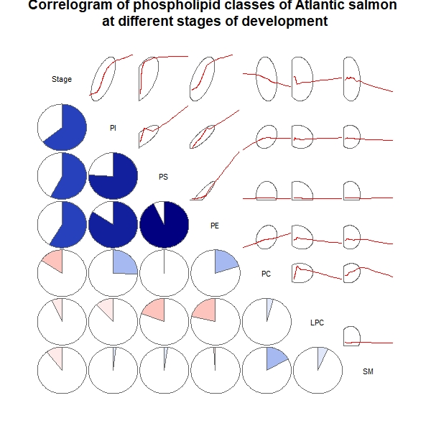
 | Stage | PI | PS | PE | PC | LPC | SM
Stage | 1 | 0.6436 | 0.575 | 0.5853 | -0.1567 | -0.06591 | -0.1061
PI | 0.6436 | 1 | 0.7596 | 0.8418 | 0.2569 | -0.1196 | 0.01977
PS | 0.575 | 0.7596 | 1 | 0.9287 | 0.007526 | -0.1946 | 0.02284
PE | 0.5853 | 0.8418 | 0.9287 | 1 | 0.2007 | -0.2157 | -0.01308
PC | -0.1567 | 0.2569 | 0.007526 | 0.2007 | 1 | 0.0459 | 0.1686
LPC | -0.06591 | -0.1196 | -0.1946 | -0.2157 | 0.0459 | 1 | 0.06767
SM | -0.1061 | 0.01977 | 0.02284 | -0.01308 | 0.1686 | 0.06767 | 1

2. Correlation matrix for unfertilized eggs

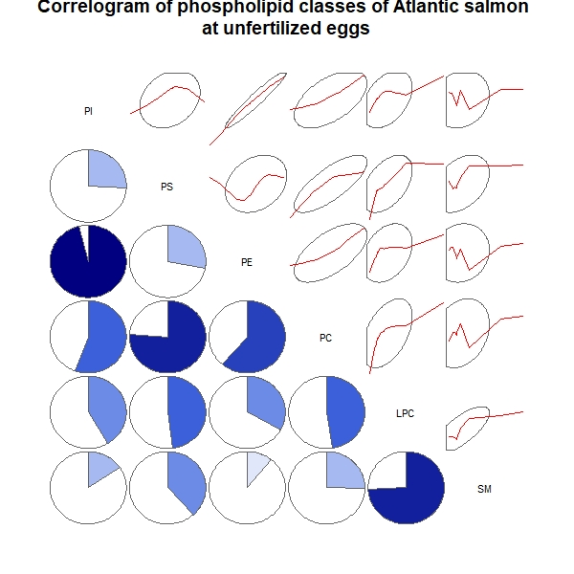
 | PI | PS | PE | PC | LPC | SM
PI | 1 | 0.2606 | 0.9614 | 0.5565 | 0.4173 | 0.1557
PS | 0.2606 | 1 | 0.2797 | 0.7623 | 0.4777 | 0.3835
PE | 0.9614 | 0.2797 | 1 | 0.6135 | 0.3329 | 0.1059
PC | 0.5565 | 0.7623 | 0.6135 | 1 | 0.4778 | 0.2524
LPC | 0.4173 | 0.4777 | 0.3329 | 0.4778 | 1 | 0.7429
SM | 0.1557 | 0.3835 | 0.1059 | 0.2524 | 0.7429 | 1

3. Correlation matrix for fertilized eggs

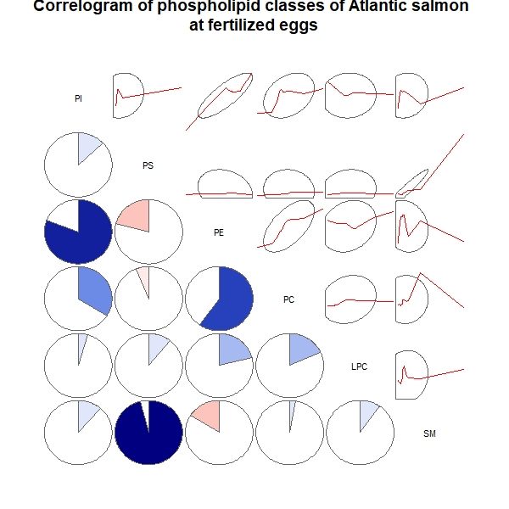
 | PI | PS | PE | PC | LPC | SM
PI | 1 | 0.1286 | 0.8079 | 0.3386 | 0.04592 | 0.1143
PS | 0.1286 | 1 | -0.2074 | -0.06258 | 0.1083 | 0.9611
PE | 0.8079 | -0.2074 | 1 | 0.5984 | 0.2114 | -0.1608
PC | 0.3386 | -0.06258 | 0.5984 | 1 | 0.1812 | 0.02832
LPC | 0.04592 | 0.1083 | 0.2114 | 0.1812 | 1 | 0.09753
SM | 0.1143 | 0.9611 | -0.1608 | 0.02832 | 0.09753 | 1

4. Correlation matrix for blastula

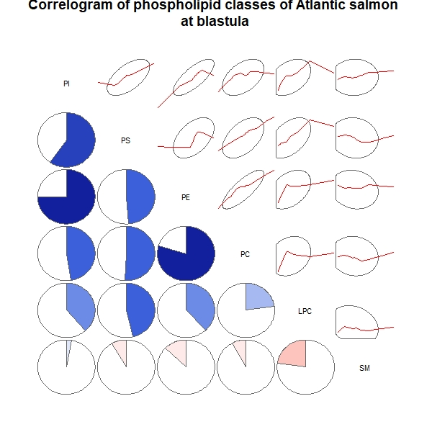
 | PI | PS | PE | PC | LPC | SM
PI | 1 | 0.5976 | 0.7497 | 0.4738 | 0.3866 | 0.03027
PS | 0.5976 | 1 | 0.4883 | 0.506 | 0.4614 | -0.08363
PE | 0.7497 | 0.4883 | 1 | 0.7965 | 0.3815 | -0.1292
PC | 0.4738 | 0.506 | 0.7965 | 1 | 0.2262 | -0.08036
LPC | 0.3866 | 0.4614 | 0.3815 | 0.2262 | 1 | -0.2266
SM | 0.03027 | -0.08363 | -0.1292 | -0.08036 | -0.2266 | 1

5. Correlation matrix for gastrula

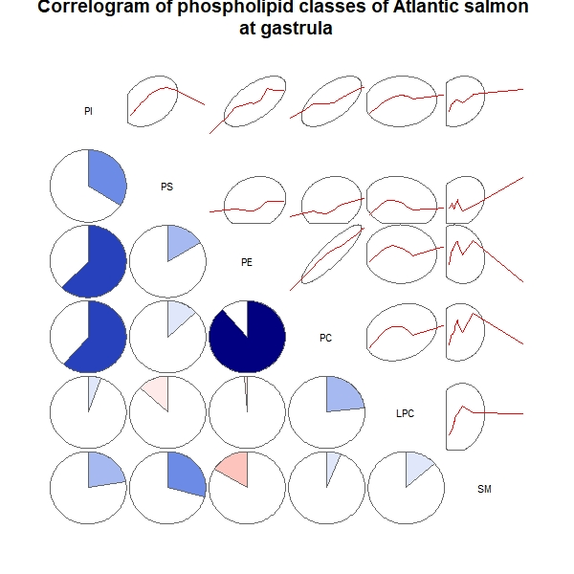
 | PI | PS | PE | PC | LPC | SM
PI | 1 | 0.3411 | 0.621 | 0.6139 | 0.05449 | 0.2247
PS | 0.3411 | 1 | 0.1645 | 0.131 | -0.1306 | 0.2907
PE | 0.621 | 0.1645 | 1 | 0.8857 | -0.01277 | -0.1651
PC | 0.6139 | 0.131 | 0.8857 | 1 | 0.2312 | 0.06163
LPC | 0.05449 | -0.1306 | -0.01277 | 0.2312 | 1 | 0.133
SM | 0.2247 | 0.2907 | -0.1651 | 0.06163 | 0.133 | 1

6. Correlation matrix for organogenesis

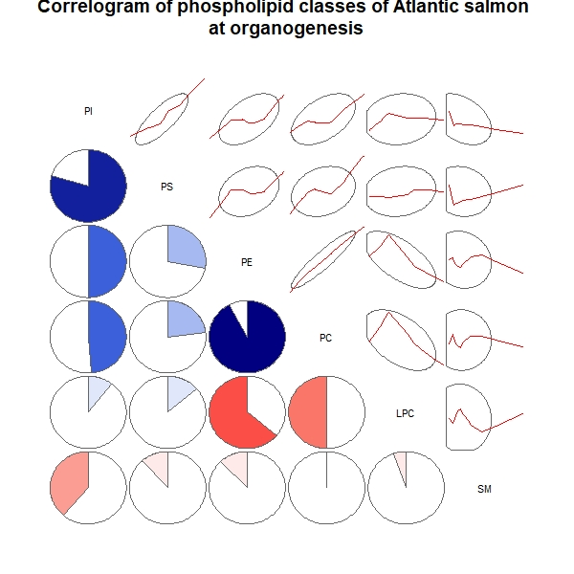
 | PI | PS | PE | PC | LPC | SM
PI | 1 | 0.7956 | 0.5008 | 0.4885 | 0.1061 | -0.3868
PS | 0.7956 | 1 | 0.2803 | 0.2314 | 0.1369 | -0.1163
PE | 0.5008 | 0.2803 | 1 | 0.9234 | -0.6406 | -0.1218
PC | 0.4885 | 0.2314 | 0.9234 | 1 | -0.4995 | -0.004171
LPC | 0.1061 | 0.1369 | -0.6406 | -0.4995 | 1 | -0.05402
SM | -0.3868 | -0.1163 | -0.1218 | -0.004171 | -0.05402 | 1

7. Correlation matrix for eye pigmentation

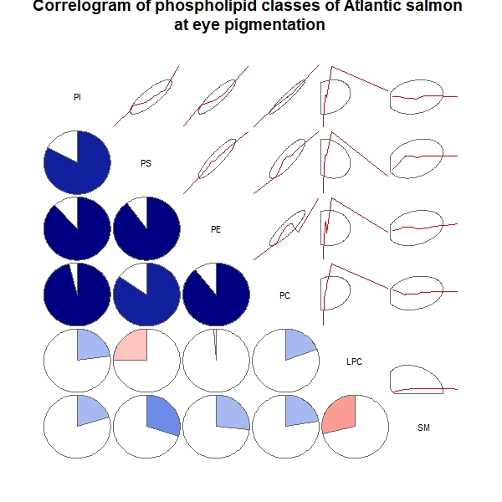
 | PI | PS | PE | PC | LPC | SM
PI | 1 | 0.8299 | 0.8835 | 0.9626 | 0.2281 | 0.2014
PS | 0.8299 | 1 | 0.9001 | 0.8484 | -0.2489 | 0.3002
PE | 0.8835 | 0.9001 | 1 | 0.8949 | -0.01217 | 0.2663
PC | 0.9626 | 0.8484 | 0.8949 | 1 | 0.1916 | 0.2218
LPC | 0.2281 | -0.2489 | -0.01217 | 0.1916 | 1 | -0.286
SM | 0.2014 | 0.3002 | 0.2663 | 0.2218 | -0.286 | 1

8. Correlation matrix for pre-hatching embryo

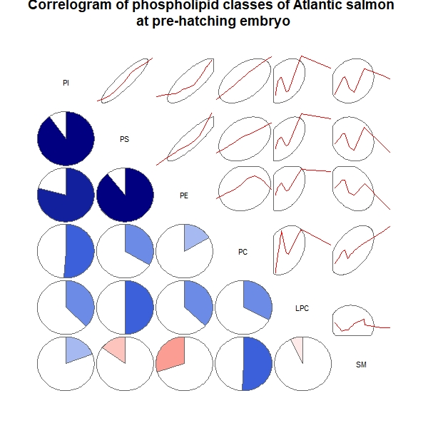
 | PI | PS | PE | PC | LPC | SM
PI | 1 | 0.9034 | 0.7927 | 0.5099 | 0.3749 | 0.1921
PS | 0.9034 | 1 | 0.8935 | 0.3335 | 0.4999 | -0.1482
PE | 0.7927 | 0.8935 | 1 | 0.166 | 0.37 | -0.299
PC | 0.5099 | 0.3335 | 0.166 | 1 | 0.3275 | 0.5083
LPC | 0.3749 | 0.4999 | 0.37 | 0.3275 | 1 | -0.07115
SM | 0.1921 | -0.1482 | -0.299 | 0.5083 | -0.07115 | 1

9. Correlation matrix for alevin

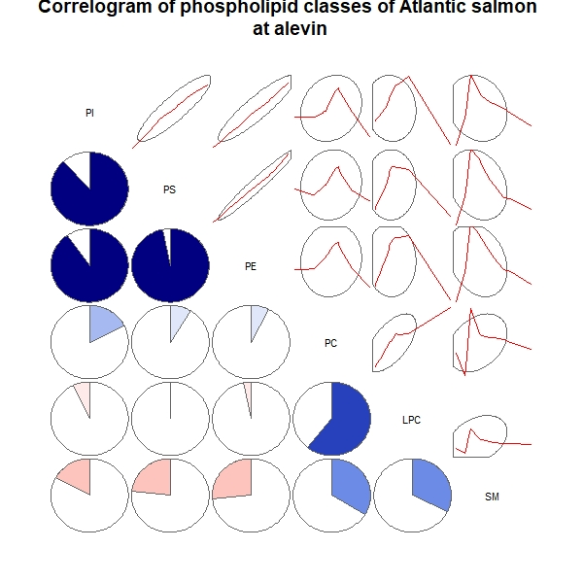
 | PI | PS | PE | PC | LPC | SM
PI | 1 | 0.8846 | 0.9021 | 0.1769 | -0.06853 | -0.1698
PS | 0.8846 | 1 | 0.9705 | 0.08864 | 0.006305 | -0.2315
PE | 0.9021 | 0.9705 | 1 | 0.07324 | -0.03202 | -0.2646
PC | 0.1769 | 0.08864 | 0.07324 | 1 | 0.6086 | 0.3363
LPC | -0.06853 | 0.006305 | -0.03202 | 0.6086 | 1 | 0.3216
SM | -0.1698 | -0.2315 | -0.2646 | 0.3363 | 0.3216 | 1

Correlation tables and correlograms for Brown trout (Salmo trutta L.):
1. General correlation for all stages of development

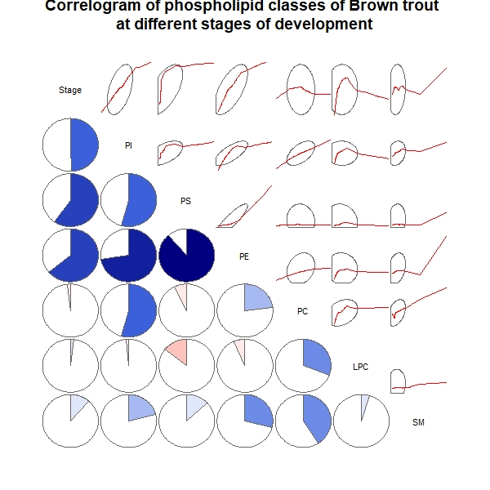
 | Stage | PI | PS |  | PE | PC | LPC | SM
Stage | 1 | 0.4931 |  | 0.6004 | 0.6404 | -0.01753 | 0.01965 | 0.1147
PI | 0.4931 | 1 |  | 0.5407 | 0.7249 | 0.543 | -0.01574 | 0.2097
PS | 0.6004 | 0.5407 |  | 1 | 0.8874 | -0.07241 | -0.144 | 0.1306
PE | 0.6404 | 0.7249 |  | 0.8874 | 1 | 0.2302 | -0.06693 | 0.2901
PC | -0.01753 | 0.543 |  | -0.07241 | 0.2302 | 1 | 0.3088 | 0.4076
LPC | 0.01965 | -0.01574 |  | -0.144 | -0.06693 | 0.3088 | 1 | 0.04955
SM | 0.1147 | 0.2097 |  | 0.1306 | 0.2901 | 0.4076 | 0.04955 | 1

2. Correlation matrix for unfertilized eggs

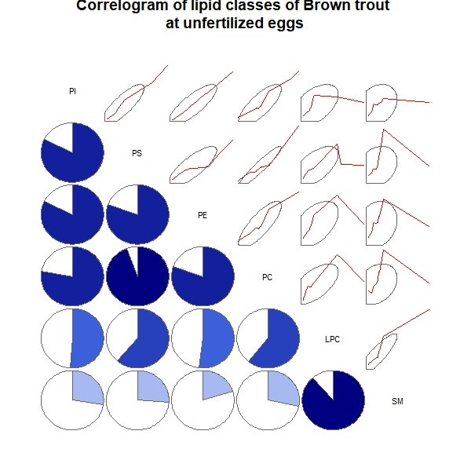
 | PI | PS | PE | PC | LPC | SM
PI | 1 | 0.8237 | 0.8219 | 0.7766 | 0.5124 | 0.274
PS | 0.8237 | 1 | 0.8055 | 0.944 | 0.6114 | 0.2599
PE | 0.8219 | 0.8055 | 1 | 0.8025 | 0.5183 | 0.2024
PC | 0.7766 | 0.944 | 0.8025 | 1 | 0.6059 | 0.283
LPC | 0.5124 | 0.6114 | 0.5183 | 0.6059 | 1 | 0.8863
SM | 0.274 | 0.2599 | 0.2024 | 0.283 | 0.8863 | 1

3. Correlation matrix for fertilized eggs

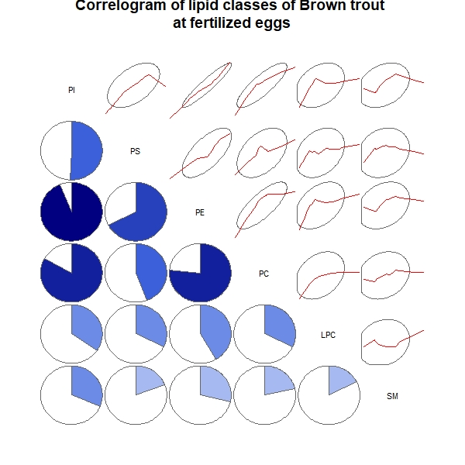
 | PI | PS | PE | PC | LPC | SM
PI | 1 | 0.505 | 0.9392 | 0.8337 | 0.3453 | 0.3116
PS | 0.505 | 1 | 0.676 | 0.4437 | 0.3197 | 0.1928
PE | 0.9392 | 0.676 | 1 | 0.7658 | 0.414 | 0.2847
PC | 0.8337 | 0.4437 | 0.7658 | 1 | 0.3207 | 0.2132
LPC | 0.3453 | 0.3197 | 0.414 | 0.3207 | 1 | 0.175
SM | 0.3116 | 0.1928 | 0.2847 | 0.2132 | 0.175 | 1

4. Correlation matrix for blastula

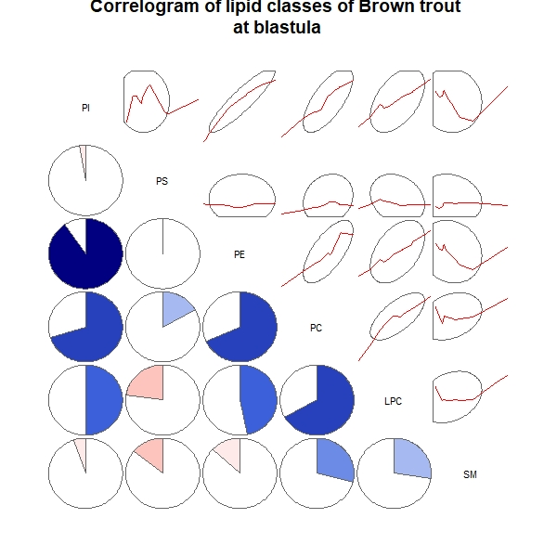
 | PI | PS | PE | PC | LPC | SM
PI | 1 | -0.02515 | 0.9052 | 0.7028 | 0.4994 | -0.05384
PS | -0.02515 | 1 | -0.006964 | 0.1701 | -0.2274 | -0.1436
PE | 0.9052 | -0.006964 | 1 | 0.6819 | 0.4696 | -0.1321
PC | 0.7028 | 0.1701 | 0.6819 | 1 | 0.671 | 0.2897
LPC | 0.4994 | -0.2274 | 0.4696 | 0.671 | 1 | 0.2749
SM | -0.05384 | -0.1436 | -0.1321 | 0.2897 | 0.2749 | 1

5. Correlation matrix for gastrula

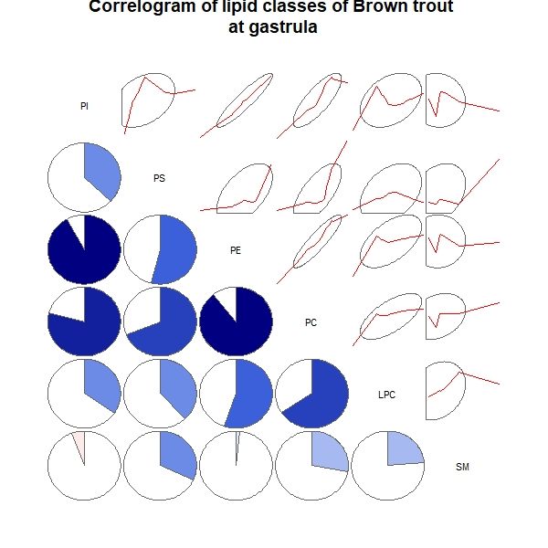
 | PI | PS | PE | PC | LPC | SM
PI | 1 | 0.3685 | 0.9204 | 0.789 | 0.3439 | -0.05796
PS | 0.3685 | 1 | 0.54 | 0.6879 | 0.3799 | 0.3188
PE | 0.9204 | 0.54 | 1 | 0.8928 | 0.554 | 0.01541
PC | 0.789 | 0.6879 | 0.8928 | 1 | 0.6581 | 0.28
LPC | 0.3439 | 0.3799 | 0.554 | 0.6581 | 1 | 0.2363
SM | -0.05796 | 0.3188 | 0.01541 | 0.28 | 0.2363 | 1

6. Correlation matrix for organogenesis

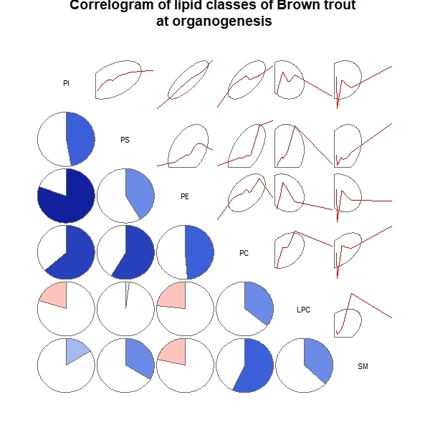
 | PI | PS | PE | PC | LPC | SM
PI | 1 | 0.4724 | 0.8051 | 0.6341 | -0.2003 | 0.1609
PS | 0.4724 | 1 | 0.4147 | 0.5851 | 0.02193 | 0.3359
PE | 0.8051 | 0.4147 | 1 | 0.4877 | -0.2321 | -0.2134
PC | 0.6341 | 0.5851 | 0.4877 | 1 | 0.3568 | 0.5706
LPC | -0.2003 | 0.02193 | -0.2321 | 0.3568 | 1 | 0.3702
SM | 0.1609 | 0.3359 | -0.2134 | 0.5706 | 0.3702 | 1

7. Correlation matrix for eye pigmentation

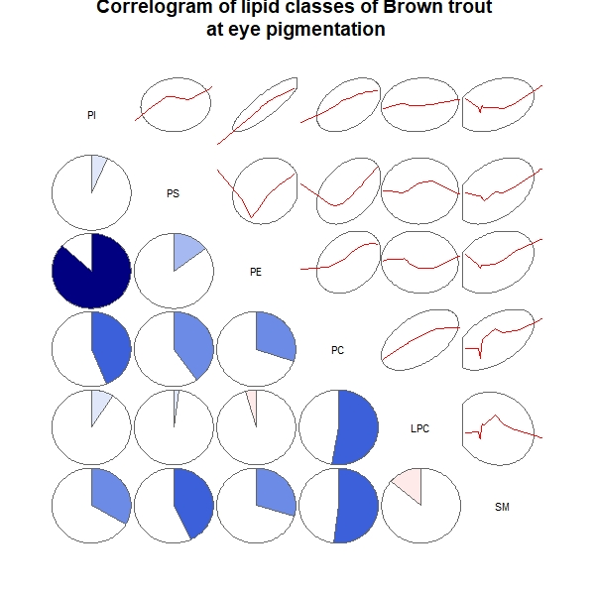
 | PI | PS | PE | PC | LPC | SM
PI | 1 | 0.06524 | 0.8686 | 0.438 | 0.09039 | 0.3339
PS | 0.06524 | 1 | 0.1491 | 0.4026 | 0.02157 | 0.4288
PE | 0.8686 | 0.1491 | 1 | 0.3022 | -0.04282 | 0.2974
PC | 0.438 | 0.4026 | 0.3022 | 1 | 0.5272 | 0.5202
LPC | 0.09039 | 0.02157 | -0.04282 | 0.5272 | 1 | -0.1365
SM | 0.3339 | 0.4288 | 0.2974 | 0.5202 | -0.1365 | 1

8. Correlation matrix for pre-hatching embryo

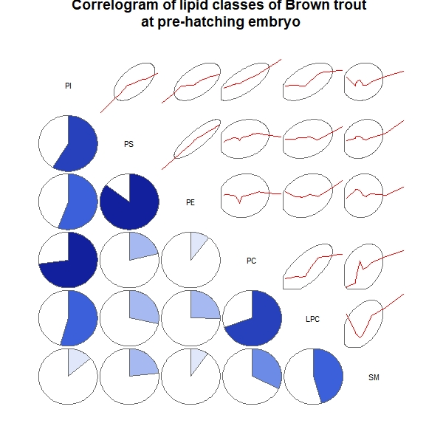
 | PI | PS | PE | PC | LPC | SM
PI | 1 | 0.5858 | 0.5553 | 0.7275 | 0.5416 | 0.1368
PS | 0.5858 | 1 | 0.854 | 0.2144 | 0.2839 | 0.2337
PE | 0.5553 | 0.854 | 1 | 0.1037 | 0.2509 | 0.09647
PC | 0.7275 | 0.2144 | 0.1037 | 1 | 0.6978 | 0.322
LPC | 0.5416 | 0.2839 | 0.2509 | 0.6978 | 1 | 0.456
SM | 0.1368 | 0.2337 | 0.09647 | 0.322 | 0.456 | 1

9. Correlation matrix for alevin

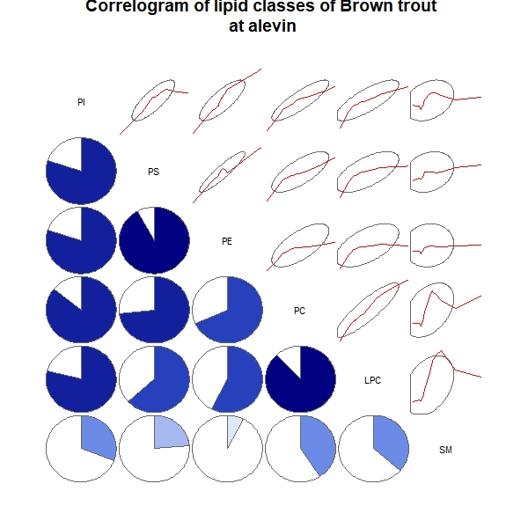
 | PI | PS | PE | PC | LPC | SM
PI | 1 | 0.8002 | 0.798 | 0.8571 | 0.7884 | 0.3093
PS | 0.8002 | 1 | 0.9196 | 0.7325 | 0.6345 | 0.2375
PE | 0.798 | 0.9196 | 1 | 0.682 | 0.5727 | 0.07399
PC | 0.8571 | 0.7325 | 0.682 | 1 | 0.8787 | 0.4066
LPC | 0.7884 | 0.6345 | 0.5727 | 0.8787 | 1 | 0.3637
SM | 0.3093 | 0.2375 | 0.07399 | 0.4066 | 0.3637 | 1

