Supplementary 2. Составы минералов включений в оливиновых фенокристах (Ol–1)

Диопсид-шпинелевые дендритовидные ламели

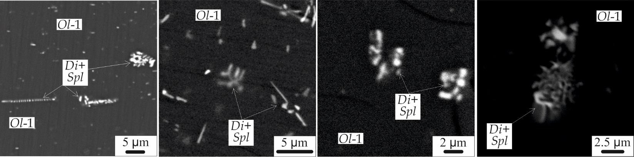
Рис. 1. Микрофотографии дендритовидных ламелярных диопсид-шпинелевых включений в Ol–1–Ц. BSE.

Табл.1 Состав (EPMA) диопсид-шпинелевых ламелей

№  пп | MgO | Al2O3 | SiO2 | CaO | Cr2O3 | FeO | Сумма
1 | 44.19 | – | 40.70 | 1.64 | – | 12.88 | 99.41
2 | 18.21 | – | 11.21 | – | 1.25 | 74.10 | 104.77
3 | 42.03 | – | 30.88 | – | 1.16 | 43.63 | 117.70
4 | 42.64 | 0.78 | 38.89 | 1.21 | 0.79 | 14.28 | 98.59
5 | 42.01 | 0.71 | 41.01 | 2.49 | – | 12.69 | 98.91
6 | 39.85 | 1.14 | 40.21 | 3.23 | – | 13.28 | 97.71
7 | 35.50 | 0.64 | 37.41 | 3.95 | 2.12 | 13.47 | 93.09
8 | 19.80 | 3.41 | 37.04 | 10.20 | 8.56 | 13.57 | 92.58
9 | 20.42 | 5.08 | 27.03 | 5.38 | 17.30 | 22.07 | 97.28
10 | 20.62 | 5.61 | 30.17 | 8.78 | 16.88 | 22.56 | 104.62
11 | 23.52 | 2.92 | 36.29 | 7.31 | 8.26 | 17.26 | 95.56
12 | 11.56 | 6.02 | 7.38 | – | 48.71 | 30.82 | 104.49
13 | 8.66 | 8.45 | 6.17 | – | 44.05 | 33.85 | 101.18
14 | 11.14 | 8.32 | 16.02 | 3.94 | 38.11 | 32.28 | 109.81
15 | 40.02 | 0.37 | 40.47 | 1.80 | – | 18.48 | 101.14
16 | 13.32 | 6.81 | 17.41 | 5.06 | 30.17 | 34.29 | 107.06
17 | 12.70 | 5.86 | 18.67 | 5.21 | 30.76 | 32.43 | 105.63
18 | 18.19 | 6.40 | 19.52 | 4.59 | 27.61 | 34.34 | 110.65
19 | 13.64 | 7.25 | 19.54 | 6.48 | 23.97 | 30.85 | 101.73
20 | 15.81 | 8.98 | 16.74 | 4.30 | 31.47 | 32.85 | 110.15
21 | 8.48 | 8.11 | 7.44 | 0.69 | 43.90 | 33.79 | 102.41
Примечание: Прочерк - концентрации ниже ПО.

Кристаллические включения в Ol–1-Ц

Кристаллические включения в Ol–1-Ц из пикродолеритов (обр. Са-507-1)

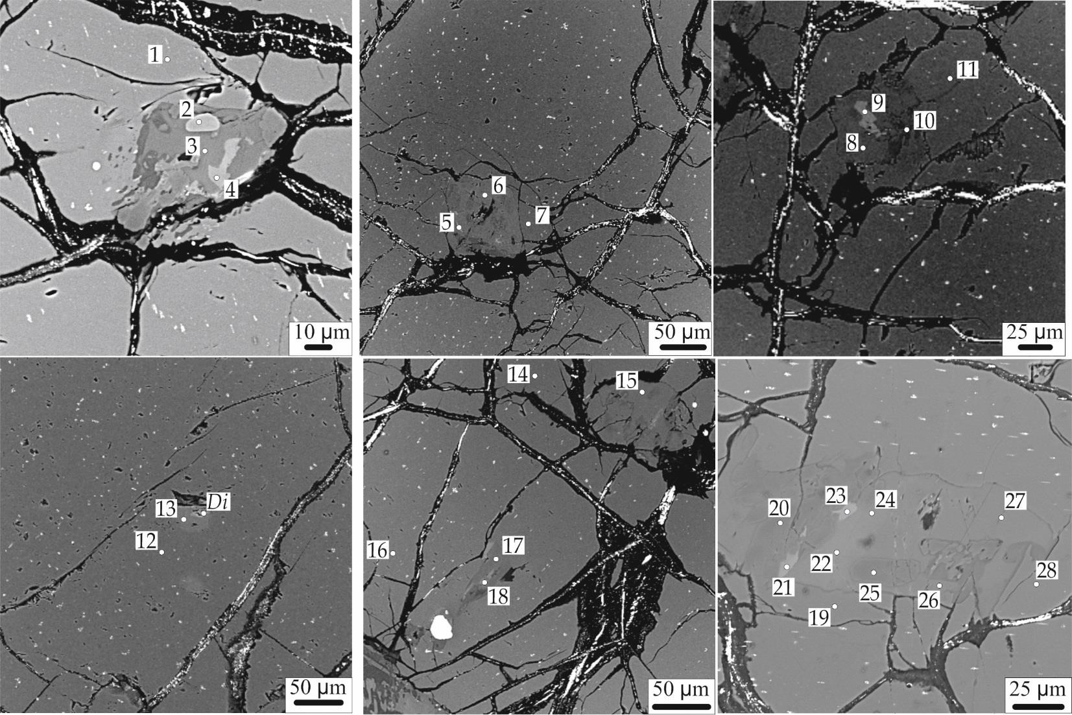

Рис. 2. Кристаллические полифазные включения в Ol–1–Ц из пикродолеритов. Номера точек соответствуют номерам анализов в табл. 2.

Таблица 2. Состав кристаллических включений и их вмещающего оливина из пикродолеритов

Точка | Минерал | SiO2 | TiO2 | Al2O3 | Cr2O3 | FeO | MnO | MgO | NiO | CaO | Na2O | K2O | Сумма | Mg#
1 | Ol–1–Ц | 39.36 | 0.02 | 0.19 | 0.05 | 15.13 | 0.19 | 44.27 | 0.33 | 0.11 | – | – | 99.65 | 84
2 | Cr-Spl* | 0.82 | 0.02 | 60.43 | 6.84 | 14.93 | 0.08 | 17.84 | 0.31 | – | – | – | 102.94 | 68
3 | Pargasite | 42.76 | 2.24 | 15.54 | – | 4.73 | – | 16.23 | – | 11.98 | 2.32 | 0.17 | 98.45 | 86
4 | Diopside | 50.26 | 0.97 | 7.02 | 0.25 | 4.28 | 0.09 | 15.46 | 0.07 | 21.08 | 0.30 | – | 99.78 | 87
5 | Enstatite | 42.57 | 0.10 | 0.50 | – | 10.26 | 0.12 | 47.57 | 0.42 | 0.10 | 0.03 | – | 101.67 | 89
6 | Tschermakite | 44.72 | 0.54 | 14.93 | 0.17 | 4.04 | 0.05 | 17.76 | 0.11 | 11.80 | 2.49 | 0.30 | 99.05 | 89
7 | Ol–1–Ц | 40.47 | 0.03 | 0.18 | 0.24 | 10.39 | 0.14 | 47.05 | 0.43 | 0.82 | – | – | 99.75 | 89
8 | Tschermakite | 44.55 | 0.62 | 15.14 | 0.15 | 4.39 | 0.07 | 17.02 | 0.15 | 11.71 | 2.45 | 0.23 | 98.61 | 87
9 | Augite | 51.24 | 0.87 | 5.81 | 0.12 | 4.38 | 0.04 | 15.79 | 0.08 | 21.09 | 0.20 | – | 99.62 | 87
10 | Augite | 57.00 | 0.06 | 1.89 | 0.09 | 1.87 | 0.03 | 22.38 | 0.07 | 12.73 | 0.10 | 0.01 | 96.23 | 96
11 | Ol–1–Ц | 40.51 | 0.01 | 0.05 | 0.04 | 12.15 | 0.16 | 45.92 | 0.45 | 0.05 | – | – | 99.33 | 87
12 | Pargasite | 44.42 | 0.64 | 14.90 | 0.43 | 3.41 | 0.04 | 17.84 | 0.14 | 11.80 | 2.58 | 0.20 | 98.53 | 90
13 | Ol–1–Ц | 40.98 | 0.02 | 0.07 | – | 8.19 | 0.11 | 49.29 | 0.43 | 0.14 | – | – | 99.24 | 91
14 | Ol–1–Ц | 40.59 | 0.03 | 0.05 | 0.06 | 11.01 | 0.12 | 47.02 | 0.36 | 0.03 | – | – | 99.28 | 88
15 | Pargasite | 45.41 | 0.61 | 14.08 | 0.45 | 3.98 | 0.09 | 17.73 | 0.13 | 11.79 | 2.56 | 0.26 | 99.23 | 89
16 | Ol–1–Ц | 39.77 | 0.03 | 0.05 | 0.06 | 13.93 | 0.17 | 45.03 | 0.42 | 0.06 | – | – | 99.51 | 85
17 | Enstatite | 56.35 | 0.53 | 1.04 | 0.33 | 9.54 | 0.23 | 30.60 | 0.04 | 1.75 | 0.01 | – | 100.42 | 85
18 | Pigeonite | 50.13 | 0.23 | 13.16 | 0.15 | 6.39 | 0.11 | 20.27 | 0.07 | 7.49 | 2.33 | 0.05 | 100.38 | 85
19 | Ol-1-Ц | 40.82 | – | 0.40 | – | 11.51 | – | 48.82 | – | 0.08 | – | – | 101.63 | 88
20 | Enstatite | 55.54 | – | 5.08 | 0.05 | 8.38 | – | 31.80 | – | 1.04 | – | – | 101.89 | 87
21 | Diopside | 51.90 | 0.91 | 6.24 | – | 4.01 | – | 17.10 | – | 22.66 | 0.32 | – | 103.14 | 88
22 | Pargasite | 42.46 | 4.22 | 16.09 | – | 4.66 | – | 16.90 | – | 12.65 | 2.36 | 0.27 | 99.61 | 87
23 | Diopside | 49.65 | 1.33 | 8.00 | – | 5.01 | – | 15.26 | – | 22.63 | 0.26 | – | 102.14 | 84
24 | Pargasite | 43.90 | 2.67 | 15.86 | – | 4.56 | – | 17.29 | – | 12.59 | 2.31 | – | 99.18 | 87
25 | Enstatite | 55.02 | – | 5.16 | 0.24 | 7.49 | – | 32.29 | – | 1.25 | – | – | 101.45 | 88
26 | Pargasite | 44.65 | 0.83 | 15.57 | – | 4.40 | – | 18.48 | – | 12.76 | 2.90 | – | 99.59 | 88
27 | Pargasite | 44.52 | 0.66 | 15.87 | – | 4.69 | – | 18.41 | – | 12.98 | 3.01 | 0.40 | 100.54 | 87
28 | Ol–1–Ц | 41.26 | – | 0.20 | – | 12.53 | – | 48.46 | – | 0.38 | – | – | 102.83 | 87
Примечание: Cr-Spl*– V2O3 – 0.06 мас.%, ZnO – 1.62 мас.%, Cr# 7 (Cr# = Cr/(Cr+Al)*100); Mg#= Mg/(Mg+Fe); Прочерк - концентрации ниже ПО.

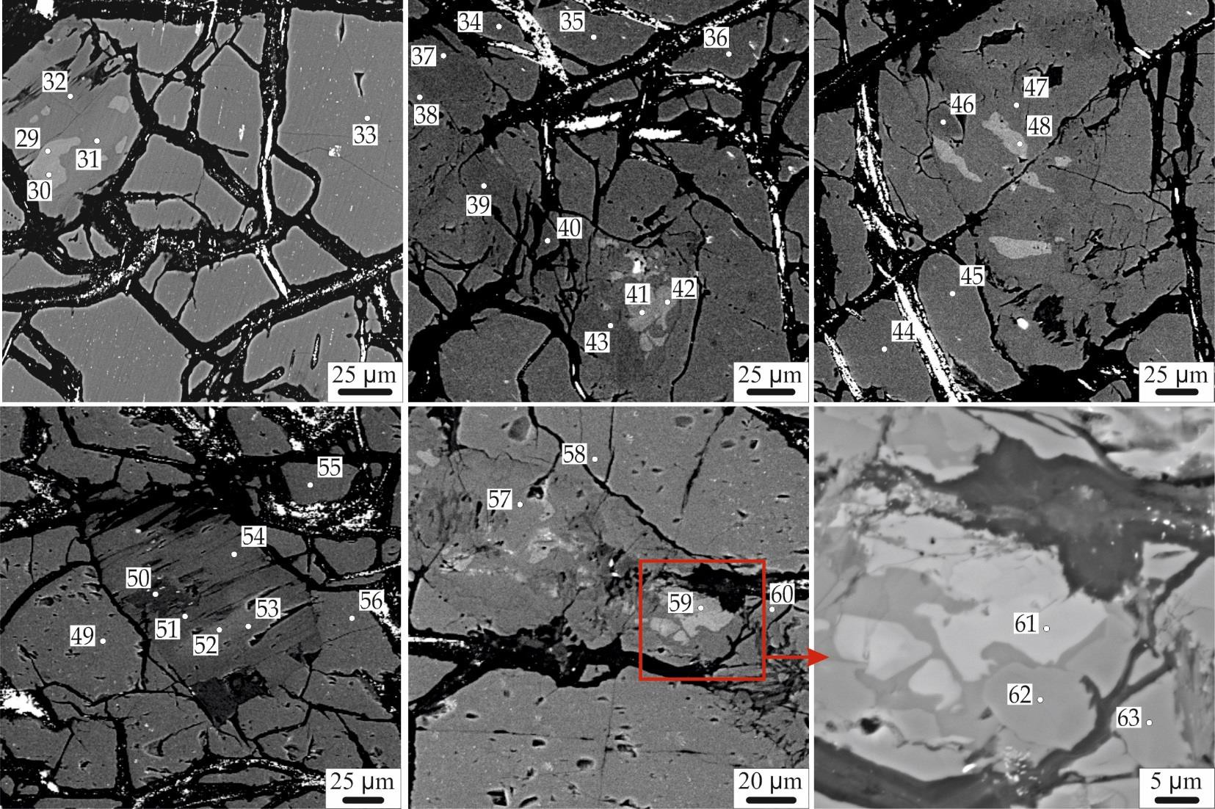Кристаллические включения в Ol–1–Ц из Ol габброноритов (обр. Са-506-2, Са-511-4)

Рис. 3. Кристаллические полифазные включения в Ol–1 из Ol габброноритов. Номера точек соответствуют номерам анализов в табл. 3.

Таблица 3. Состав кристаллических включений и их вмещающего оливина из Ol габброноритов
Точка | Минерал | SiO2 | TiO2 | Al2O3 | Cr2O3 | FeO | MnO | MgO | NiO | CaO | Na2O | K2O | Сумма | Mg#
29 | Diopside | 50.29 | 0.92 | 6.2 | 0.33 | 4.17 | 0.1 | 15.75 | – | 21.84 | 0.28 | – | 99.88 | 87
30 | Diopside | 50.68 | 0.97 | 6.02 | 0.29 | 4.96 | 0.10 | 15.61 | 0.03 | 21.66 | 0.27 | – | 100.60 | 85
31 | Pargasite | 42.83 | 1.98 | 15.93 | 0.52 | 5.36 | – | 16.77 | 0.12 | 11.93 | 2.92 | 0.27 | 98.75 | 85
32 | Enstatite | 54.86 | 0.19 | 3.01 | 0.14 | 9.21 | 0.21 | 30.96 | – | 1.82 | – | – | 100.4 | 86
33 | Ol–1–Ц | 40.54 | 0.029 | 0.082 | 0.119 | 13.97 | 0.196 | 46.12 | 0.137 | 0.123 | – | – | 101.32 | 85
34 | Ol–1–Ц | 39.60 | – | 0.08 | – | 12.21 | – | 46.22 | 0.10 | – | – | – | 98.21 | 87
35 | Ol–1–Ц | 38.93 | – | 0.05 | – | 12.35 | – | 46.22 | 0.56 | – | – | – | 98.11 | 87
36 | Ol–1–Ц | 39.42 | – | – | – | 11.91 | – | 46.66 | 0.42 | 0.04 | – | – | 98.45 | 87
37 | Enstatite | 53.9 | – | 3.94 | – | 8.67 | – | 31.23 | – | 0.99 | – | – | 98.73 | 87
38 | Pargasite | 43.27 | – | 15.09 | – | 5.09 | – | 17.48 | – | 12.33 | 2.72 | 0.53 | 96.51 | 86
39 | Enstatite | 53.09 | – | 4.34 | – | 9.21 | – | 31.19 | – | 0.88 | – | – | 98.71 | 86
40 | Enstatite | 53.95 | – | 5.02 | – | 8.17 | – | 30.73 | – | 1.16 | – | – | 99.03 | 87
41 | Diopside | 52.87 | – | 1.85 | – | 3.51 | – | 17 | – | 23.57 | 0.32 | – | 99.12 | 90
42 | Diopside | 53.15 | – | 3.49 | – | 3.54 | – | 16.26 | – | 23.59 | 0.29 | – | 100.32 | 89
43 | Enstatite | 54.34 | – | 4.47 | – | 8.54 | – | 30.72 | – | 1.33 | – | – | 99.4 | 87
44 | Ol–1–Ц | 39.85 | – | – | – | 12.44 | – | 46.49 | – | – | – | – | 98.78 | 87
45 | Ol–1–Ц | 40.28 | – | 0.23 | – | 12.71 | – | 46.62 | 0.42 | 0.03 | – | – | 100.29 | 87
46 | Enstatite | 54.47 | – | 3.95 | – | 8.1 | – | 31.74 | – | 1.15 | – | – | 99.41 | 87
47 | Pargasite | 42.25 | 0.84 | 14.43 | – | 4.34 | – | 17.43 | – | 12.24 | 2.78 | 0.32 | 94.63 | 88
48 | Diopside | 50.06 | 0.82 | 5.31 | – | 4.47 | – | 16.15 | – | 22.36 | 0.29 | – | 99.46 | 87
49 | Ol–1–Ц | 40.03 | – | 0.11 | 0.06 | 15.83 | – | 44.63 | 0.37 | 0.64 | – | – | 101.67 | 83
50 | Pargasite | 40.57 | 3.94 | 16.02 | – | 5.9 | – | 15.09 | – | 12.23 | 2.74 | 0.28 | 96.77 | 82
51 | Enstatite | 52.48 | 0.6 | 6.8 | – | 10 | – | 29.91 | – | 0.98 | – | – | 100.77 | 84
52 | Pargasite | 40.18 | 0.45 | 14.73 | – | 4.99 | – | 24.76 | – | – | – | 9.39 | 94.5 | 90
53 | Pargasite | 40.78 | 3.79 | 15.21 | – | 6.22 | – | 15.24 | – | 11.73 | 2.8 | 0.31 | 96.08 | 81
54 | Pargasite | 42.92 | 0.62 | 15.96 | – | 6.19 | – | 16.4 | – | 12.42 | 3.13 | – | 97.64 | 83
55 | Ol–1–Ц | 39.26 | – | 0.23 | 0.04 | 14.16 | – | 44.77 | 0.32 | 0.14 | – | – | 98.92 | 85
56 | Ol–1–Ц | 38.84 | – | 0.32 | – | 14.23 | – | 44.43 | 0.43 | – | – | – | 98.25 | 85
57 | Pargasite | 42.81 | 2.29 | 14.97 | – | 5.75 | – | 16.22 | – | 11.83 | 2.81 | – | 96.68 | 83
58 | Ol–1–Ц | 40.05 | – | 0.08 | 0.18 | 14.20 | – | 45.90 | 0.10 | 0.11 | – | – | 100.62 | 85
59 | Diopside | 46.82 | 1.43 | 9.56 | – | 6.37 | – | 12 | – | 23.63 | – | – | 99.81 | 77
60 | Ol–1–Ц | 39.43 | – | 0.16 | – | 14.13 | – | 45.74 | 0.43 | 0.07 | – | – | 99.96 | 85
61 | Diopside | 48.24 | 0.74 | 7.04 | – | 5.64 | – | 14.65 | – | 21.66 | – | – | 97.97 | 82
62 | Enstatite | 53.22 | – | 3.69 | – | 10.12 | – | 29.46 | – | 1.54 | – | – | 98.03 | 84
63 | Enstatite | 50.05 | – | 6.81 | – | 9.94 | – | 28.4 | – | 1.39 | – | – | 96.59 | 84

Включения шпинели в Ol–1–К и Ol–2
Ol
ГАББРОНОРИТ
ПИКРОДОЛЕРИТ

Таблица 4. Состав шпинели и содержащего ее оливина из пикродолеритов и Ol габброноритов
Порода | № Минерал пп | SiO2 | TiO2 | Al2O3 | Cr2O3 | FeO | MnO | MgO | NiO | CaO | V2O3 | ZnO | Сумма | Mg# | Cr#
 | 1 Ol–1–К | 39.26 | 0.02 | – | 0.03 | 17.67 | 0.25 | 42.85 | 0.37 | 0.09 | – | – | 100.54 | 81
 | Spl | 6.21 | 5.51 | 11.96 | 31.30 | 35.98 | 0.44 | 6.39 | 0.07 | – | 0.39 | 0.58 | 98.82 | 24 | 64
 | 2 Ol–1–К | 39.37 | 0.04 | 0.04 | 0.03 | 15.43 | 0.19 | 44.32 | 0.31 | 0.07 | – | – | 99.80 | 84
 | Spl | 0.07 | 3.43 | 17.61 | 39.98 | 33.47 | 0.39 | 4.67 | 0.06 | – | 0.32 | 0.30 | 100.30 | 20 | 58
 | 3 Ol–1–К | 39.37 | 0.04 | 0.02 | 0.03 | 18.65 | 0.20 | 41.70 | 0.31 | 0.03 | – | – | 100.35 | 80
 | Spl | 0.07 | 0.48 | 12.45 | 46.90 | 36.21 | 0.36 | 3.28 | 0.07 | – | 0.27 | 0.38 | 100.47 | 14 | 64
 | 4 Ol–1–К | 39.62 | 0.03 | 0.06 | 0.06 | 17.16 | 0.18 | 42.95 | 0.39 | 0.15 | – | – | 100.61 | 82
 | Spl | 0.19 | 0.40 | 12.93 | 47.29 | 33.87 | 0.41 | 3.47 | 0.06 | – | 0.28 | 0.59 | 99.49 | 15 | 65
 | 5 Ol–1–К | 39.48 | 0.03 | 0.04 | 0.09 | 16.20 | 0.22 | 43.47 | 0.32 | 0.05 | – | – | 99.90 | 83
 | Spl | 0.11 | 1.81 | 13.32 | 44.93 | 35.74 | 0.45 | 3.89 | 0.05 | – | 0.29 | 0.41 | 100.99 | 16 | 63
 | 6 Ol–1–К | 40.11 | 0.01 | 0.02 | 0.06 | 13.36 | 0.19 | 45.42 | 0.34 | 0.07 | – | – | 99.57 | 86
 | Spl | 0.19 | 0.26 | 14.80 | 45.87 | 32.24 | 0.46 | 4.39 | 0.04 | – | 0.28 | 0.62 | 99.15 | 20 | 62
 | 7 Ol–1–К | 39.93 | 0.03 | 0.05 | 0.04 | 14.77 | 0.19 | 44.93 | 0.30 | 0.08 | – | – | 100.33 | 84
 | Spl | 0.17 | 0.25 | 15.08 | 45.75 | 32.42 | 0.43 | 4.07 | 0.07 | – | 0.28 | 0.44 | 98.95 | 18 | 62
 | 8 Ol–1–К | 40.11 | 0.01 | 0.02 | 0.06 | 13.36 | 0.19 | 45.42 | 0.34 | 0.07 | – | – | 99.57 | 86
 | Spl | 0.13 | 0.48 | 15.01 | 49.19 | 29.47 | 0.42 | 4.57 | 0.07 | – | 0.29 | 0.29 | 99.92 | 22 | 67
 | 9 Ol–1–К | 40.00 | 0.01 | 0.03 | 0.25 | 16.51 | 0.18 | 43.06 | 0.30 | 0.18 | – | – | 100.52 | 82
 | Spl | 0.08 | 0.47 | 12.91 | 47.95 | 34.57 | 0.42 | 3.35 | 0.05 | – | 0.28 | 0.35 | 100.43 | 15 | 66
 | 10 Ol–2 | 38.49 | – | 0.15 | – | 24.83 | – | 37.14 | – | 0.36 | – | – | 100.97 | 73
 | Spl | 2.21 | – | 10.66 | 42.71 | 37.94 | – | 3.39 | – | – | – | – | 96.91 | 14 | 64
 | 11 Ol–2 | 39.51 | 0.05 | 0.02 | – | 16.90 | 0.25 | 42.76 | 0.34 | 0.05 | – | – | 99.87 | 82
 | Spl | 0.08 | 0.84 | 13.26 | 44.93 | 35.51 | 0.46 | 3.26 | 0.10 | – | 0.28 | 0.50 | 99.21 | 14 | 63
 | 12 Ol–2 | 39.78 | 0.03 | 0.03 | 0.05 | 15.97 | 0.20 | 43.59 | 0.31 | 0.27 | – | – | 100.22 | 83
 | Spl | 0.14 | 1.17 | 10.84 | 48.92 | 34.63 | 0.43 | 3.58 | 0.06 | – | 0.23 | 0.27 | 100.26 | 16 | 69
 | 13 Ol–1–К | 39.05 | – | 0.21 | 0.19 | 13.57 | – | 44.73 | 0.24 | 0.37 | – | – | 98.36 | 85
 | Spl* | – | 1.02 | 13.05 | 44.73 | 33.31 | – | 4.24 | – | – | – | – | 96.98 | 18 | 65
 | 14 Ol–1–К | 39.96 | – | – | – | 18.43 | – | 42.63 | 0.42 | – | – | – | 101.44 | 80
 | Spl** | – | – | 10.43 | 49.40 | 36.87 | – | 3.11 | – | – | – | – | 100.47 | 13 | 69
 | 15 Ol–1–К | 38.90 | 0.08 | 0.30 | – | 17.31 | 0.26 | 42.19 | 0.31 | 0.32 | – | – | 99.67 | 81
 | Spl*** | 0.23 | 0.36 | 11.41 | 47.02 | 37.11 | 0.53 | 2.65 | – | – | – | 0.55 | 100.31 | 11 | 66

Продолжение табл. 4.
Ol ГАББРОНОРИТ

Порода | №  пп | Минерал | SiO2 | TiO2 | Al2O3 | Cr2O3 | FeO | MnO | MgO | NiO | CaO | V2O3 | ZnO | Сумма | Mg# | Cr#
 | 16  17  18  19 | Ol–1–К Spl Ol–1–К Spl Ol–1–К Spl Ol–1–К  Spl | 40.01  –  39.31  0.12  39.96  0.05  39.37  0.06 | –  –  0.03  0.66  0.02  0.26  0.01  0.27 | –  9.30  0.03  12.28  0.04  13.69  0.08  11.40 | 0.11  46.72  0.38  47.28  0.48  45.97  0.07  46.70 | 19.97  36.80  16.17  35.31  16.23  36.48  18.15  37.63 | –  –  0.23  0.50  0.23  0.51  0.23  0.47 | 42.67  2.26  42.24  2.96  42.77  2.99  41.27  2.21 | 0.22  –  0.31  0.08  0.31  0.08  0.32  0.04 | 0.16  –  0.03  –  0.02  –  0.33  – | –  –  –  0.30  –  0.31  –  0.25 | –  –  –  0.55  –  0.55  –  0.68 | 103.14  95.08  98.75  100.04  100.07  100.88  99.85  99.71 | 79  10  82  13  82  13  80  9 | 68  66  62  65
 | 20 | Ol–1–К | 39.27 | 0.01 | 0.06 | 0.06 | 16.11 | 0.22 | 41.91 | 0.31 | 0.28 | – | – | 98.24 | 82
 |  | Spl | 0.11 | 0.27 | 11.61 | 48.65 | 34.69 | 0.48 | 3.03 | 0.08 | – | 0.29 | 0.81 | 100.02 | 13 | 67
 | 21 | Ol–1–К | 39.88 | 0.01 | 0.05 | 0.11 | 13.84 | 0.19 | 43.95 | 0.34 | 0.27 | – | – | 98.65 | 85
 |  | Spl | 0.07 | 0.54 | 12.74 | 48.34 | 33.35 | 0.49 | 3.90 | 0.07 | – | 0.27 | 0.49 | 100.25 | 17 | 66
 | 22 | Ol–1–К | 39.74 | 0.01 | 0.04 | 0.09 | 14.10 | 0.19 | 44.40 | 0.34 | 0.04 | – | – | 98.97 | 85
 |  | Spl | 0.14 | 0.29 | 14.85 | 46.45 | 33.87 | 0.49 | 4.09 | 0.09 | – | 0.20 | 0.71 | 101.17 | 18 | 62
 | 23 | Ol–2 | 39.48 | – | 0.11 | 0.05 | 17.20 | 0.20 | 39.32 | 0.31 | 1.64 | – | – | 98.30 | 80
 |  | Spl | 0.04 | 9.63 | 14.72 | 27.61 | 42.15 | 0.53 | 3.19 | 0.10 | – | 1.02 | 0.46 | 99.45 | 12 | 50
 | 24 | Ol–2 | 39.20 | 0.02 | 0.03 | 0.08 | 17.60 | 0.24 | 41.77 | 0.31 | 0.02 | – | – | 99.28 | 81
 |  | Spl | 0.07 | 0.78 | 12.06 | 45.09 | 37.61 | 0.50 | 2.58 | 0.11 | – | 0.30 | 0.39 | 99.49 | 11 | 63
 | 25 | Ol–2 | 39.38 | 0.04 | 0.07 | 0.17 | 17.61 | 0.24 | 41.87 | 0.29 | 0.06 | – | – | 99.74 | 81
 |  | Spl | 0.04 | 0.85 | 13.63 | 42.06 | 39.62 | 0.46 | 2.64 | 0.07 | – | 0.46 | 0.56 | 100.38 | 11 | 58
 | 26 | Ol–2 | 39.19 | 0.02 | 0.01 | 0.17 | 18.63 | 0.25 | 40.96 | 0.31 | 0.01 | – | – | 99.56 | 80
 |  | Spl | 0.06 | 0.34 | 12.76 | 45.01 | 37.86 | 0.44 | 2.38 | 0.03 | – | 0.45 | 1.07 | 100.40 | 10 | 62
Примечания: Spl*– V2O5 – 0.63 мас. %, Spl**– V2O5 – 0.66 мас.%, Spl***– V2O5 – 0.45 мас.%.

