SUPPLEMENTARY MATERIALS – ДОПОЛНИТЕЛЬНЫЕ МАТЕРИАЛЫ

CONTENTS AND DISTRIBUTION OF 137Cs IN PODZOLS IN THE LOCATION AREA OF THE KOLA NUCLEAR POWER PLANT

СОДЕРЖАНИЕ И РАСПРЕДЕЛЕНИЕ 137Cs В ПОДЗОЛИСТЫХ ПОЧВАХ В РАЙОНЕ РАСПОЛОЖЕНИЯ КОЛЬСКОЙ АТОМНОЙ ЭЛЕКТРОСТАНЦИИ

M.B. Popova, D.V. Manakhov, A.N. Kizeev, S.F. Ushamova, D.N. Lipatov, A.Yu. Chirkov, P.S. Orlov, S.V. Mamikhin

Попова М.Б., Манахов Д.В., Кизеев А.Н., Ушамова С.Ф., Липатов Д.Н., Чирков А.Ю.,

Орлов П.С., Мамихин С.В.

Eurasian Soil Science.
Почвоведение.

Table S1. Physical and chemical properties of podzols in the location area of the

Kola nuclear power plant.

Таблица S1. Физико-химические показатели подзолов в зоне влияния

Кольской атомной электростанции.
Horizon pH H2O |  | pH KCl | Loss on  ignition, Corg.,  % |  | Exchangeable Mobile Base Particle size fractions  Total acidity, cations K2O, saturation,  cmol(+)/kg Ca2+ Mg2+ mg/100 g % <0.001 mm <0.01 mm  cmol(+)/kg %
 |  |  |  |  |  | F (site)
О | 4.3 | 2.8 | 85.76 |  | 123.70 | 16.50 | 3.83 | 64.29 | 14.92 | - | -
АО | 4.3 | 2.8 | 61.36 |  | 105.60 | 7.96 | 1.59 | 57.14 | 9.25 | - | -
E | 4.7 | 3.1 |  | 0.44 | 3.13 | 0.19 | 0.01 | 0.71 | 6.44 | 0.95 | 8.55
B1f | 4.8 | 4.4 |  | 1.41 | 4.52 | 0.24 | 0.02 | 0.96 | 6.01 | 1.45 | 10.90
B2f | 5.0 | 4.7 |  | 1.26 | 2.07 | 0.14 | 0.01 | 0.76 | 7.61 | 1.33 | 10.72
BC | 5.6 | 5.0 |  | 0.10 | 1.06 | 0.10 | 0.01 | 0.83 | 10.62 | 1.23 | 9.59
C | 5.7 | 5.0 |  | 0.05 | 0.87 | 0.07 | 0.02 | 0.64 | 11.46 | 1.54 | 10.10
 |  |  |  |  |  | S1
О | 4.3 | 3.0 | 81.45 |  | 65.9 | 7.12 | 1.92 | 103.57 | 14,57 | - | -
АО | 4.5 | 3.2 | 27.08 |  | 34.3 | 3.47 | 0.65 | 39.29 | 12,63 | - | -
E | 4.7 | 3.4 |  | 0.27 | 1.98 | 0.17 | 0.01 | 0.76 | 9,14 | 0.20 | 2.93
B1f | 5.6 | 4.7 |  | 0.65 | 3.33 | 0.34 | 0.04 | 0.90 | 10,67 | 0.31 | 2.75
B2f | 6.0 | 5.1 |  | 0.17 | 1.63 | 0.14 | 0.01 | 0.59 | 9,00 | 0.20 | 1.12
BC | 6.0 | 4.8 |  | 0.16 | 1.28 | 0.07 | 0.00 | 1.11 | 7,10 | 0.50 | 2.41
 |  |  |  |  |  | S2
ОL | 4.5 | 3.8 | 96.01 |  | 50.3 | 15.14 | 9.43 | 135.71 | 35,32 | - | -
OF | 3.9 | 2.8 | 82.54 |  | 82.5 | 7.71 | 1.63 | 75.00 | 11,71 | - | -
АО | 4.0 | 2.7 | 29.67 |  | 48.1 | 1.38 | 0.55 | 46.43 | 5,72 | - | -
E | 4.3 | 3.0 |  | 0.51 | 2.86 | 0.17 | 0.05 | 1.07 | 7,77 | 0.48 | 5.32
B1f | 4.7 | 4.0 |  | 1.78 | 10.8 | 0.20 | 0.08 | 1.57 | 2,85 | 1.73 | 9.38
B2f | 4.9 | 3.9 |  | 1.50 | 9.84 | 0.22 | 0.03 | 1.21 | 2,73 | 1.69 | 10.73
 |  |  |  |  |  | P-1
О | 4.2 | 2.7 | 54.85 |  | 52.6 | 7.40 | 0.79 | 50.00 | 14,97 | - | -

%

АО | 4.1 | 2.6 | 50.85 |  | 64.4 | 4.29 | 0.54 | 53.57 | 8,48 | - | -
E | 4.4 | 2.8 |  | 0.49 | 3.56 | 0.20 | 0.22 | 0.79 | 10,92 | 0.27 | 2.90
B1f | 5.1 | 4.7 |  | 1.84 | 2.25 | 0.27 | 0.08 | 0.55 | 13,75 | 0.10 | 1.59
B2f | 5.6 | 4.8 |  | 0.23 | 1.03 | 0.12 | 0.08 | 0.21 | 16,76 | 0.05 | 0.40
BC | 5.8 | 4.9 |  | 0.19 | 0.89 | 0.14 | 0.02 | 0.21 | 15,72 | 0.07 | 0.28
C | 6.0 | 4.8 |  | 0.05 | 0.72 | 0.12 | 0.02 | 0.28 | 17,37 | 0.03 | 0.12
P-2
О | 4.2 | 2.9 | 86.37 |  | 82.5 | 14.48 | 1.42 | 114.29 | 18,18 | - | -
АО | 4.4 | 2.7 | 41.29 |  | 48.1 | 6.45 | 0.69 | 42.86 | 14,33 | - | -
E | 4.3 | 3.0 |  | 0.50 | 2.68 | 0.10 | 0.04 | 1.08 | 5,51 | 0.53 | 7.59
B1f | 5.0 | 4.2 |  | 0.98 | 4.92 | 0.29 | 0.01 | 1.38 | 6,36 | 1.34 | 11.02
B2f | 5.2 | 4.6 |  | 0.65 | 1.94 | 0.18 | 0.01 | 0.83 | 9,75 | 1.00 | 11.88
P-3
О | 4.1 | 2.8 | 84.36 |  | 82.5 | 11.75 | 1.50 | 50.00 | 14,78 | - | -
АО | 4.4 | 2.7 | 46.18 |  | 61.6 | 4.31 | 1.01 | 35.71 | 8,98 | - | -
E | 4.4 | 3.0 |  | 0.51 | 3.19 | 0.17 | 0.01 | 1.11 | 6,05 | 0.91 | 6.96
B1f | 4.5 | 3.8 |  | 1.14 | 8.45 | 0.24 | 0.02 | 1.26 | 3,36 | 1.20 | 8.32
B2f | 5.3 | 4.8 |  | 0.36 | 2.35 | 0.13 | 0.01 | 0.67 | 6,07 | 0.82 | 2.01
BC | 5.3 | 4.7 |  | 0.11 | 1.53 | 0.14 | 0.01 | 0.52 | 9,59 | 0.43 | 1.86
C | 5.5 | 4.5 |  | 0.09 | 1.63 | 0.07 | 0.02 | 0.74 | 6,47 | 0.13 | 1.15
P-4
О | 4.1 | 2.9 | 88.44 |  | 94.4 | 23.92 | 2.42 | 96.43 | 23,12 | - | -
АО | 4.2 | 2.7 | 59.36 |  | 108 | 8.51 | 0.71 | 35.71 | 8,46 | - | -
E | 4.2 | 2.8 |  | 0.78 | 2.68 | 0.19 | 0.02 | 0.89 | 7,93 | 0.67 | 7.75
B1f | 4.4 | 3.6 |  | 2.46 | 12.8 | 0.40 | 0.01 | 1.07 | 3,27 | 1.77 | 12.23
B2f | 5.1 | 4.5 |  | 0.45 | 2.41 | 0.19 | 0.01 | 1.04 | 8,49 | 1.56 | 2.57
BC | 5.6 | 4.4 |  | 0.14 | 1.34 | 0.14 | 0.01 | 0.67 | 10,83 | 0.54 | 1.69
C | 5.7 | 4.4 |  | 0.11 | 1.26 | 0.11 | 0.01 | 0.74 | 9,99 | 0.45 | 1.13
P-5
О | 4.3 | 3.3 | 89.61 |  | 113 | 10.42 | 0.46 | 96.43 | 10,27 | - | -
АО | 4.5 | 2.9 | 81.80 |  | 120.9 | 3.61 | 1.11 | 75.00 | 4,96 | - | -
E | 4.3 | 2.9 |  | 0.39 | 2.25 | 0.22 | 0.04 | 1.07 | 11,12 | 0.85 | 9.77
B1f | 4.6 | 4.2 |  | 1.40 | 3.71 | 0.26 | 0.05 | 0.83 | 8,17 | 1.65 | 11.43
B2f | 4.9 | 4.6 |  | 0.50 | 2.31 | 0.14 | 0.01 | 1.10 | 6,90 | 1.39 | 2.30
BC | 5.4 | 4.7 |  | 0.15 | 0.97 | 0.10 | 0.01 | 1.38 | 12,89 | 0.72 | 2.27
C | 5.3 | 4.6 |  | 0.12 | 1.43 | 0.10 | 0.00 | 0.97 | 7,78 | 0.59 | 1.48
К-I
О | 4.2 | 3.2 | 76.56 |  | 96.5 | 7.40 | 0.79 | 42.86 | 8,62 | - | -
АО | 4.5 | 3.3 | 45.16 |  | 82.5 | 4.29 | 0.54 | 28.57 | 6,18 | - | -
E | 4.6 | 3.3 |  | 0.35 | 2.11 | 0.12 | 0.02 | 0.54 | 7,07 | 0.29 | 3.90
B1f | 4.9 | 4.4 |  | 1.11 | 3.71 | 0.20 | 0.01 | 1.69 | 6,25 | 0.76 | 5.11
B2f | 5.3 | 4.9 |  | 0.35 | 1.63 | 0.20 | 0.00 | 1.19 | 12,03 | 0.68 | 5.10
К-II
О | 3.9 | 2.8 | 93.31 |  | 126.5 | 18.64 | 1.63 | 128.57 | 15,39 | - | -
АО | 3.7 | 2.7 | 56.72 |  | 94.4 | 6.21 | 1.74 | 60.71 | 8,92 | - | -
AE | 4.1 | 2.7 | 8.88 |  | 22.9 | 1.57 | 0.26 | 8.52 | 8,09 | - | -
E | 4.1 | 2.9 |  | 0.89 | 4.42 | 0.20 | 0.01 | 1.24 | 5,09 | 0.49 | 5.43
B1f | 4.5 | 4.1 |  | 1.66 | 6.53 | 0.31 | 0.01 | 1.57 | 5,23 | 0.92 | 11.90
B2f | 4.6 | 4.3 |  | 1.08 | 2.57 | 0.14 | 0.01 | 1.14 | 6,26 | 0.82 | 11.34
К-III
О | 3.9 | 2.7 | 95.57 |  | 113 | 10.50 | 0.77 | 78.57 | 10,28 | - | -
АО | 3.8 | 2.7 | 43.38 |  | 120.9 | 6.04 | 1.45 | 50.00 | 6,61 | - | -
E | 4.3 | 3.1 |  | 0.34 | 4.52 | 0.16 | 0.01 | 0.55 | 3,78 | 0.39 | 5.58
B1f | 4.6 | 4.4 |  | 0.69 | 6.25 | 0.28 | 0.04 | 1.52 | 5,25 | 1.78 | 11.22
B2f | 5.2 | 5.1 |  | 0.32 | 2.62 | 0.20 | 0.02 | 1.21 | 8,63 | 1.13 | 8.36
BC | 5.4 | 4.9 |  | 0.17 | 2.11 | 0.14 | 0.01 | 0.79 | 7,31 | 1.49 | 9.26
C | 5.7 | 4.8 |  | 0.10 | 1.94 | 0.10 | 0.01 | 0.79 | 5,99 | 1.15 | 6.19
К-IV
О | 4.0 | 2.9 | 76.13 |  | 113 | 13.90 | 2.02 | 85.71 | 13,57 | - | -
АО | 3.9 | 2.7 | 32.10 |  | 90.2 | 4.86 | 1.02 | 53.57 | 7,22 | - | -
E | 4.3 | 2.9 |  | 0.28 | 3.96 | 0.19 | 0.02 | 1.14 | 5,70 | 0.24 | 4.72
B1f | 4.9 | 4.6 |  | 1.88 | 6.69 | 0.25 | 0.01 | 1.79 | 4,34 | 0.97 | 13.99
B2f | 5.1 | 4.9 |  | 0.71 | 3.26 | 0.10 | 0.02 | 1.08 | 4,26 | 1.05 | 10.68
BC | 5.1 | 4.8 |  | 0.08 | 2.52 | 0.07 | 0.01 | 0.67 | 3,86 | 0.59 | 4.86
Notes:
Dash - not measured

Table S2. Contamination density and the specific activities of 137Cs in the genetic horizons of the researched soils.

Таблица S2. Плотность загрязнения и удельные активности 137Cs в генетических горизонтах исследованных почв

Site |  |  | S1 | S2 | P-1 | P-2 | P-3 | P-4 | P-5 | К-I | К-II | К-III | К-IV | F
Contamination density with  137Cs of the root  zone (0-30 sm layer) |  | kBq/m2 | 0.75 | 1.04 | 1.27 | 2.46 | 0.81 | 1.03 | 0.97 | 0.53 | 1.87 | 0.92 | 1.46 | 1.03
Contamination density with  137Cs of the for organogenic layers |  |  | 0.15 | 0.25 | 0.18 | 0.27 | 0.33 | 0.18 | 0.13 | 0.12 | 0.33 | 0.21 | 0.13 | 0.11
Specific activities of 137Cs | O | Bq/kg | 30.1 | 47.2 | 43.5 | 86.6 | 103.7 | 66.5 | 72.5 | 80.5 | 92.0 | 51.2 | 43.9 | 65.3
 | AO |  | 51.7 | 14.1 | 35.3 | 24.3 | 57.3 | 13.6 | 44.1 | 43.5 | 48.9 | 27.4 | 26.5 | 68.9
 | E |  | 2.5 | 2.6 | 4.3 | 5.2 | 3.0 | 7.2 | 8.0 | 1.2 | 12.5 | 3.4 | 3.8 | 7.2
 | B1f |  | 1.0 | 3.7 | 3.4 | 7.5 | 3.8 | 2.4 | 1.0 | 1.2 | 2.3 | 1.1 | 5.4 | 2.3
 | B2f |  | 0.4 | 2.9 | 0.7 | 1.3 | <0.7 | 1.1 | <0.8 | 0.2 | 1.0 | <0.7 | 2.6 | 0.9

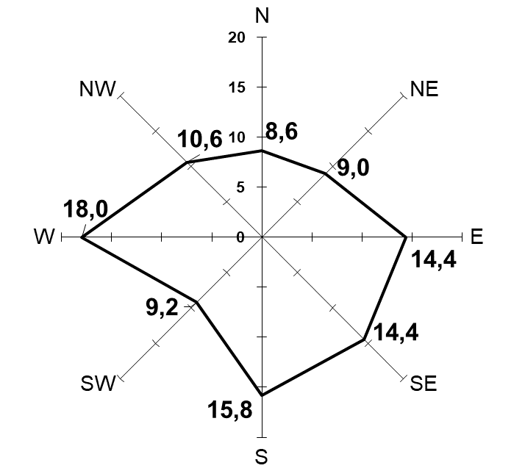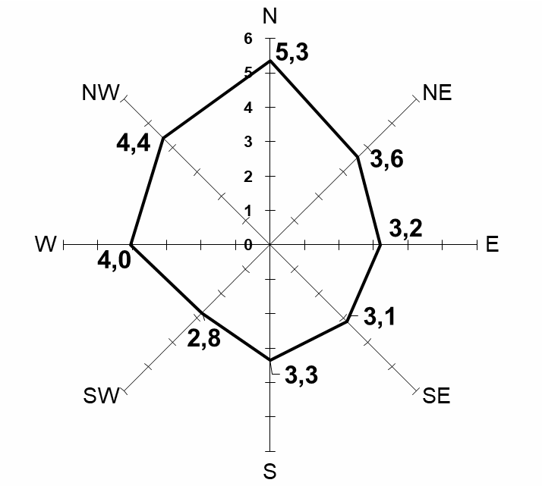A B

Fig. S1. Wind recurrence, % (a) and average wind speed, m/s (b) in the location area of the Kola nuclear power plant for 2012-2016 according to the KNPP weather station AMS-1.
Рис. S1. Повторяемость ветров, % (а) и средняя скорость ветра, м/с (б) в районе размещения Кольской атомной электростанции за 2012-2016 гг. по данным метеостанции АМС-1 АСКРО КоАЭС.

