SUPPLEMENTARY MATERIALS – ДОПОЛНИТЕЛЬНЫЕ МАТЕРИАЛЫ
Transformation of surface layer pf ploughed soil horizon under the impact of atmospheric precipitation
Трансформация поверхностного слоя пахотного горизонта почв под влиянием атмосферных условий
Elena Prudnikova, Igor Savin, Marina Lebedeva, Dmitriy Volkov, Olga Rogova, Evgeniy Varlamov, Konstantin Abrosimov
Е.Ю. Прудникова, И.Ю. Савин, М.П. Лебедева, Д.С. Волков, О.Б. Рогова, Е.Б. Варламов, К.Н. Абросимов

Eurasian Soil Science.
Почвоведение.
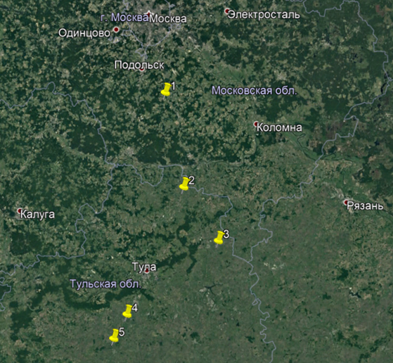
Fig. S1. Test plots for the collection of soil samples and field survey: 1 - Domodedovo region of Moscow oblast; 2 - Yasnogorsk region of Tula oblast; 3 - Venev region of Tula oblast; 4 - Schekino region of Tula oblast; 5 - Plavsk region of Tula oblast.
Рис. S1. Тестовые участки для отбора образцов почв и полевых наблюдений: 1 - Домодедовский район Московской области; 2 - Ясногорский район Тульской области; 3 - Веневский район Тульской области; 4 - Щекинский район Тульской области; 5 - Плавский район Тульской области
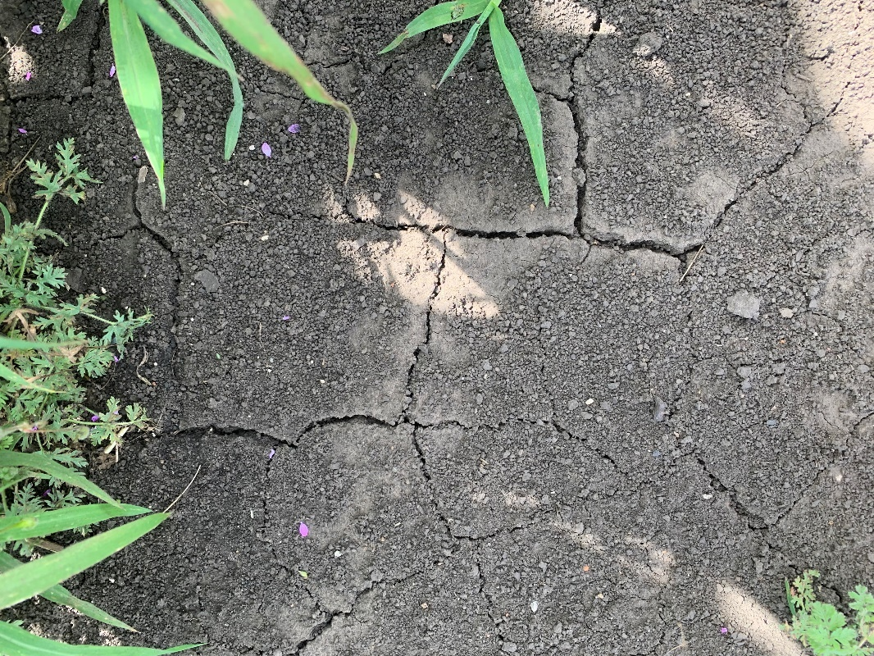

Fig. S2. Water-resistant humus aggregates on the surface of chernozem soils in the field
Рис. S2. Водоустойчивые гумусированные агрегаты на поверхности черноземных почв в поле

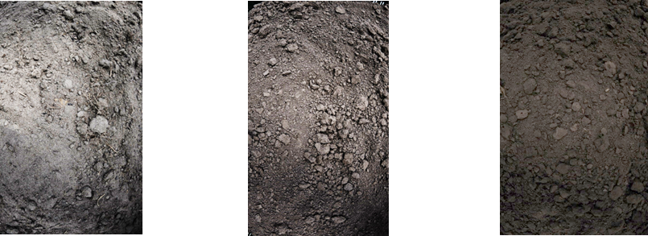
а б в

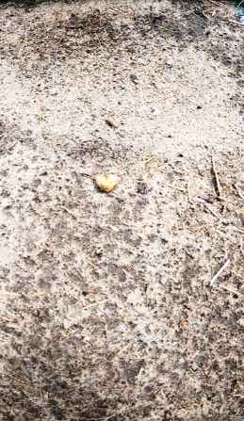

г д е
Fig. S3. Transformation of soil surface under the impact of atmospheric conditions in model experiment (sod-podzolic soils (а, г), gray forest soils (б, д), leached chernozem (в, е); soil surface before transformation – а, б, в; after transformation – г, д, е).
Рис. S3. Трансформация поверхности почв под воздействием атмосферных условий в модельном эксперименте: дерново-подзолистая почва (а, г), серая лесная почва (б, д), чернозем выщелоченный (в, е); нетрансформированная поверхность – а, б, в; трансформированная – г, д, е.
а б в
Fig. S4. Models of micromonoliths of upper 4-cm of soil surface layer (a – leached chernozem, б – grey forest soil, в – sod-podzolic soil).
Рис. S4. Модели микромонолитов поверхностного 4-сантиметрового слоя почв (а – чернозем выщелоченный, б – серая лесная почва, в – дерново-подзолистая почва).

Table S1. Chemical properties, content of macro- and microelements of ploughed horizon of grey forest soils (24 samples).
Таблица S1. Химические свойства, содержание макро- и микроэлементов в пахотном горизонте серых лесных пахотных почв (24 образца).
Parameter | Mixed sample of ploughed horizon (0-20 sm) |  |  |  |  |  | Crust layer (0-2 mm)
 | min | max | mean | median | standard deviation | coefficient of variation (%) | min | max | mean | median | standard deviation | coefficient of variation (%)
Chemical properties
pHw | 5.8 | 7.5 | 6.5 | 6.3 | 0.6 | 9.3 | 5.8 | 7.5 | 6.3 | 6.2 | 0.6 | 9.1
pHs | 4.9 | 6.7 | 5.5 | 5.1 | 0.7 | 13.4 | 4.8 | 6.7 | 5.4 | 5.1 | 0.7 | 12.9
Ca_{ex}, cmol_{c}/kg | 16.3 | 86.6 | 38.2 | 32.5 | 22.2 | 58.0 | 25.2 | 116.6 | 42.3 | 27.7 | 28.6 | 67.7
Mg_{ex}, cmol_{c}/kg | 1.4 | 2.3 | 1.9 | 1.9 | 0.3 | 16.9 | 1.7 | 3.0 | 2.2 | 2.1 | 0.4 | 19.1
K_{ex}, cmol_{c}/kg | 0.3 | 0.9 | 0.5 | 0.4 | 0.2 | 34.9 | 0.3 | 0.7 | 0.4 | 0.4 | 0.1 | 32.2
Na_{ex}, cmol_{c}/kg | 0.0 | 0.1 | 0.1 | 0.0 | 0.0 | 26.0 | 0.0 | 0.2 | 0.1 | 0.1 | 0.1 | 58.9
P₂O₅av (mg/100 g) | 11.1 | 304.9 | 77.6 | 13.4 | 107.6 | 138.7 | 8.9 | 367.8 | 74.7 | 12.2 | 122.0 | 163.3
K₂Oav (mg/100 g) | 16.2 | 38.8 | 22.9 | 19.0 | 7.8 | 34.1 | 14.3 | 30.4 | 19.3 | 16.4 | 6.0 | 30.8
Na₂Oav (mg/100 g) | 0.3 | 0.7 | 0.4 | 0.4 | 0.2 | 35.1 | 0.1 | 1.2 | 0.7 | 0.7 | 0.4 | 58.1
Content of macroelements (%)
Al₂O₃ | 11.0 | 12.2 | 11.6 | 11.6 | 0.4 | 3.7 | 10.7 | 12.8 | 12.0 | 12.1 | 0.7 | 5.8
SiO₂ | 69.9 | 73.2 | 71.6 | 71.7 | 1.3 | 1.8 | 68.1 | 72.7 | 71.0 | 70.9 | 1.4 | 2.0
P₂O₅ | 0.1 | 0.6 | 0.2 | 0.2 | 0.2 | 68.3 | 0.1 | 0.5 | 0.2 | 0.1 | 0.1 | 66.0
SO₃ | 0.2 | 0.4 | 0.3 | 0.2 | 0.1 | 22.9 | 0.2 | 0.3 | 0.3 | 0.3 | 0.0 | 16.7
Cl | 0.0 | 0.0 | 0.0 | 0.0 | 0.0 | 26.6 | 0.0 | 0.0 | 0.0 | 0.0 | 0.0 | 30.5
K₂O | 2.1 | 2.3 | 2.2 | 2.2 | 0.1 | 2.8 | 2.1 | 2.3 | 2.2 | 2.2 | 0.1 | 2.4
CaO | 0.9 | 2.2 | 1.2 | 0.9 | 0.5 | 41.1 | 0.9 | 2.5 | 1.2 | 1.0 | 0.5 | 43.1
TiO₂ | 0.7 | 0.9 | 0.8 | 0.9 | 0.1 | 8.4 | 0.7 | 0.9 | 0.8 | 0.9 | 0.0 | 5.6
Cr₂O₃ | 0.0 | 0.0 | 0.0 | 0.0 | 0.0 | 13.8 | 0.0 | 0.0 | 0.0 | 0.0 | 0.0 | 12.2
MnO | 0.1 | 0.1 | 0.1 | 0.1 | 0.0 | 12.4 | 0.1 | 0.1 | 0.1 | 0.1 | 0.0 | 16.9
Fe₂O₃ | 3.6 | 4.1 | 3.8 | 3.7 | 0.2 | 4.6 | 3.6 | 4.2 | 3.9 | 3.9 | 0.2 | 5.1
Content of microelements (µg/g)
Ni | 24.0 | 36.0 | 30.5 | 32.0 | 4.4 | 14.3 | 23.0 | 41.0 | 32.3 | 32.0 | 5.8 | 17.9
Cu | 18.0 | 33.0 | 24.5 | 23.5 | 5.2 | 21.0 | 22.0 | 31.0 | 26.8 | 27.0 | 3.3 | 12.4
Zn | 56.0 | 94.0 | 67.1 | 62.0 | 13.2 | 19.7 | 55.0 | 92.0 | 66.3 | 62.5 | 10.9 | 16.4
Ga | 17.0 | 25.0 | 20.6 | 20.0 | 3.2 | 15.3 | 16.0 | 23.0 | 20.9 | 21.5 | 2.5 | 11.8
As | 7.0 | 11.0 | 8.1 | 8.0 | 1.4 | 16.7 | 4.0 | 14.0 | 8.0 | 7.0 | 3.5 | 44.1
Br | 16.0 | 21.0 | 18.0 | 17.5 | 2.1 | 11.9 | 6.0 | 19.0 | 12.1 | 12.5 | 4.6 | 38.1
Pb | 92.0 | 99.0 | 95.0 | 95.5 | 2.5 | 2.6 | 13.0 | 97.0 | 55.1 | 54.5 | 42.3 | 76.8
Rb | 124.0 | 141.0 | 129.3 | 126.5 | 6.5 | 5.0 | 95.0 | 145.0 | 114.0 | 111.0 | 19.7 | 17.3
Sr | 37.0 | 41.0 | 38.9 | 38.5 | 1.6 | 4.2 | 35.0 | 131.0 | 82.2 | 81.5 | 46.6 | 56.7
Y | 466.0 | 531.0 | 511.8 | 516.5 | 21.0 | 4.1 | 39.0 | 528.0 | 271.6 | 259.5 | 243.9 | 89.8
Zr | 15.0 | 20.0 | 17.9 | 19.0 | 2.0 | 11.0 | 16.0 | 544.0 | 267.3 | 257.5 | 263.5 | 98.6
Nb | 0.0 | 0.0 | 0.0 | 0.0 | 0.0 | - | 0.0 | 21.0 | 9.6 | 8.5 | 10.2 | 106.0
pHw – рН водной вытяжки (pH of water extract), pHs – рН солевой вытяжки (pH of KCl extract), Ca_{ex}, Mg_{ex}, K_{ex}, Na_{ex} – обменные катионы кальция, магния, калия и натрия по Шолленбергеру (exchangeable cations of calcium, magnesium, potassium and sodium by Shollenberger); P₂O₅av – подвижные соединения фосфора по методу Кирсанова (mobile phosphorus by Kirsanov method), K₂Oav – обменный калий по методу Масловой (exchangeable potassium by Maslova method), Na₂Oav – обменный натрий (exchangeable sodium).

Table S2. Chemical properties, content of macro- and microelements of ploughed horizon of leached chernozems (14 samples).
Таблица S2. Химические свойства, содержание макро- и микроэлементов в пахотном горизонте черноземов оподзоленных (14 образцов).
Parameter | Mixed sample of ploughed horizon (0-20 sm) |  |  |  |  |  | Crust layer (0-2 mm)
 | min | max | mean | median | standard deviation | coefficient of variation (%) | min | max | mean | median | standard deviation | coefficient of variation (%)
Chemical properties
pHw | 5.8 | 6.2 | 5.9 | 5.9 | 0.2 | 2.9 | 5.8 | 6.1 | 5.9 | 5.9 | 0.1 | 2.1
pHs | 4.6 | 5.0 | 4.8 | 4.9 | 0.2 | 3.5 | 4.7 | 5.0 | 4.8 | 4.8 | 0.1 | 2.5
Ca_{ex}, cmol_{c}/kg | 31.4 | 41.2 | 36.5 | 36.8 | 5.0 | 13.6 | 13.6 | 55.6 | 34.2 | 33.8 | 18.4 | 53.6
Mg_{ex}, cmol_{c}/kg | 2.2 | 2.6 | 2.4 | 2.5 | 0.2 | 8.5 | 1.9 | 3.1 | 2.4 | 2.3 | 0.6 | 22.9
K_{ex}, cmol_{c}/kg | 0.4 | 0.7 | 0.5 | 0.6 | 0.1 | 19.8 | 0.5 | 0.6 | 0.5 | 0.5 | 0.0 | 9.1
Na_{ex}, cmol_{c}/kg | 0.1 | 0.1 | 0.1 | 0.1 | 0.0 | 19.2 | 0.1 | 0.1 | 0.1 | 0.1 | 0.0 | 12.3
P₂O₅av (mg/100 g) | 11.4 | 15.6 | 13.3 | 13.1 | 1.8 | 13.5 | 12.5 | 13.4 | 12.9 | 12.8 | 0.4 | 3.3
K₂Oav (mg/100 g) | 18.7 | 29.0 | 24.2 | 24.4 | 4.8 | 19.7 | 22.3 | 26.6 | 24.0 | 23.6 | 1.9 | 7.8
Na₂Oav (mg/100 g) | 0.0 | 1.4 | 0.4 | 0.2 | 0.6 | 150.0 | 0.0 | 2.8 | 0.7 | 0.1 | 1.4 | 187.1
Content of macroelements (%)
Al₂O₃ | 11.5 | 12.5 | 12.2 | 12.3 | 0.4 | 3.7 | 11.9 | 13.5 | 12.5 | 12.3 | 0.7 | 5.5
SiO₂ | 66.6 | 68.4 | 67.8 | 68.1 | 0.8 | 1.2 | 68.2 | 72.8 | 69.4 | 68.4 | 2.2 | 3.2
P₂O₅ | 0.2 | 0.2 | 0.2 | 0.2 | 0.0 | 10.1 | 0.2 | 0.2 | 0.2 | 0.2 | 0.0 | 12.6
SO₃ | 0.3 | 0.3 | 0.3 | 0.3 | 0.0 | 8.3 | 0.2 | 0.4 | 0.3 | 0.3 | 0.1 | 26.2
Cl | 0.0 | 0.0 | 0.0 | 0.0 | 0.0 | 25.9 | 0.0 | 0.0 | 0.0 | 0.0 | 0.0 | 30.5
K₂O | 2.0 | 2.2 | 2.1 | 2.1 | 0.1 | 3.7 | 2.0 | 2.4 | 2.2 | 2.2 | 0.1 | 6.8
CaO | 1.1 | 1.2 | 1.2 | 1.2 | 0.1 | 4.8 | 1.1 | 1.5 | 1.2 | 1.2 | 0.2 | 13.4
TiO₂ | 0.8 | 0.8 | 0.8 | 0.8 | 0.0 | 1.0 | 0.8 | 0.9 | 0.8 | 0.8 | 0.0 | 3.6
Cr₂O₃ | 0.0 | 0.0 | 0.0 | 0.0 | 0.0 | 21.6 | 0.0 | 0.0 | 0.0 | 0.0 | 0.0 | 22.7
MnO | 0.1 | 0.1 | 0.1 | 0.1 | 0.0 | 5.8 | 0.1 | 0.1 | 0.1 | 0.1 | 0.0 | 6.5
Fe₂O₃ | 4.2 | 4.3 | 4.2 | 4.3 | 0.1 | 1.4 | 4.1 | 4.4 | 4.2 | 4.3 | 0.1 | 2.7
Content of microelements (µg/g)
Ni | 27.0 | 38.0 | 32.8 | 33.0 | 4.8 | 14.6 | 31.0 | 38.0 | 34.0 | 33.5 | 3.2 | 9.3
Cu | 19.0 | 24.0 | 21.5 | 21.5 | 2.4 | 11.1 | 22.0 | 27.0 | 24.3 | 24.0 | 2.2 | 9.1
Zn | 53.0 | 58.0 | 56.0 | 56.5 | 2.4 | 4.4 | 54.0 | 59.0 | 56.8 | 57.0 | 2.1 | 3.6
Ga | 19.0 | 26.0 | 22.8 | 23.0 | 3.0 | 13.1 | 19.0 | 25.0 | 21.5 | 21.0 | 2.6 | 12.3
As | 5.0 | 16.0 | 10.3 | 10.0 | 5.1 | 50.0 | 5.0 | 13.0 | 8.8 | 8.5 | 3.9 | 44.1
Br | 10.0 | 19.0 | 14.3 | 14.0 | 3.8 | 26.5 | 11.0 | 15.0 | 14.0 | 15.0 | 2.0 | 14.3
Pb | 13.0 | 99.0 | 56.3 | 56.5 | 47.7 | 84.8 | 14.0 | 97.0 | 56.0 | 56.5 | 46.8 | 83.5
Rb | 94.0 | 134.0 | 113.0 | 112.0 | 21.5 | 19.0 | 95.0 | 135.0 | 115.0 | 115.0 | 21.4 | 18.6
Sr | 37.0 | 137.0 | 86.8 | 86.5 | 56.3 | 64.9 | 37.0 | 134.0 | 84.5 | 83.5 | 54.3 | 64.3
Y | 38.0 | 475.0 | 247.8 | 239.0 | 242.1 | 97.7 | 37.0 | 482.0 | 259.5 | 259.5 | 256.3 | 98.8
Zr | 18.0 | 505.0 | 255.8 | 250.0 | 274.7 | 107.4 | 18.0 | 501.0 | 249.3 | 239.0 | 267.0 | 107.1
Nb | 16.0 | 17.0 | 16.5 | 16.5 | 0.7 | 4.3 | 17.0 | 18.0 | 17.5 | 17.5 | 0.7 | 4.0
pHw – рН водной вытяжки (pH of water extract), pHs – рН солевой вытяжки (pH of KCl extract), Ca_{ex}, Mg_{ex}, K_{ex}, Na_{ex} – обменные катионы кальция, магния, калия и натрия по Шолленбергеру (exchangeable cations of calcium, magnesium, potassium and sodium by Shollenberger); P₂O₅av – подвижные соединения фосфора по методу Кирсанова (mobile phosphorus by Kirsanov method), K₂Oav – обменный калий по методу Масловой (exchangeable potassium by Maslova method), Na₂Oav – обменный натрий (exchangeable sodium).

