SUPPLEMENTARY MATERIALS – ДОПОЛНИТЕЛЬНЫЕ МАТЕРИАЛЫ
The nature of soil dioxin contamination near former landfills
Характер загрязнения диоксинами почвы вблизи мест захоронения твердых бытовых отходов

Anastasia D. Kudryavtseva, Elena Ya. Mir-Kadyrova, Galina A. Kalinkevich, Efim S. Brodskii
А. Д. Кудрявцева, Е. Я. Мир-Кадырова, Г. А. Калинкевич, Е. С. Бродский

Eurasian Soil Science.
Почвоведение.
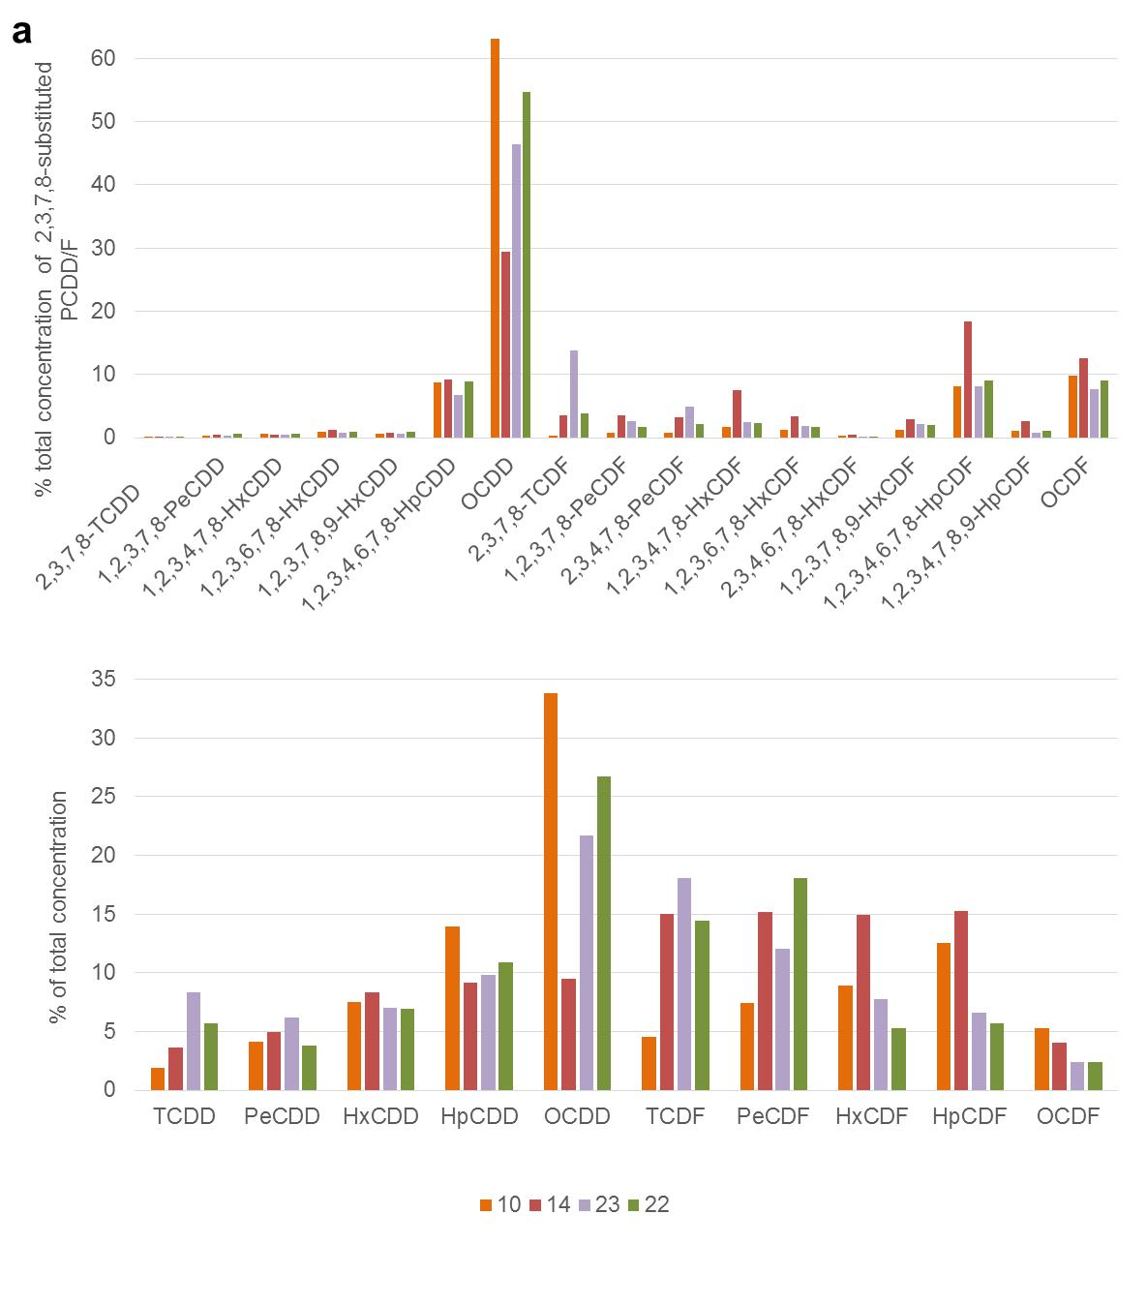
Fig. S1. 2,3,7,8-substituted PCDD/F congener profiles (a) and homologue profiles (b) in three samples with highest contamination levels (10, 14 and 24) and one urban soil sample with moderate contamination level (22).
Рис. S1. Профили ПХДД/Ф в трех точках с наиболее высоким уровнем загрязнения (10, 14 и 24), а также профиль одной из городских почв со средним уровнем загрязнения (22), по 2,3,7,8-замещенным конгенерам (a) и по гомологам (b).
Fig. S2. Loadings plot of 2,3,7,8-substituted congeners (a and b) and of homologues (c).
Рис. S2. Факторные нагрузки по 2,3,7,8-замещенным конгенерам (a и b) и по гомологам (c).

Table S1. Dioxin contamination levels of urban soils in different countries. Min and max values are provided in parenthesis where available.
Таблица S1. Уровни загрязнения городских почв диоксинами в разных странах. В скобках указаны минимальное и максимальное значения (при наличии).

Location |  | Total TEQ | TEF system
Russia | Moscow [1] | 6.8 (3.6-15.7) – parks  5.6 (0.27-15.4) – residential area  5.7 (0.67-16.1) – industrial zones | WHO-TEF₁₉₉₈
 | Chechen Republic [3] | 0.68 (0.05-1.99) – residential area 41.85 (0.16-543.2) – anthropogenic and post-war pollution | NA
 | Ufa [2] | 3.19 | I-TEF
 | Chita [2] | 1.94 | I-TEF
 | Ukhta [2] | 1.19 | I-TEF
 | Vladivostok [2] | 437.7 | I-TEF
 | Kurgan [2] | 3.69 | I-TEF
Austria [5] | Salzburg | 3.42 (1.0-8.3) | I-TEF
UK [6] |  | 26 | I-TEF
Canada [4] |  | 11.3 | I-TEF
Czech Republic [7] | Beroun | 1.82 (0.97-7.11) | I-TEF
 | Zlin | 2.42  (1.27-4.45) | I-TEF
Denmark [12] |  | 0.74 (0.25-3.0) | I-TEF
USA [11] |  | 4.1-51.2* | WHO-TEF₂₀₀₅
China [8] |  | 0.1–5.7* | WHO-TEF₁₉₉₈
Australia [9] | Darwin | 1.4 | WHO-TEF₁₉₉₈
 | Cairns | 2.1-9.2 | WHO-TEF₁₉₉₈
 | Brisbane | 3.0-7.5 | WHO-TEF₁₉₉₈
 | Newcastle | 3.3 | WHO-TEF₁₉₉₈
 | Sydney | 4.0-9.7 | WHO-TEF₁₉₉₈
 | Canberra | 0.72 | WHO-TEF₁₉₉₈
 | Wollongong | 3.3-23 | WHO-TEF₁₉₉₈
Philippines [10] |  | 520 – open dumping site | WHO-TEF₁₉₉₈
Cambodia [10] |  | 390 – open dumping site  1.9 – background urban soil | WHO-TEF₁₉₉₈
India [10] |  | 47 – open dumping site  0.2– background urban soil | WHO-TEF₁₉₉₈
Vietnam [10] | Hanoi | 95 – open dumping site  1 – background urban soil | WHO-TEF₁₉₉₈
 | Ho Chi Minh | 2.21 – open dumping site  1.15 – background urban soil | WHO-TEF₁₉₉₈
*range of mean values from different cities

References:

- Shelepchikov A.A., Brodskii E.S., Feshin D.B., Zhil’nikov V.G., Mir-Kadyrova E.Ya., Balashova S.P. Polychlorinated dibenzo-p-dioxins, dibenzofurans, and biphenyls in soils of Moscow // Eurasian Soil Science. 2011.V. 44. P. 286–296. https://doi.org/10.1134/S1064229311030124.)
- Amirova Z., Kruglov E. Levels in abiotic compartments monitoring of PCDD/Fs and PCBs in soil of Russia cities (from Bryansk to Vladivostok). Organohalogen Compounds. 2002. V. 57. P. 281-284.
- Amirova Z., Shahtamirov I. The consequences of oil and military technogenesis in the Сhechen Republic, Russia. II. PCDD/ Fs and PCBs-WHO pollution of soils // Organohalogen Compounds. 2010. V.72. P. 312-315.
- Birmingham B. Analysis of PCDD and PCDF patterns in soil samples: use in the estimation of the risk of exposure // Chemosphere. 1990. V. 20(7-9). P.807-814. doi:https://doi.org/10.1016/0045-6535(90)90186-W
- Boos R., Himsl A., Wurst F., Prey T., Scheidl K., Sperka G., Gläser O. Determination of PCDDs and PCDFs in soil samples from Salzburg, Austria // Chemosphere. 1992. V. 25(3). P. 283–291. https://doi.org/10.1016/0045-6535(92)90544-2
- Duarte-Davidson R., Sewart A., Alcock R.E., Cousins I.T., Jones K.C. Critical review exploring the balance between sources, deposition, and the environmental burden of PCDD/Fs in the U.K. terrestrial environment: an aid to identifying uncertainties and research needs // Environmental Science and Technology. 1997. V.31(1). P.1-11. https://doi.org/10.1021/es960121s
- Holoubek I., Hofman J., Jech L. Spatial and temporal trends in persistent organic pollutants soil contamination in the Czech Republic // Organohalogen Compounds. 2003. V. 463. P. 460-463.
- Lei R., Liu W., Wu X., Ni T., Jia T. A review of levels and profiles of polychlorinated dibenzo-p-dioxins and dibenzofurans in different environmental media from China // Chemosphere. 2020 V. 239 № 124685. doi:10.1016/j.chemosphere.2019.124685
- Müller J., Muller R., Goudkamp K., Shaw M., Mortimer M., Haynes D., Burniston D., Symons R., Moore M. Dioxins in Soil in Australia. National Dioxins Program Technical Report No. 5. Canberra. 2004. 98 p.
- Nguyen H.M., Tu B.M., Mafumi W., Tatsuya K., In M., Shinsuke T., Shinichi S., Annamalai S., Karuppian S., Pham H.V., Bui C.T., Touch S.T., Maricar S.P. Open dumping site in Asian developing countries: a potential source of polychlorinated dibenzo-p-dioxins and polychlorinated dibenzofurans // Environmental Science and Technology. 2003. V.37(8). P.1493-1502. doi:https://doi.org/10.1021/es026078s
- Urban J.D., Wikoff D.S., Bunch A.T.G., Harris M.A., Haws L.C. A review of background dioxin concentrations in urban/suburban and rural soils across the United States: Implications for site assessments and the establishment of soil cleanup levels // Science of The Total Environment. 2014. V. 466–467. P. 586-597. https://doi.org/10.1016/j.scitotenv.2013.07.065
- Vikelsøe J. Dioxins in Danish soil // Organohalogen Compounds. 2002 V. 57. P. 373-376.

