BIOCONTROL potential of novel borrelidin-producing streptomyces rochei 3IZ-6
I. G. Shirokih¹, I. A. Osterman^{2,3}, D. A. Lukianov^{2,3}, V. I. Marina^{2,3}, M. V. Biryukov², O. A. Belozerova³, E. B. Guglya^{3,4}, A. A. Shirokih¹, Ya. I. Nazarova¹, N. A. Bokov¹, Yu. V. Zakalyukina^{2,*}
¹Federal Agricultural Research Center of the North-East named N. V. Rudnitsky, 610007, Kirov, Russia
²Lomonosov Moscow State University, 119991, Moscow, Russia
³Skolkovo Institute of Science and Technology, Center of Life Sciences, Bolshoy Boulevard 30, bld. 1Moscow, Russia 121205
⁴Shemyakin-Ovchinnikov Institute of Bioorganic Chemistry, Miklukho-Maklaya 16/10, 117997 Moscow, Russia
⁵Pirogov Russian National Research Medical University, Ostrovitianov 1, 117997 Moscow, Russia
Supporting Material

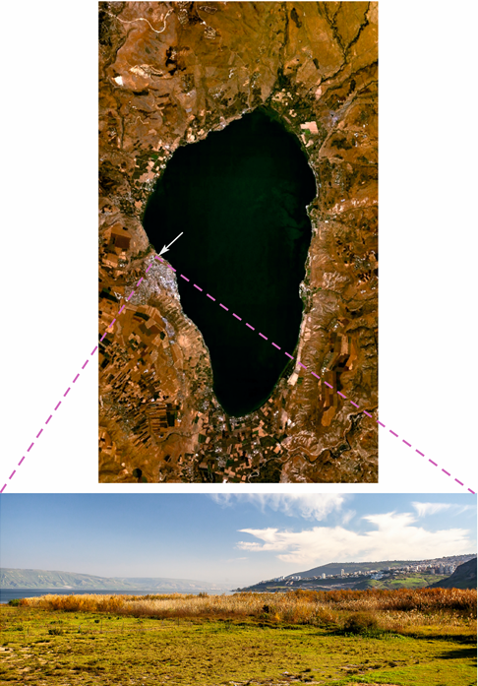

ESM_Fig.1. Sampling location. The arrow indicates the place of collection of samples on the western shore of the lake Kinneret (Lower Galilee, Israel) under a grass field.
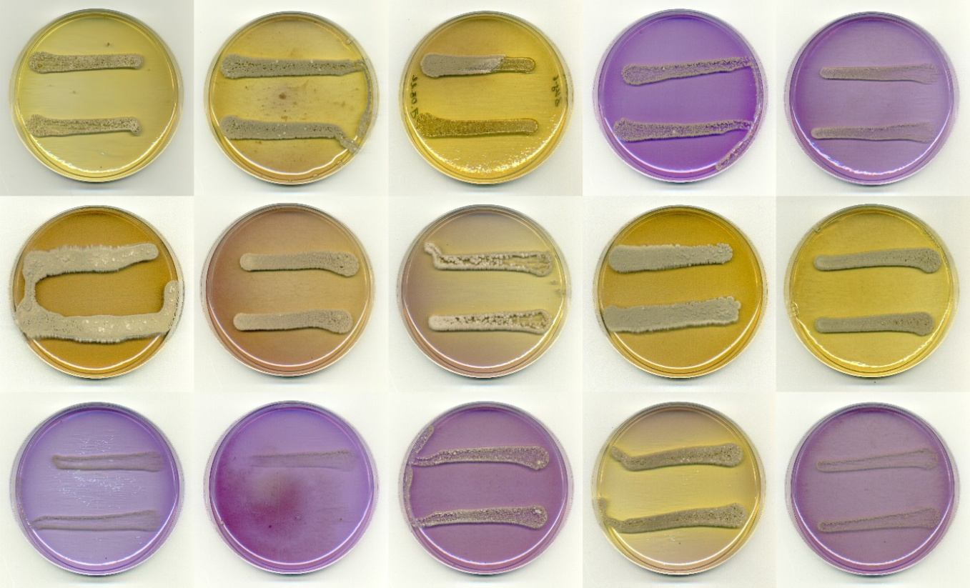

ESM_Fig. 2. Phenotypic properties of 3IZ-6: utilization as sole carbon source (1.0 %, w/v).
Top row, left to right: arabinose, galactose, glucose, inositol, xylose;
middle row, left to right: lactose, maltose, mannitol, mannose, rhamnose;
bottom row: raffinose, sucrose, sorbitol, fructose, mineral base without sugar.

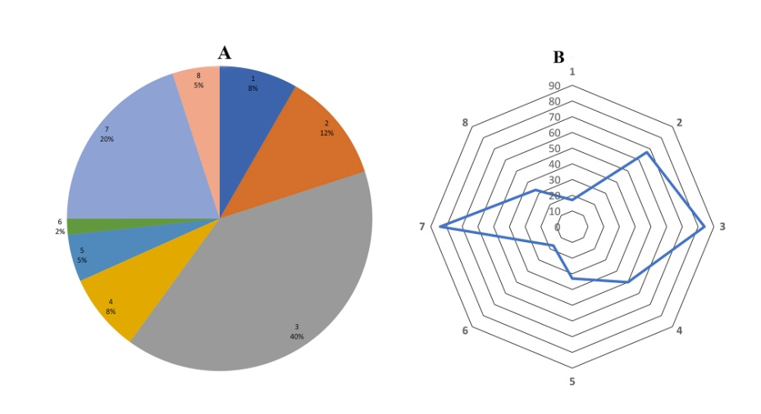

ESM_Fig. 3. The proportion (A) and frequency of occurrence (B) of streptomycete species from different color sections and series (Gauze at al., 1983): 1 – Cinereus Chromogenes, 2 - Cinereus Achromogenes, 3 - Cinereus Violaceus, 4 - Cinereus Aureus, 5 – Cinereus Chrizomallus, 6 – Albus Albocoloratus, 7 – Helvolo-Flavus Helvolus, 8- Imperfeсtus.

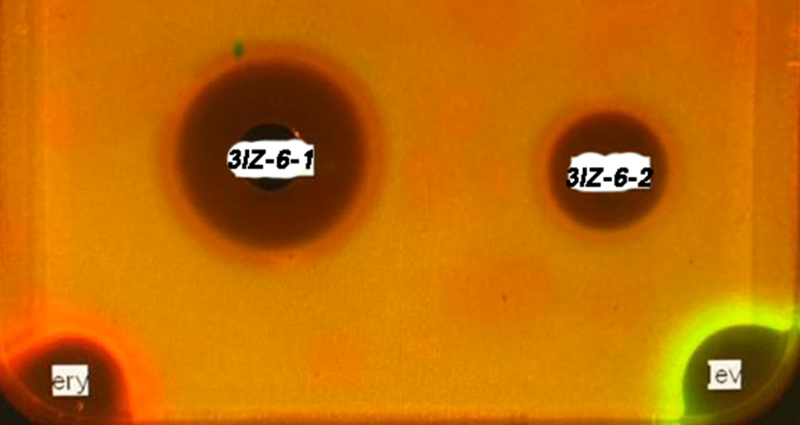
ESM_Fig4. Double reporter system pDualrep2: the fluorescence induction detection using an imaging system. Agar plate coated with the E.coli ΔtolC JW5503 strain transformed with the pDualrep2 plasmid and spotted with erythromycin (Ery, 2µg) and levofloxacin (Lev, 0.05 µg). The plate was scanned in TurboRFP (Cy3) and Katushka2S (Cy5) channels, shown as green and red pseudocolors, respectively. Aliquots of 100 µL of fermentation broth of Streptomyces rochei 3IZ-6 (3IZ-6-1) and 10 µL of active fraction being eluted from the LPS-500-H sorbent with a 50% aqueous acetonitrile (3IZ-6-2).

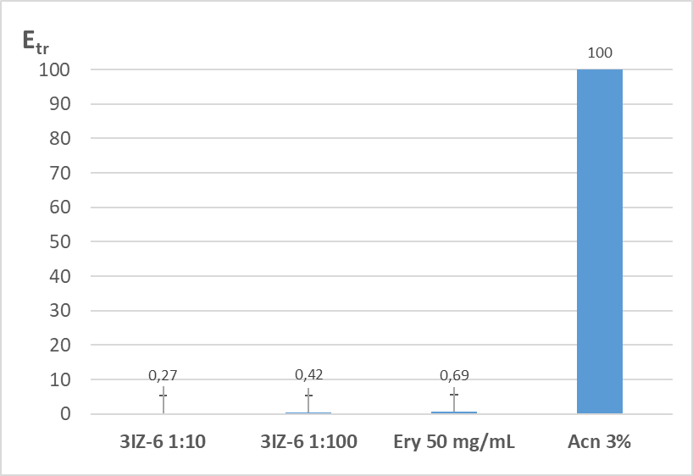
ESM_Fig. 5. In vitro translation inhibition:
E_{tr} -- translation efficiency (%), erythromycin (Ery) is substance used to inhibit translation (negative control), acetonitrile (Acn) used to extract the active substance (positive control).
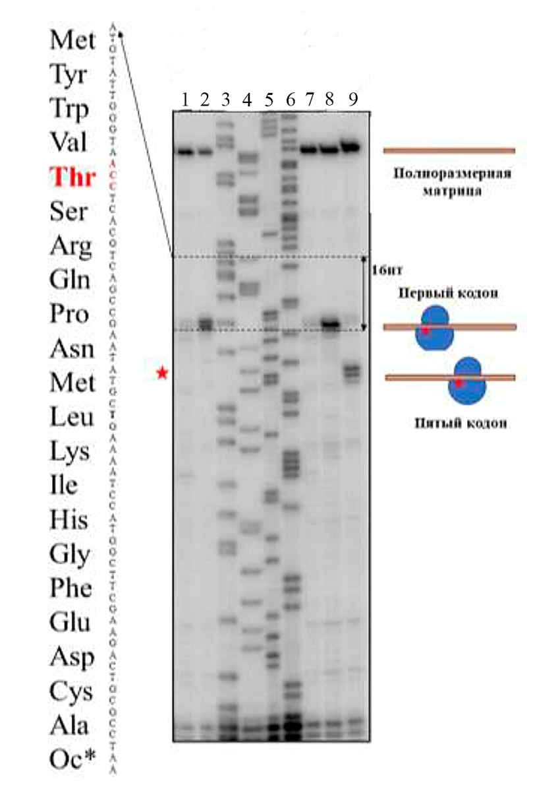
ESM_Fig. 6. Toe-print analysis on RST1 template: 1 – negative control, 1% DMSO; 2 – control antibiotic thiostrepton (50 µМ); 3-6 (T, G, C, A) – sequences of gene rst1; 7-8 – control antibiotics streptomycin (50 µМ) and kanamycin (50 µМ); 9 - toeprint in the present of 1/10 dilution of the concentrated active fraction of 3IZ-6. A red asterisk marks the place where the ribosome stops for sample 3 IZ-6 (A is the ribosome site, corresponds to a distance of 13 nt).
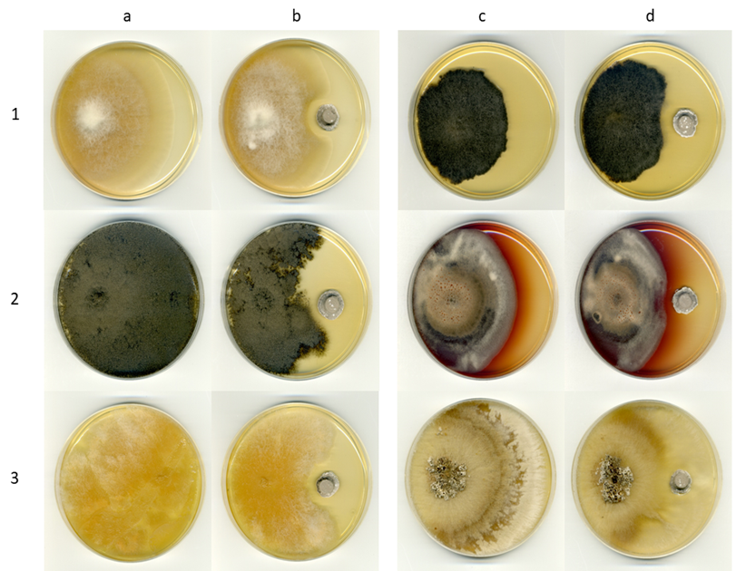
ESM_Fig. 7. Growth of phytopathogenic fungi separately (a, c) and in the presence of the strain S. rochei 3IZ-6 (b, d): Fusarium solani F-819 (1 а, 1b), Botrytis cinerea F-4549 (2 a, 2b), Fusarium sambucinum F-842 (3 a, 3 b), Alternaria radicina F-1843 (1 c, 1 d), Alternaria solani F-3048 (2 c, 2 d), Rhizoctonia solani F-2935 (3 c, 3 d) (PDA, 10 d).

