SUPPLEMENTARY MATERIALS –
The influence of meso- and microclimatic conditions on the CO2 emission of soils of the urban green infrastructure of the Moscow metropolis

Vyacheslav Vasenev
Eurasian Soil Science.
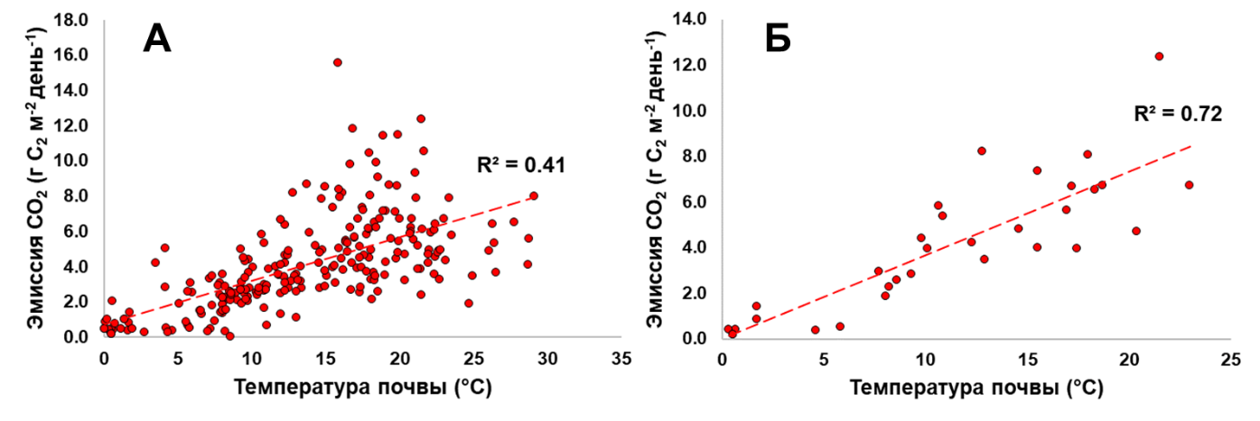
Fig. S1. The dependence of CO2 emissions on the soil surface temperature for the general sample (A) and for the lawns of the RUDN site (Б).

